World History (to 1300)

UNIT 1 Materials

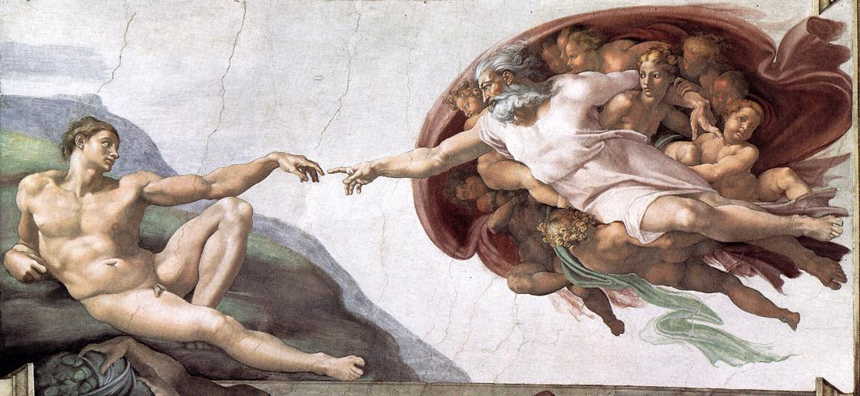

History, Humanity,
& Human Origins

TERMS LIST | Unit 1: Human Origins  World History (to 1300)

Defining History | Humanity and Human Rights
Defining History (What is it?)  Anno Domini  Herodotus  Historiae (meaning ____________)  Literary vs. Non-literary Evidence  Stonehenge  Otzi the Iceman | Malcolm X (and Human Rights)  Human Advantages (Physical and Intellectual)  Tool Use vs. Technology Use  Cicero  The “Humanities”  Fundamental differences vs. differences By Degree  Raphael (Artist), The School of Athens  Congo the Chimp (Painter)  Special Creation vs. Evolutionary Theory  Michelangelo, The Creation of Adam  Charles Darwin  Theistic vs. Non-theistic  John Locke  Thomas Hobbes  State of Nature  Natural Rights  Social Darwinism
Hominids and the Stone Age
Lucy
Hominid

Note key characteristics of the following hominids:

Homo erectus
Neanderthal Man
Cro-Magnon Man

The Discovery of Fire (most important tech EVER)
Prometheus and Epimetheus (Greek Mythology)

Identify and compare the key characteristics of the Paleolithic, Mesolithic, and Neolithic Ages

Venus Figurines
Cave Art
Neolithic Revolution

Writing (as technology)
Odin (Norse Mythology)

PowerPoints, Class Notes, and Review Videos are available on my website!

The Iceman of the Alps
A Historical Inquiry

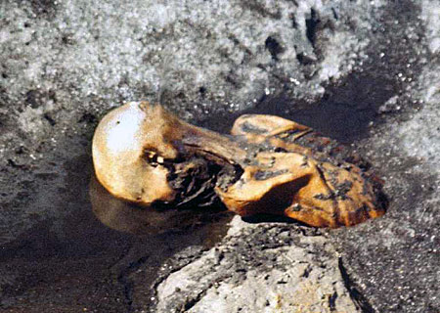
In 1991, hikers in the Alps found a dead body and notified the authorities. They thought the person might have died on a recent hike, but extensive scientific testing revealed the body to be around 5,000 years old! Since the “Iceman” was frozen for all of this time, his body, clothing, and tools were all preserved intact, giving us a rare glimpse of what it must have been like to live in the Neolithic Era.
Photo by Helmut Simon
Reproduced for Instructional Use

The discovery of the Iceman has also given us a mystery to solve. The autopsy revealed many signs of a violent death. When historians inquire about the past, they examine evidence and put it together to tell a story. Examine the evidence below. What story does it tell?

Artifacts | Autopsy
- Copper Axe  - Flint Knife  - 14 bone-tipped arrows  - two finished  - twelve unfinished  - Unfinished Longbow  - Flints  - Mushrooms | - Cerebral Trauma to the head  - Cuts and bruises on hands  - Arrow wound in shoulder (arrow probably removed)  - Blood from four people (DNA)  - 57 Carbon Tattoos (dots and lines on lower spine, back of knees, and right ankle)  - About 5,000 years old!
PREWRITING:
YOUR ASSIGNMENT:

By yourself or with a partner, use at least six pieces of evidence to tell a story about the events leading to the Iceman’s death. Remember that the only wrong answer in history is an answer that lacks evidence. Be creative and have fun with this!

Your finished product should be about one page handwritten. Use the space provided for brainstorming and prewriting.

World History (to 1300)
First Quarter Essay

Your Prompt:
DUE DATES:

A Day: ________, #/##

B Day: ________, #/##

“What does it mean to be Human?”

Length: 2-3 Pages Typed
(11-12 pt Standard Font / Double-Spaced / One Inch Margins)

THIRD PERSON

(This is not an opinionated essay, but a thoughtful assessment of the human condition supported by logical argument and evidence. It should be on a higher level than writing about your favorite kind of ice cream, etc., so you should state your thoughts as facts.)

PRE-WRITING | Your first paragraph should include a clear thesis that communicates your central theme to the reader and summarizes your key points.

CONSTRUCTING A THESIS
THEME (a word or phrase):
- A good historical essay should revolve around a central theme. If you were to sum up being human in a word or phrase, how would you do it?

- If you were to support your contention with three main points, what would they be?
Each of these supporting points should be broad enough that you can create a paragraph out of it, but specific enough to be clear.

Think about the three bears and the porridge – it needs to be just right!
- ___________________________
- ___________________________
- ___________________________

THESIS (This should communicate the central theme and preview the three main points):

______________________________________________________________________________
______________________________________________________________________________
______________________________________________________________________________
OUTLINE:
What specific arguments and evidence will you use to support your points in the body paragraphs?

1. | 2. | 3.

World History (to 1300)
First Quarter Essay

Your Prompt:
DUE DATES:

A Day: Tuesday, 9/13

B Day: Wednesday, 9/14

Evaluate the extent to which this statement is valid:
Human beings are civilized.

Length: 2-3 Pages Typed
(11-12 pt Standard Font / Double-Spaced / One Inch Margins)

THIRD PERSON

(This is not an opinionated essay, but a thoughtful assessment of the mindset and traits of a conqueror supported by logical argument and evidence. It should be on a higher level than writing about your favorite kind of ice cream, etc., so you should state your thoughts as facts.)

PRE-WRITING | Your first paragraph should include a clear thesis that communicates your central theme to the reader and summarizes your key points.

CONSTRUCTING A THESIS
THEME (a word or phrase):

A good historical essay should revolve around a central theme. If you were to sum up being a conqueror in a word or phrase, how would you do it?

If you were to support your contention with three main points, what would they be?
Each of these supporting points should be broad enough that you can create a paragraph out of it, but specific enough to be clear.

Think about the three bears and the porridge – it needs to be just right!
- __________________________________
- __________________________________
- __________________________________

THESIS (This should communicate the central theme and preview the three main points):

______________________________________________________________________________
______________________________________________________________________________
______________________________________________________________________________
OUTLINE: What specific arguments and evidence will you use to support your points in the body paragraphs?

First Argument: | Second Argument: | Third Argument (Counterpoint):
Historical Evidence: | Historical Evidence: | Historical Evidence:

Non-encyclopedic sources (print or web) should be cited with a footnote or on a “Works Cited” page.

Graphic Organizer 1.1 Name: ______________________
Hominids of the Homo Genus

Over the years, archaeologists have unearthed skeletal remains that have humanlike characteristics, but are too different from human skeletons to be classified as Homo sapiens (though similar enough to warrant the Homo prefix). Scientists classify these fossil remains as hominids and proponents of evolutionary theory believe that some of these hominids are ancestors of modern humans.

Scientific  Name | Homo ________ | Homo Neanderthalensis | Homo ________
Meaning
Extinction?
Technology
& Lifestyle

NOTE: The debate over human origins is far from settled in our society. There is no expectation that you personally believe that these hominids existed, but it is still essential for you to be aware of how modern science explains the origins of humanity.

Graphic Organizer 1.2
The Stone Age

 | _______lithic | ______lithic | ______lithic
Etymology
Time Frame
Food Production
Lifestyle
Achievements

An Ancient Greek Story of Creation
From Plato, Protagoras

Document

1.1

The Internet Classics Archive: http://classics.mit.edu/Plato/protagoras.html
Active Reading
Once upon a time there were gods only, and no mortal creatures. But when the time came that these also should be created, the gods fashioned them out of earth and fire and various mixtures of both elements in the interior of the earth; and when they were about to bring them into the light of day, they ordered Prometheus and Epimetheus to equip them, and to distribute to them severally their proper qualities. Epimetheus said to Prometheus: "Let me distribute, and you inspect." This was agreed, and Epimetheus made the distribution. There were some to whom he gave strength without swiftness, while he equipped the weaker with swiftness; some he armed, and others he left unarmed; and devised for the latter some other means of preservation, making some large, and having their size as a protection, and others small, whose nature was to fly in the air or burrow in the ground; this was to be their way of escape. Thus did he compensate them with the view of preventing any race from becoming extinct.
And when he had provided against their destruction by one another, he contrived also a means of protecting them against the seasons of heaven; clothing them with close hair and thick skins sufficient to defend them against the winter cold and able to resist the summer heat, so that they might have a natural bed of their own when they wanted to rest; also he furnished them with hoofs and hair and hard and callous skins under their feet. Then he gave them varieties of food-herb of the soil to some, to others fruits of trees, and to others roots, and to some again he gave other animals as food. And some he made to have few young ones, while those who were their prey were very prolific; and in this manner the race was preserved.
Thus did Epimetheus, who, not being very wise, forgot that he had distributed among the brute animals all the qualities which he had to give-and when he came to man, who was still unprovided, he was terribly perplexed. Now while he was in this perplexity, Prometheus came to inspect the distribution, and he found that the other animals were suitably furnished, but that man alone was naked and shoeless, and had neither bed nor arms of defense. The appointed hour was approaching when man in his turn was to go forth into the light of day; and Prometheus, not knowing how he could devise his salvation, stole the mechanical arts of Hephaestus and Athena, and fire with them (they could neither have been acquired nor used without fire), and gave them to man… And in this way man was supplied with the means of life. But Prometheus is said to have been afterwards prosecuted for theft, owing to the blunder of Epimetheus.

QUESTIONS TO CONSIDER

- What problem did humans face after Epimetheus distributed the gifts and how did Prometheus solve it?

- What does this story tell us about the role technology plays in supporting human existence?
Lose your copy??? Download another one from my website!

The examination of a corpse in order to determine the manner of death
Derived from Greek words meaning forethought and afterthought

