Submission regarding planning application 14/02155/OUTM

Chris Rose
15 Thirlmere Rd., Barnehurst.
DA7 6PU
07590 046502 / chrisrose@gn.apc.org

ON BEHALF OF BEXLEY NATURAL ENVIRONMENT FORUM – the umbrella body for Friends of Parks and Open Spaces groups, local wildlife experts and conservationists and sustainability campaigners in the Borough. We work to protect, restore and enhance habitats and biodiversity across Bexley and are delivering some £41,000 worth of volunteer habitat management per annum.

ERITH QUARRY – BEXLEY’S ‘LAST GREAT WILDERNESS’

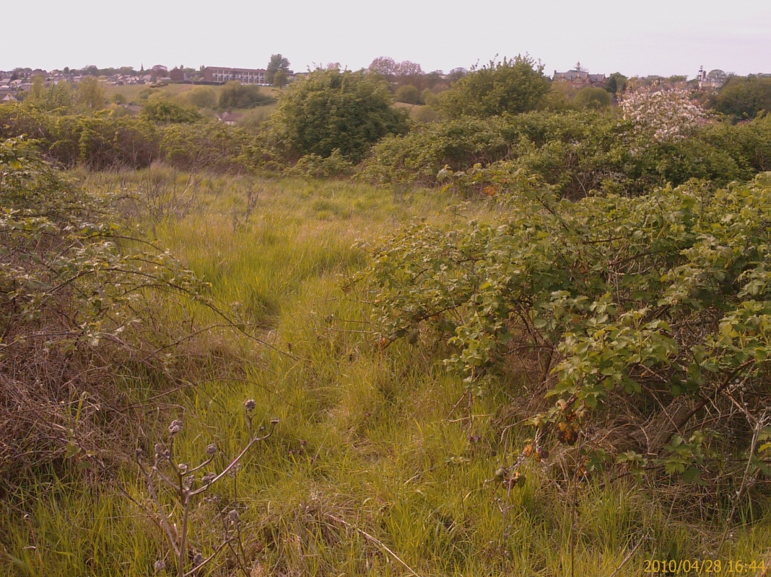

1) OBJECTION

Bexley Natural Environment Forum objects to the application on the grounds that the amount of ‘development’ proposed for this Grade 1 Site of Importance for Nature Conservation in the Borough, which is nearly 75% of the area of the site, is far too large, is not ‘commensurate’ with its conservation status as required by policy 7.19 ‘Biodiversity and access to nature’ of the London Plan (2011), and in our view is highly likely to result in a loss of species, including some of conservation concern and will lead to a very significant reduction in bioabundance. No attempt is made to quantify this. We are also concerned that a fall in abundances of more mobile species will negatively impact neighbouring SINCs at Hollyhill, Erith Cemetery/Streamway and possibly Franks Park, because it seems very likely that Erith Quarry provides a significant food resource for these animals in this overall area. There is no adequate assessment of this and how it would affect the conservation status of any of these other sites, despite the The National Planning Policy Framework (DCLG, 2012) promoting planning for biodiversity at landscape- scale ‘by establishing coherent ecological networks.’

On the basis of ranking and size Erith Quarry is one of the 12 best wildlife sites in the Borough, and by far the best scrub site in the north of Bexley ifnot the whole Borough. Scrub is an impoprtant habitat in its own right. English Nature scrub management handbook Sept 2003: ‘Scrub is an important component of many of the UK Biodiversity Action Plan (BAP) Habitats and EU Priority Habitats. Consequently, it has a high priority for conservation in Britain and Ireland. It is also an important feature of the countryside; in addition to its high value for wildlife, it contributes to the natural beauty of the landscape.

If the application is passed as submitted the site will go from being the 6th biggest Grade 1 site to the second smallest of 14. If the same extent of loss was allowed across all Grade 1, Grade 2 and Local classes of SINC in Bexley then that would be equivalent in land area to 8.3 Danson Parks or 18 East Wickham Open Spaces.

Given there is a hierarchy of nature conservation designations in the Borough, and non-designated sites, including ‘young’ brownfied sites, we question why it is that the Council is not facilitating this developmment taking place on a less biologically important site.

The Mayor’s Biodiversity Strategy (GLA, 2002) says of sites of Borough Importance that:

A1.2.6 These are sites which are important on a borough perspective
in the same way as the Metropolitan sites are important to the whole of
London. Although sites of similar quality may be found elsewhere in
London, damage to these sites would mean a significant loss to the
borough.

We do not accept the claim at 3.98 ‘that through implementation of appropriate mitigation, the biodiversity value of the site would be enhanced compared to the existing situation and would be secured in the long term through an appropriate management plan.’

2) BIODIVERSITY CONSERVATION CONTEXT

The application is conflicted and confused, with the approach of the ‘developer’ having been to self-servingly lead on ‘negative’ issues with the site at public consultations, such as modest fly-tipping, whilst downplaying the actual and potential biodiversity value and then going on to co-opt nature into its ‘iconography’ for commercial and sales pitch purposes – complete with ‘modernist’ marketing waffle such as ‘Our vision for Erith Quarry is to deliver a 21st century sustainable suburb. Ecological, Elevated and Enlightened. Authentic, Aspirational and Accessible. Real, Robust and Rooted.’

We note that at iteration 1 of the ‘developer’s’ plans they were so ecologically enlightened that they proposed to obliterate all the semi-natural habitat bar the woodland, which the saved UDP policies sought to retain anyway.

a) IMPORTANT SPECIES

We then find that the site is, in fact, very important for insects. At 2.2.11 it is reported that a total of 15 species recorded during the survey are designated as “Nationally Scarce” ... , representing 12.5% of the total species inventory. The best sites for invertebrates in the wider London area record 10% or greater, depending upon habitat type.

It has populations of three reptile species (all of which are London and UK Biodiversity Action Plan species), which the ‘developer’ misleading describes as ‘common’ on a number of occasions, conveniently trying to deflect attention from the fact that they are in decline and legally defined as being conservation concern.
We are told that the way to protect all these species is to build on much of the site. Conservation policy – as specified by DEFRA – should be directed towards sustaining and increasing populations and ranges of declining species, not supressing them or simply maintaining a tick list of species present. Extinction starts at home. That is where numbers start to fall, populations are lost or destroyed and ranges contract. That is why London and local authorities have their own biodiversity action plans.

The ‘developer’ states that ‘nature has gradually taken over.’ We say good! It says ’Now is the time to restore the balance with a managed approach to the ecosystem and a critical mass of new homes.’ We say nonsense. Destroying 75% of the semi-natural habitat is not a balanced approach. We note that these will not be ‘affordable’ homes.

b) SIZE

The ‘developer’ claims at 4.1.31. ‘In conclusion, whilst the more species-rich elements of the
grassland are considered to remain of value at the Borough level (as per the existing site citation), the vast majority of the site is of little intrinsic nature conservation value.’ This ignores the intrinsivc value and potential of a large site from the point of view of bioabundance, population robustness and of biodiversity if better managed overall.

At 3.16.14. we read that the national BAP species ‘the Brown-banded Carder Bee Bombus humilis is a bumble bee whose main populations’ are in the ‘London area and parts of South Wales. Populations appear to operate at a landscape scale, which in urban London implies dependency upon the entire metahabitat of post-industrial sites and other ruderal sites.’ i.e. across a large area of land.

Much is made by the ‘developer’ of the loss of open areas to bramble, but that is a management issue. It is ironic that the cover of the Design and Access Statement November 2014 uses an aerial photograph pre-dating the cynical and indiscriminate bulldozing of the site by former owners DHL Ltd in the name of ‘Japanese Knotweed Control’, which probably had the opposite effect and destroyed much of the open scrub, which would have helped favour Bramble in the first place. If this was a statutory nature conservation site the ambition would be to return it to better condition, not build over it. In fact a number of aerial photographs in the documentation, along with the view from Hollyhill, support the ‘developers’ own statement that ‘Significant areas of rough grassland and ruderal vegetation are still present across the site’ – in other words ‘open areas’, and that these are not confined to the small 3.25ha area proposed to be left in the north west corner.

If the Council accepts a ‘developer’s’ argument that a large part of a designated site should now be destroyed because of ‘unfavourable’ vegetation changes, then that will be a licence to owners of other private SINCs, who might want to sell them for ‘development’, to allow or encourage changes unfavourable to key species on them precisely in order to increase their prospects of getting planning permission.

If it accepts 3.92’s statement that ‘bramble scrub is the dominant habitat present on site, while other habitats present include rough grassland, wooded belts, bare ground and rubble, and a small, overgrown stream. ..... The majority of habitats present within the site are of limited ecological value’ then it is suggesting that most of the remaining open spaces in the Borough are pretty worthless.

The State of Nature Report (2013) said that 60% of the 3,148 UK species assessed have declined over the last 50 years and 31% have declined strongly.

The Living Planet report (2014) and Defra UK Biodiversity Indicators (December 2014) show a serious decline in species and abundances, including of formerly common species. The former said that the Living Planet Index (LPI), which measures more than 10,000 representative populations of mammals, birds, reptiles, amphibians and fish, has declined by 52 per cent since 1970. Put another way, in less than two human generations, population sizes of vertebrate species have dropped by half.

It is likely that these were already starting from an eroded baseline because a lot of decline happened before more scientific monitoring and counting began. There is therefore no excuse for complacency. It is worrying, therefore, that the ecological survey of Erith Quarry was very much focussed on what is there now, with an emphasis on rarer species, and a lack of attention to the future potential of a large site to provide an even better home for nature.

The developer’s own report admits that the potential of a site should be taken into account, but only the building and not the future wildlife potential is properly discussed in the numerous and voluminous planning application documents. It further refers to, and therefore acknowledges the biodiversity crisis in our own country at: 3.16.9. UK BAP priority species were those that were identified as being the most threatened and requiring conservation action under the UK Biodiversity Action Plan (UK BAP). The original list of UK BAP priority species was created between 1995 and 1999. In 2007, however, a revised list was produced, following a 2-year review of the priority species and habitats lists. Following the review, the list of UK BAP priority species increased from less than 600 to 1150.

We submit that the rational response to this is to protect and enhance such (semi-)natural sites.

The latest Bexley SINC review formally designates a number of wildlife corridors, on the basis that greater areas of more connected habitat are more advantageous for wildlife. We know that bigger sites are better for wildlife, and the new focus on ‘landscape level’ conservation and ‘habitat connectivity’ is the logical consequence of that. Leaving a margin of hemmed-in woodland and a small area of grassland in one corner would contribute to the general trend of habitat fragmentation and erosion of site sizes. Size matters .......

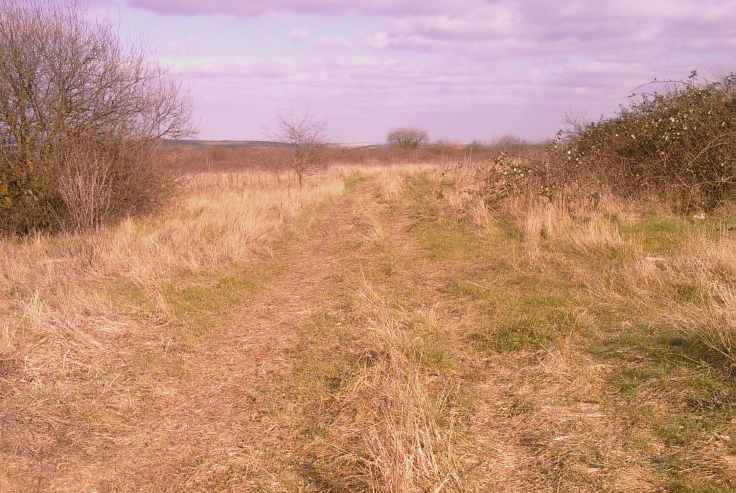
We reject the claim repated at 5.1.12. that ‘In conclusion, it is considered that emerging development proposals can fully retain, and indeed enhance the ecological interest of Erith Quarry by retaining the most important areas, enhancing key features and by instigating appropriate management.’

3) UK, LONDON AND BEXLEY POLICY

a) LOCAL DEVELOPMENT FRAMEWORK (CORE STRATEGY) AND BIODIVERSITY ACTION PLAN

We contend that the scale of this development runs counter to important Bexley policies as set out in the LDF and elsewhere, and compromises the ability to deliver others.

LDF policy CS18 states that Council policy will be one of:

b) protecting, conserving and enhancing Bexley’s Sites of Special Scientific Interest
(SSSI) and Sites of Importance for Nature Conservation (SINC);

The whole of the Quarry site is a Grade 1 SINC so it is not clear how building on nearly three quarters of it delivers this policy, and in our view the amount of ‘mitigation’ proposed will not do so.

c) resisting development that will have a significant impact on the population or
conservation status of protected species and priority species as identified in the UK,
London and Bexley Biodiversity Action Plans;

Reptiles. There are three species of reptile on the site, all of which are BAP priority species at UK and London levels. There is an abject failure on the part of the ‘developer’ and its paid assistants to address the regional or local conservation status of these species. In our opinion the numbers of animals found are high by London and Bexley standards. There are few places in the Borough where all three of these species can be found, and they are large sites.

Only 3 of the 15 Common Lizard populations in the Borough (13 if two of these are counted as meta-populations on conjoined sites) can be considered to occur in reasonably large, secure and hospitable areas with connections to a wider landscape of suitable habitat.

A decision to reduce the number of reptile sites and/or available habitat in the Borough should take the wider importance of Bexley in this regard fully into account.

Bexley Council has already sanctioned the removal of two other Common Lizard populations in the last 5 years, with the second translocation going to the same site as the first, contrary to best practice guidelines. It must start taking into account the cumulative effect of sequential ‘developments’.

The ‘developer’s report states that the Common Lizard population at Erith Quarry is ‘small’, but no peer-reviewed evidence is presented to support the idea that a token retained patch of 3.25ha will adequately support it, or allow for a significant increase. Common sense suggests that the way to increase the population is to have a greater area of suitable habitat than the small remnant currently proposed.

Moreover, following a translocation that was not conducted according to best practice guidelines the animals are currently corraled in an area of only 1ha, and it is clear from paragraphs 3.83 to 3.86 of the Ecological Assessment Interim report that they will not be released into the whole of the 3.25ha area until well after they have emerged from hibernation. Indeed further animals found during the proposed destructive search will be put into this 1ha area before the fencing around that is removed. This is not acceptable.
Despite the controversy surrounding the second translocation mentioned above, Bexley does not have a written definition of what is or is not a ‘significant impact on the population or conservation status of protected species and priority species as identified in the UK, London and Bexley Biodiversity Action Plans;’, or to have specified what it considers to be an ‘acceptable’ population and size and number of sites for good conservation status. We contend that it is therefore incapable of determining whether or not the application complies with policy CS18 c).

We further note that the London Biodiversity Action Plan has a policy aim ‘To protect and conserve the native reptile populations of Greater London.’

BNEF rejects the claim (table NS8) that shoe-horning the reptile populations into a remnant 3.25ha area, and at this moment in time, a 1ha area, coupled with some habitat management work will have a ‘Moderate positive significance at the site level.’ No peer-reviewed evidence is submitted to support this claim, and the ‘developers’ have failed to take into account the regional and Bexley-level conservation status of these declining species.

This is despite the fact that they have quoted NPPF requirements:

‘ 2.3. Protected Species. The ES should assess the impact of all phases of the proposal on protected species. Records of protected species should be sought from appropriate local biological record centres, nature conservation organisations, groups and individuals; and consideration should be given to the wider context of the site for example in terms of habitat linkages and protected species populations in the wider area, to assist in the impact assessment.’

There is no proper data-supported assessment for reptiles or other species, or of actual and potential habitat linkages, in the wider area.

The situation regarding reptiles is dealt with in more detail in the submission of the London Amphibian and Reptile Group.

d) ...... Preference will also be given to
enhancements which help to deliver the targets for habitats and species set out in
the London Plan and Bexley Biodiversity Action Plan;

Woodland. The fact that the ‘development’ is proposed to come close to the retained woodland fringe, with the main road directly adjoing it and requiring a retaining wall in part, runs counter to the principle set out in Bexley Council’s woodland BAP where the aim is to let edges ‘bleed out’ into scrub, which has been the situation at the Quarry site.

WO01-12
Where woodlands in the Council's open
spaces border more open habitats, such as
Shenstone Park, ensure where possible
that the edges are managed as gradual
transition zones rather than vertical edges.

The woodland will instead be hemmed in, which limits regeneration potential and therefore long-term health and vitality.

Bats. Reference the Bats Species Action Plan 2010-2015

We aim to maintain the current bat
population in Bexley and to work with
others to reverse the recent population
declines in London’s bats.

Even if the Bat population at the Quarry is small, maintaining and reversing declines mean it should be thoroughly protected and allowed sufficient retained habitat to increase. Woodland edge habitat will be replaced with a sharp change from woodland to roadway and buildings. However carefully the lighting fixtures are designed and placed, there is likely to be leakage from buildings plus other disturbance in areas where bats would be expected to forage along this margin. The ‘developer’s’ own survey results showed that Bat ‘activity was found to be mostly limited to along the wooded belt along the site periphery.’ There is also a strong emphasis in the planning application documentation as a whole on the importance of such ‘edge’ habitat for Bats and other animal species.

A ‘very dense covering of mature Ivy Hedera helix over trunk’ is cited by the ‘developers’ as being necessary for bat roosting potential, but elsewhere the arboriculturalist’s report talks about removing ivy from trees.

The ‘developers’ consider that it is ‘highly unlikely that any of the bat species recorded, or indeed any other bat species, would be in any way reliant on the site for roosting or foraging purposes.’ Which, of course, conveniently ignores the cumulative impact of ever more ‘development’. If you keep chipping away at areas, whether the sole habitat used or not, numbers will inevitably wind up declining.

Heathland. Erith Quarry already features Gorse and Broom, so would appear to be a candidate for implementation of the Heathland Habitat Action Plan 2010-2015

HL02-02
Explore the feasibility of healthland creation
at sites identified in the London Habitat
Suitability maps, particularly East Wickham
Open Space, Burstead Woods Open
Space, the top of Hall Place around Gravel
Hill, Hollyhill, and the southern edge of
Danson Park, with the aim of creating at
least 1 hectare of new heathland by 2015.

Erith Quarry effectively mirrors Hollyhill on the other side of the valley, which further suggests its potential in this regard. We note that zero progress has been made on practical implementation of this policy. Building on a site where it could be done further hinders the scope for delivery. We further note that heathland is good habitat for reptiles.

b) BIRDS

We agree with the London Wildlife Trust’s assessment that several bird species are almost certainly going to be lost from the site as breeders because of the lack of suitably retained undisturbed habitat, and that this will include Whitethroat and Red-listed Linnet. Other species will also have a much reduced capacity to breed due to available space and disturbance. Vulnerable species like the Song thrush, Chiffchaff and Dunnock have the potential to become extinct on the site.
4.1.19. of the environmental reports says ‘The uniform, and species poor nature of this scrub habitat is considered to be a severe limitation in ecological terms overall, although some bird species such as Whitethroat, Willow Warbler and to some extent Linnet would utilise this habitat type for foraging and/or nesting purposes’. We point out that Linnet is a Red-listed species in the UK, i.e. one of those in most serious decline. ‘Uniform and species poor scrub’ is of rather more value to it than a uniform and even more species poor array of buildings.

A Turtle Dove was recorded on the site this year. Ralph Todd, compiler of the respected six-monthly ‘Bexley Bird Report’ has said (pers comm) that ‘Erith Quarry looks just the sort of place for Turtle Dove so not surprising – I think we have a few good sites (including Braeburn Park) but the bird is in serious decline for other reasons but if they do recover and don't have the habitats left then they'll continue to be in trouble.’ This species is in serious danger of UK extinction, and relies on scrubby edges to woodland – which will be lost to buildings here – and good supplies of weed seeds. Indeed RSPB Turtle Dove advice says: ‘Maintain tall, thick hedgerows and areas of scrub ...... and allow the shrub layer to develop along woodland edges for nesting.’

c) AREAS OF NATURE DEFICIENCY

The remnant ‘ecology area’ that the ‘developers’ propose to leave is, rather perversely, the furthest part of the site from the large part of Erith designated in the LDF as being ‘Deficient in nature conservation’ at Map 4.8.

d) SURVEY WORK

It is claimed that ‘3.94 The desk study and field surveys carried out to date follow published guidelines accepted by statutory and non-statutory agencies, including Natural England and relevant professional bodies such as the Chartered Institute of Ecological and Environmental Management (CIEEM).’

According to previous correspondence between Buglife and the Council 'The invertebrate survey scheduled for 3 visits in mid-July, will not be an adequate assessment of the site. Under Natural England guidelines, invertebrate surveys should be carried out over 3 to 7 days of fieldwork, depending upon the size of the site, covering the period fom March to
October. This is because different species are active over specific times within the period, and are unlikely to be active if it is overcast, cold or raining. Buglife recommends that an invertebrate survey following the Natural England guidelines should be carried out so that the biodiversity impacts of the development can be fully assessed.'

According to the invertebrate survey report presented, the survey work was done on 4 days, but only in June, July and September.

The English Nature best practice guidelines for reptile translocations have not been followed (for further details see the London Amphibian and Reptile Group submission).

e) VIEWS

There is a 134 page document dealing with the effects of the development on views, complete with a number of photographs. Incredibly, this fails to include photos of the best and most open view across the valley (of the now buried Streamway stream) from Hollyhill, which provides one of the most rural-looking panoramas in the Borough. Instead it uses a sight-line in which the Quarry site is largely obscured by substantial trees. We believe the claim in Table NTS8 that ‘Visual effects on completion and in the long-term on users of Holly Hill open space Will be Long-term: Minor neutral.’ to be blatantly untrue.

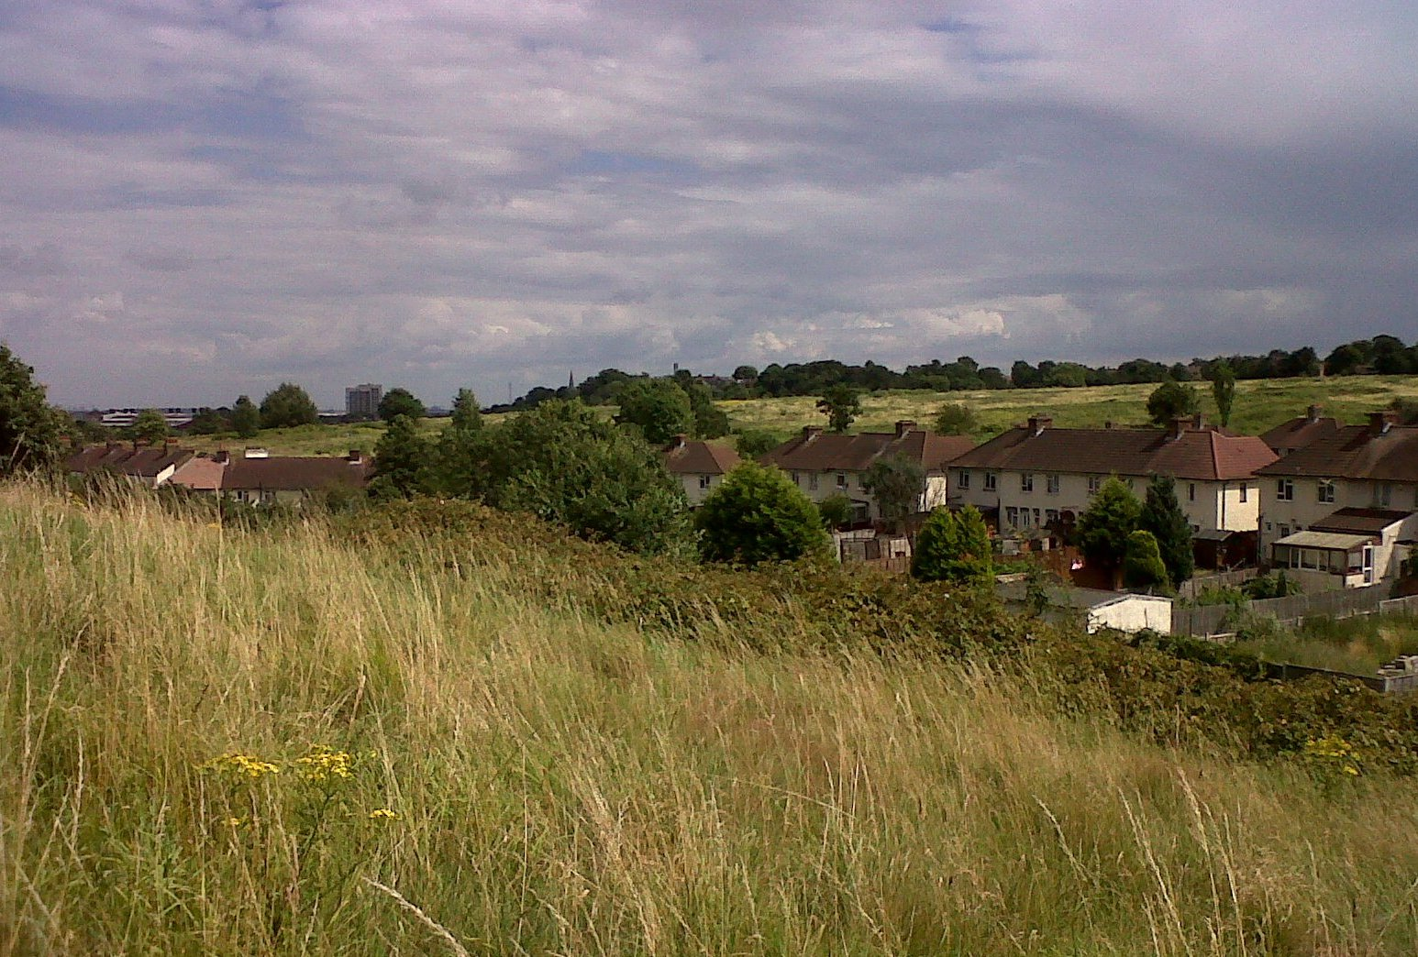

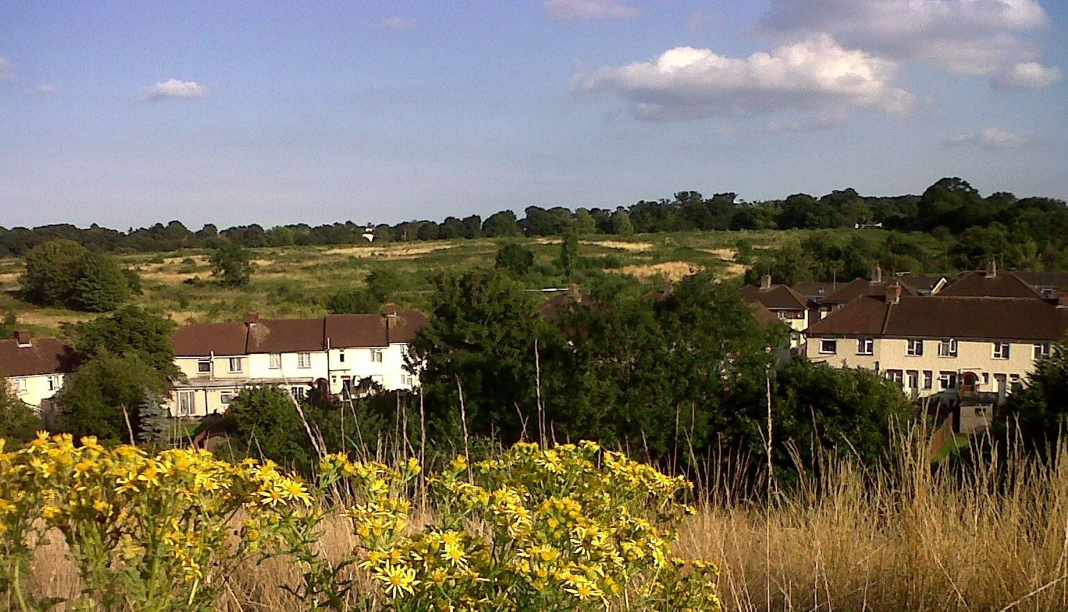

Erith Quarry from Hollyhill

We note that the Detailed Policies and Sites consultation raised the prospect of designating ’protected views’, but this process is now seriously behind schedule and there has therefore been no opportinity to take that proposition forward.

4) IF ANY ‘DEVELOPMENT’ IS APPROVED

a) CARS

At 4.1.2 Principle 2 the ‘developer’ trumpets ‘New links across the site will encourage pedestrians and cyclists to travel through the site, rather than go around it. These proposals will ensure that the site is seamlessly stitched into the area, as a new piece of urban fabric. Integrated within the open space network pedestrian and cycle links are proposed, providing largely car-free green links to the surrounding areas and the wider green network.’

So given the emphais on sustainability, why not have a wholly car-free development for a change? Whilst we think the undercroft parking provision is a reasonable move, that does not comprise all the parking provision, and cars are a land use as well as a resources and energy issue, still requiring yet more ground space at multiple destination points, at a time when Bexley is struggling for room into which to cram its five-fold increase in housing numbers. Electric vehicles do not get around that issue.

b) WATER

The impending water supply stresses on the capital are highlighted in the ‘London Infrastructure Plan 2050’. Whilst the attention to SUDs is welcomed, and at last someone is actually proposing to fit something as cheap as a water butt to expensive houses at the outset, we would be looking for rainwater and greywater capture for ‘low grade’ uses to further reduce demand on mains supplies. The undercrofts provide a space to do that. At 5.9 the ‘developer’ states that it is already intended to capture rainwater in ‘crates’ for slow release. The ‘developer’ quotes Policy 5.13 of the London plan requiring SUDs in which ‘surface water run-off is managed as close to its source as possible in line with a hierarchy that puts ‘Store rainwater for later use’ top of the list.

c) ENERGY

This looks set to be an opportunity missed to go for a much higher standard such as Passivhaus. It is claimed that this can be done at comparable costs to poorer-performing non-Passivhaus equivalents. See e.g. http://www.passivhaushomes.co.uk/

With the exception of the proposed use of recycled aggregates in roadways, there is nothing that addresses the wider embodied energy and use of recovered materials in the actual buildings, apart from suggestions about relatively local sourcing.

d) LIGHTING

5.8 Lighting Strategy. ‘As well as providing functional lighting to meet necessary illumination requirements, certain features in the landscape will be illuminated such as feature specimen
trees signage walls or integrated into furniture.’ We submit that unnecessary lighting wastes energy and is further inimical to Bats and other wildlife. Any lighting should take into account the latest work on regimes that do not disrupt the behaviour of nocturnal insects and Bats such as amber LEDs.

e) ‘INTEGRATING’ BIODIVERSITY

Reference 5.4 Ecology & Biodiversity ‘Specialised ecological bricks that integrate bird nesting and roosting features for a range of birds including swifts, sparrows and starlings’, the desk study work should have turned up the records of the House Martin nest site at nearby Chandlers Drive. This is another declining species, so artificial House Martin nests may therefore be of value and get used. It will be important to ensure that roofline design avoids the problem at Chandlers Drive of bay window glass meeting the frontages at 90 degrees, so that the birds build in the corners and residents can reach and destroy nests which are perceived to cause a nuisance. The proposed use of reflective (thus presumably smooth) soffits may conflict with the ability of these birds to make natural nests on the buildings.

The proposal to put Bat and Bird Boxes into proposed and existing trees within the
landscape does not address whether roosting/nesting sites are the limiting factor on the existing populations. They will be window-dressing if a general lack of foraging area and inadequate food supplies come into play.

In 5.5 Ecology and Landscape, 5.5.3. Residents Play and Amenity Space Strategy, the ‘developer’ cites ‘over provision’ of natural and semi-natural open space. But this is NPPF smoke and mirrors. This is not ‘new’ space, it was there already. It has its own existing inhabitants which will be rendered homeless.

We are told there will be ‘ Invertebrate steps between the grassland and the ecological corridor that allow invertebrates to safely cross between habitats.’ There should also be provision for ground-dwelling species to get across the outer roadways, particularly between the ‘ecology area’ and the ‘ecology corridor’, and into the ‘developed’ area through the provision of some kind of grid-covered ‘tunnel’, or a gridded road surface through which wild plants can grow to provide a modicum of cover.

5.1.24 says that .... ‘The northern most section of the retained grassland will feature a series of wet sand basins which will also provide new habitats for invertebrates such as Dragonflies and Damselflies.’ Yes, but these are likely to be precisely the ‘common’ species of the kind dismissed by the ‘ecologists’.

3.51 says ‘The provision of marginal aquatic planting within these features, to utilise a range of native and wildlife beneficial species such as Ragged Robin Lychnis flos-cuculi, Water Plantain, Alisma plantago-aquatica and Marsh Marigold Caltha palustris will allow for a significant enhancement in the site’s ecological value and will ultimately provide novel
opportunities for a range of faunal groups such as aquatic invertebrates and amphibians should these faunal group colonise in the future.’ With the exception of Ragged Robin these are fairly common waterside plants in Bexley, so the claim that they will ‘significantly enhance the site’s ecological value’ when most of the environmental documentation keeps telling us the common species are of little value and therefore 75% of the site is expendable is just blatant greenwash, and part of the underlying ‘developer’ narrative seeking to persuade us that you can somehow have your cake and eat it.

At 3.82, ‘The creation of additional areas of green space, such as the open play areas and a village green, both of which will be planted with native species and wildlife beneficial species, will provide additional habitat which will further support and enhance the opportunities available to these protected species groups’ – which, according to the preceduing paragraph includes reptiles – is both ignorant and laughable. .

f) PLANTING

A greater harmonius blend with the existing site would be achived by allowing non-hard-surfaced areas re-colonise with flora native to the site/surrounding area, as the old Quarry did once filled. That would be ‘progressive’. There is a surfeit of ’controlled’ planting, not all of which will be especially beneficial to wildlife, including in terms of vegetation structure. This will lead to avoidable management costs and time. We therefore agree with the sentence we have italicised in 5.1.8. ‘Where formal areas of landscaping are proposed, such as within areas of public open space, planting will comprise native and wildlife beneficial species where possible. Additionally, it is recommended that ‘set aside’ areas are considered, within which habitats are allowed to colonise naturally. These measures will ensure that a range of ecologically valuable habitats are present throughout the site, with the formal elements complementing the retained ecology areas.

In terms of proposed planting specifics, there is a known horticultural issue over the longevity of Echinacea. Miscanthus is starting to pop up as self-sown plants on railway ballast in south-east London and could conceivably start to become problematic. We wonder whether Verbena officinalis has been confused with Verbena bonariensis.

We think that Robinia pseudoacacia is inappropriate due to potential invasiveness. It also has fairly brittle wood which can lead to loss of limbs. Quercus petraea is more appropriate than a non-native Oak given that it is the domminant tree of the Thames valley scarp at Lesnes / Franks Park. It also predominates in the church grounds along Carlton Rd, and as veteran street trees here.

We would recommend collecting Hare’s-foot Clover seed off the Erith Swimming pool site and sowing into areas of bare poor soil and brown roofs, as this is a London rarity with attractive flower/seed heads. If it hasn’t been destroyed by operations to date, there used to be a clump of Dittander near the north east corner of the site which could be moved to a retained area, as it is also infrequent in the capital.

g) GREEN / BROWN ROOFS

Reference Bexley LDF policy CS08 i) supporting green infrastructure (e.g. green and brown roofs) and the contribution it can make, to managing flood risk and surface water, and to the mitigation of the urban heat island effect; ........ At one point in the documentation under
‘Land use and ecology’ it is stated that ‘the school and housing will include wildflower green roofs and residents will have access to both private and communal outdoor spaces.’ But at a meeting with the ‘developer’ we were told that the housing would not have these because of solar panel considerations. This would appear to need clarifying. Since flat roofs are envisaged for the housing, with the solar panels on frames, it ought to be possible to have an extent of brown roof without the height of vegetation causing problems. We suggest that allowing natural colonisation rather than deliberate planting would make for for better integration with the ‘indigenous’ suite of species. This would also be in tune with the recolonisation of the quarry by nature.

In any event the taller mixed use buildings proposed for the north west corner of the site are slated for CHP so should be able to accomodate brown roofs.

5) DECISIONS, CONDITIONS AND INFORMATIVES.

a) BNEF believes that approving the application as it stands would be contrary to the LDF Core Strategy in several respects, and there would be a significant adverse impact upon the existing biodiversity, notably the almost complete loss or change of a Site of Borough Importance for Nature Conservation. The potential for maintaining or enhancing the biodiversity on the site after development will be extremely limited due to the small size of the remaining semi-natural area. This small size and the proximity of the development to key habitat features will exacerbate pressures on protected species such as bats, reptiles, and breeding birds, undermining attempts to achieve biodiversity targets as set out in the London Plan. Inadequate evidence has been presented to convince us that this will not be the case.
Permission should be refused for the application as it stands, on the grounds of the site designation and the potential biodiversity impacts on protected species within the development area and the site as a whole.

Should any ‘development’ be approved:

b) It is regrettable that besides the biodiversity designation, the iste also has a conflicting development one. Whilst SINCs have no statutory protection, London Plan policy is that any development that is allowed on such sites should be ‘commensurate’ with their status. It is perverse to argue that this status should only apply in full to the area proposed to be left undeveloped, when the condition of the rest of the site could be readily recovered through suitable management, as would be expected if it was a SSSI. The claim that the site will ‘deteriorate’ if the ‘development’ is not allowed is down to the decisions of the site owner and is not inevitable. We think that ‘developing’ nearly 75% is not ‘commensurate’ given the importance of the site for nature in a Bexley context, and the potential its size provides to increase the populations of rarer and declining species. If some amount of ‘development’ is approved, is should be significantly less than 75%, and probably no more than 50%.

c) In particular we argue that a larger undeveloped area made suitable for reptiles should be retained. This could be achieved by declining all or part of Phase 4.

d) Reptile fencing should not continue to be used to exclude animals from the Phase 4 area, because even if the application is passed, we understand that this area may not be built on until the early 2020s. In the meantime there appears to be suitable reptile habitat there, and exclusion unreasonably prejudices future planning decisions in which this is a material consideration.

e) If the application is passed there should be a spring round of capture in early phase areas using ‘tins’ through to at least May (or later if weather is poor) before a ‘destructive search’, as the data actually made available suggests that this is when most animals were found, as would in any case be expected.

f) The best practice guidelines referred to above go into considerable detail about the conduct of ’destructive searches’. These should be adhered to, with Bexley Council oversight.

g) The numbers of animals so far moved to the ‘holding area’, and otherwise found within the 3.25ha area, should be made public, as should any number of animals captured and moved in 2015 or therafter. The number captured during any destructive search should be separately detailed in such reports, along with the numbers of animals killed and injured during that process.

h) There should be a reptile population monitoring plan for at least 5 years (or better, a 10 year period, perhaps done every 2 years) – rather than at the 3 and 7 year points proposed. In addition, the results should be made public at the end of each year, so that the claims regarding insignificant effects on the population, and the efficacy of ongoing habitat manipulation, can be properly judged so as to inform future planning decisions where reptiles may be affected. [If the population is failing, and this cannot be convincingly ascribed to ‘inadequate’ habitat management, we wonder whether more space will then be made available .....]

i) Monitoring should include the effects of development on the populations of more mobile species such as birds at the nearby SINCs, as well as within the Erith Quarry site.

j) The detailed habitat management plan should be agreed with Bexley Council and take into account UK, London and Bexley BAPs.

k) The proposed information leaflets for residents should cover Slow Worms and Grass Snake as these species may wander into ground-level gardens and open spaces, or may be come across by users of the remnant ‘ecology area’. The destructive effects of cats and fires should be highlighted.

l) There should be less planting, instead allowing more natural colonisation by existing species of plants within the ‘developed’ area, as suggested by the ‘developer’ ecologists. This would likely enhance the propects of more suitable habitat remaining available for species such as Slow Worms in the longer term.

m) Nesting provision for House Martins should be added to the list of ‘biodiversity features’ on buildings, since this is a declining species and one of the two largest nesting colonies in Bexley is relatively nearby at Chandlers Drive.

n) The lighting arrangements should specically take into account the latest research on minimising negative impacts on Bats and nocturnal insects. The effects of light spillage from buildings and any lighting conditions attached should be rigorously monitored and steps taken to counteract problems.

o) For coherence with the London Plan, the rainwater captured in devices other than the proposed water butts should also be rendered available for use, so as to reduce demand on mains supplies given the predicted freshwater deficit in the capital.

p) In line with Bexley LDF aspirations, and given the established nature conservation value of the site, particularly for insects of early successional habitats, brown roofs should be installed on the houses as well as the apartment blocks, as both are slated to have flat roofs. We do not see this as conflicting with solar panels, which are to be mounted on frames.

q) In pursuit of LDF policy CS18 f) enabling environmental education opportunities at the borough’s schools, and investigating opportunities to involve the wider community in biodiversity or geodiversity restoration and enhancement through projects; efforts should be made to engage local experts, conservation volunteers, pupils at the proposed school and the residents of any permitted ‘development’ in the management of the ‘ecology area’.

r) As raised in a face-to-face meeting between BNEF committee members and a representative of the ‘developer’ and ecologists, we suggest that consideration should be given to gifting ownership of any land outside of the ‘developed’ area to Bexley Council, so as to cement a clearer and more accessible channel for wider public engagement with what is going on in these areas. This idea was not rejected by the representatives present at the time. The ‘developer’s’ proposed funding mechanism would remain in place, so there would not be a management cost to the Council.

s) There should be provision for ground-dwelling species to get across the outer roadways, particularly in the area between the ‘ecology area’ and the ‘ecology corridor’, and into the ‘developed’ area, also into and out of the woodland, through the provision of some kind of grid-covered ‘tunnels’, or sections of gridded road surface through which wild plants can grow to provide a modicum of cover.

t) Bexley Council should initiate a scheme to re-wild at least 17ha of manicured areas elsewhere in the Borough to ‘off-set’ the loss of (semi-)natural habitat at Erith Quarry, or some lesser amount equivalent to whatever size of ‘developed’ area might be approved, should this be reduced compared to the current application. This should include increasing the area of suitable habitat for the small population of Common Lizard at nearby Hollyhill Open Space, and also in the parkland adjacent to the Priestlands and Longlands allotment sites, to aid movement of the species between the two and enable an increase in what is again a small population. We note the BAP policy to recreate/restore heathland – which is excellent habitat for reptiles – at sites other than within Lesnes Abbey Wood, and that nothing has been done to progress that policy in practical terms. Broom and Gorse at Erith Quarry and Hollyhill suggest that these sites could be used, and Hollyhill has been identified as a potential heathland re-creation site. The Parks and Open Spaces Habitat Action Plan 2010-2015 provides at PA02 ‘Enhance at least [our emphasis] 15 parks in Bexley to improve their value for nature conservation and the experience of nature they provide for people’ so that the principle of enhancing the biodiversity potential of such areas is already accepted in Council policy
.
u) Bexley Council should define what it considers to be a favourable conservation status for protected and BAP species within the Borough as a whole so as to be able to properly take into account the cumulative effect of sequential developments.

The Council may also wish to do some ‘blue sky thinking’ and look at whether Erith Quarry could be linked at ground level with Hollyhill in pursuit of LDF policy CS17 e) protecting significant green corridors, and seeking opportunities to increase connectivity between the network of green spaces and habitats. It is literally a stone’s throw from one site to the other. If the footpath on the east side of the kink in Riverdale Road was closed, fenced and re-greened, a sunken groove across the road and into Hollyhill with a mesh ‘sky-light’ would potentially re-create that link for at least some ground-living species.

__________________________
ENDS

