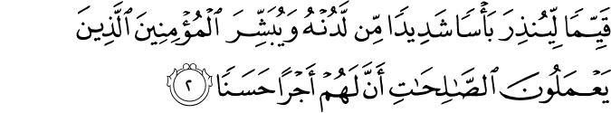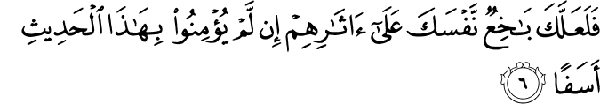
Wa ash-hadu an la’illaha illa Allah wahdahu la shareek la, lahu almulk, walahu alhamd, wa ilayhi taseer al’oomoor, wa ash-hadu anna sayyidana Muhamad 3abduhu wa rasooloho, Arsalahu Allahu bilhaq basheeran wa natheeran, wa da3iyan illa Allahi bi’ithnihi wa sirajan muneeran. Fahuwa alrahmatul muhdaaa’, wal ni3matu almustaa’ (?), wa alsiraj almuneer. Allahuma salli wasallim wa barik 3alayh, wa 3ala ‘alihi alatt-har, wa as-habihi alakhyar, wa man tabi3a sunnatuhu wa sara 3ala nahjihi illa yawm adeen.
Amma ba3d, faya akhwiti almu’minoon, salam Allahu ta3ala 3alaykum wa rahmatuhu wa barakatuhu.
Qal Allahu tabaraka wa ta3alla,

(Al-a3raf, chapter 7)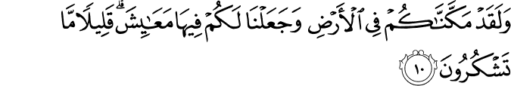
Allah said, we have established you in the earth, and have appointed for you forms of life, but little thanks do you give. Allah (subhanahu wa ta3ala) is here reproaching us with what really is a central reproach of the human condition. He gives so much, the immensity of the universe is all His gift, and none of it is for any other creation, it is for us. And how little do we give thanks? The more we discover about it, the less we seem to understand it. The more amazed we are by the beauty of it, by the order, by the depth, the harmony, the precision, by the stately procession of space and time, the less able we seem to give thanks. This is modern condition, but it is hardly new. The modern mind is the mind of Fir3own; the mind of Fir3own is old. Humans beings have always had that capacity. So Allah subhanahu wa ta3ala complains of us, (34:13)
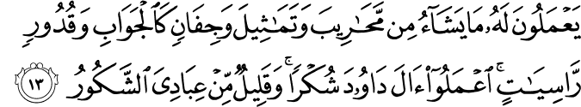
Few amongst my servants is he who really gives thanks, regularly gives thanks. But He has told us that shukr is an important principle in his book, that if we do give thanks He will give us more. (14:7)
If you give thanks I shall certainly give you more. This is the emphatic form of the verb in Arabic. If you give thanks I shall certainly give you more. This is His generosity and this is His promise. We see that the anbiyya’ and the ‘awliyya’ and the great 3ulamaa’ of this religion were people of shukr, they were shakireen. Now, we find the perfect example of this in the seerah of the loved one (salla Allahu 3alayhi wa sallam). He was shakir, grateful for the blessings of his lord. Despite the fact that of this dunya and its immensity and of the treasures of the earth, he had so little, and cared for it so little, he was the most thankful of men. Beautiful, famous hadith of 3atta’ ibn abi rabah, radiyallahu 3anhu, one of the great narrators of Hadith, he spent much with the holy widow Aisha, radiyallahu 3anha, and she was widowed for more than 50 years, during which time she narrated and she narrated and she narrated. So 3atta’ asks Aisha, radiyallahu 3anha, one day, ma a3jabu ma ra’ayti min rasoolillah, (salla Allahu 3alayhi wa sallam)? What’s the most extraordinary thing that you ever saw of Allah’s messenger (salla Allahu 3alayhi wa sallam)? Fa bakat, she wept, wa qallat, wa ayu sha’nihi lam yakun 3ajaban? And she said, and what part of his life was not extraordinary, was not amazing? And then she tells him a narrative that becomes an important principle, a rukn, a pillar of our belief, on the importance of shukr. That one night, they were together, and the holy prophet (salla Allahu 3alayhi wa sallam) says, ya ibnata Abi Bakr, oh daughter of Abu Bakr, and then he says, thareeni ata3abadu lirabbi, let me worship my lord. Fa qallat, uhibu qurbak, wa oofiru hawak. And she says I love to be near to you, but I prefer your wishes to mine. Fa athinat lahu faqaam. And so she gives him permission and he stands up, fatawadda’, he performs his wudu’. Look at this beautiful adab, a lesson for how husbands and wives should be, Fa athinat lahu, she gives him permission and he stands, fatawadda’, he makes his wudu’, fasalla, he prayed, hata albukaa’ asalat dumughuhu 3ala sadrihi. As he prayed, he wept, so that his tears flowed upon his chest, wa lam yazel kathalika hatta jaa’a bilal fa’athanuhu bissalat. And he continued like that until Bilal came and gave the athan for subh. Faqalat, ya rasool Allah, and she said, O Messenger of Allah, why is this? Wa qad ghafarallahu ma taqadama min thambika wa ma ta’akhar? And she said, why so much, when Allah has forgiven all of your sins? Faqal, he said, ya Aisha, ala akoono 3abdan shakooran? O Aisha, should I not be a thankful servant? Awalam yunzal 3alay, was it not to me that it was revealed the words, and then he narrates the great verse of khawateem ali 3imran, (3:190+)
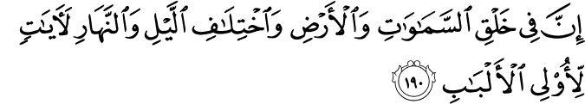Truly in the way the heavens and the earth are created, and in the succession of night and day are signs for people who understand.
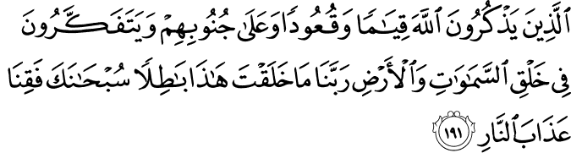Those who remember their Lord standing and sitting and on their sides, and think of the ways that the heaven and earth are created. This is a hadith that we remember when we think about the beautiful meaning of this ‘aya. Now, again the hadith repays long meditation, there are two episodes of tears in it. We wonder why. She is weeping when she is asked this question, what is the most amazing thing you’ve ever seen your husband do, she weeps. These are soft-hearted, spontaneous, natural, infinitely sincere people. It’s natural, she weeps. Why? Well, the commentators say because she misses him, (salla Allahu 3alayhi wa sallam), it was a real love story, but there’s another reason which is given later on when we find the holy prophet (salla Allahu 3alayhi wa sallam) weeping, he’s weeping in the prayer. Why? It’s not sadness that is making him weep. Why? Weeping tears is a sign of distress, a sign of absence, a sign of loss. Why is he distressed? What has he lost? Well, the secret of this is that it is tears of joy and of gratitude and not tears of distress. Commentators, when they look at this, they relate another story of the bani Israel from long ago, and insha’allah there’s benefit in it. One of the prophets of the bani Israel was walking and (marra bihajar) he passed a stone, and from this stone there was a spring flowing, on or underneath the stone. (Fata3ajiba min thalik) he was amazed at this, (fa antaq Allah alhajar) Allah gave speech to the stone, and the stone explained why is it was, as it were, the stone was weeping. (fathakartu qawlahu ta3ala) I remembered Allah’s saying (surat albaqara)
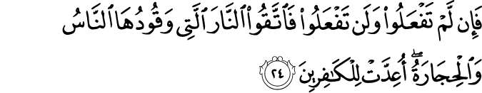
(fa ajirni) So give me protection, so the prophet prayed, (fa ajarahu Allah), Allah gave the stone protection, (fa marra 3alayhi ba3da mudda) and then he passed by it after a time, and the spring was constant, (fa sa’alahu 3an thalik) and the stone replied, (qal thalika bukaa’ alkhawf, wa hatha bukaa’ alshukr), the first were tears of fear, and these are tears of gratitude. These were the tears of the holy prophet (salla Allahu 3alayhi wa sallam). We find him weeping, and his eyes becoming moist in the hadith, very often, which is surprising to us, for men in particular, because we look at it as if it’s not virile, but he’s the most virile of men, (salla Allahu 3alayhi wa sallam), a great warrior, but he would weep, and sometimes it is through bereavement, through sorrow, through loss, when his son dies, Ibrahim. Sometimes it is for joy, and when is he is worshipping his lord, in the depths of the night, when he could be with his beloved wife, and the tears come, it’s not for sorrow, but it’s for joy, it’s for shukr.
Now this principle of shukr is something really is, in a sense, is the same as the principle of iman itself. The Prophet 3alayhi assalat wassalam benefits us by giving us this particular aya in connection with this. And there is in fact so much in the quran that inspires gratitude, we’re not very grateful, that Allah subhanahu wa ta3ala gives us much, (yadahu mabsootatan) His hands are spread out, and it’s this verse in ‘Alli 3imran, truly in the way the heavens and the earth are created and the succession of night and day, in other words, the Cosmos, the Universe in its smallness and its immensity and its symmetry and its colors and its beauty, are signs for people of understanding, and then the prayer comes, a natural response to this. It’s (Shukr al mun3im), to see that all of this has a source, and to see the beauty and balance of it and naturally the believer, when he sees the world with a humble heart, not with the arrogant heart of Fir3own, but when he sees the world with a tender, sensible humble heart, he will overflow with gratitude. That’s the natural response to so immense a gift. And thus was the heart of the holy prophet (salla Allahu 3alayhi wa sallam), absolutely overflowing with gratitude.
Now in a building like this, some of the things they study have to do with cosmology and physics and the origins of the universe and big stuff, and string theory and the rest. Let’s consider some of the things they’ve looked at which they haven’t yet attempted to theorize. Physical constants, for instance. This huge universe, or our awareness of physics works, is a lot more sophisticated than it was in the past, but still the basic problems have not been solved. Physical constants, maybe 25 or 30 of them in the world that are just givens, you don’t ask where they come from, you don’t ask how gravity was set to be a particular force, it just is. And it’s a constant, throughout the galaxy. Gravity is the same thing, and any adjustment to gravity would create a very different universe and a significant adjustment would make the universe impossible. The stars wouldn’t form, the planets wouldn’t form, and so forth. Look at the constants and Fred Hoyle who is connected to this university, a strongman cosmologist used to reflect on this, that the hydrogen nucleus – a basic thing in the universe, the hydrogen atom, very very simple, the force that binds, that pertains to the nucleus of the hydrogen atom, if it was increased by only 2%, then it would not fuse into helium, it would fuse into something called a diproton, and if you can’t have hydrogen fusing into helium, you can’t have stars, which means the universe is going to be really different and probably impossible. That’s 2%, let alone what it could be, 10,000%. 2%! There is fine tuning. So atoms themselves, the universe has fine tuning, the universe is fine-tuned. Martin Rees, professor of astronomy at this university, has books on this. The universe is fine-tuned. That’s the passive participle; is there an active participle; is there a fine tuner? Well, that’s not the business of physicists; they’re looking at the backs (stopped at 13:40)

