World History (to 1300)

UNIT 13
The Rise of Islam

Empires of Monotheism: Part II

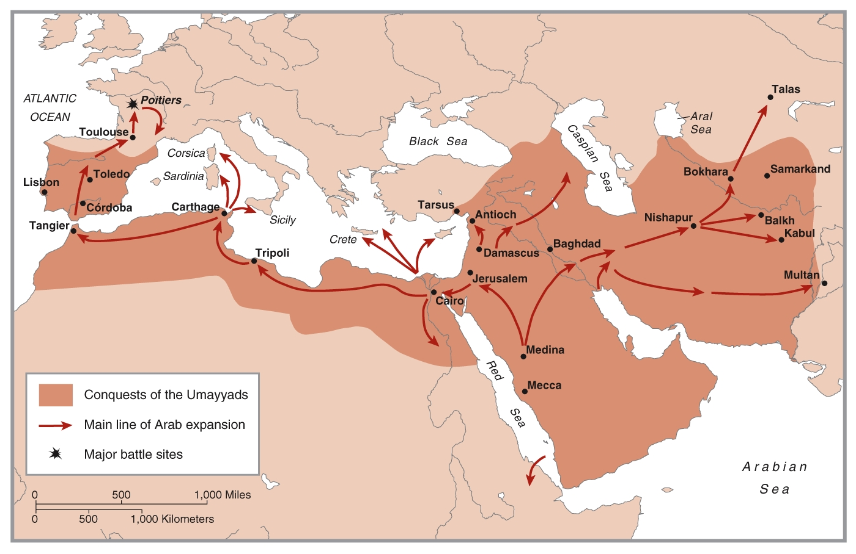

WORLD HISTORY (to 1300)
TERMS LISTS
UNIT 13
The Rise of Islam

Topic
TEXT

Map 13.1

The Rise of Islam

Name: _____________

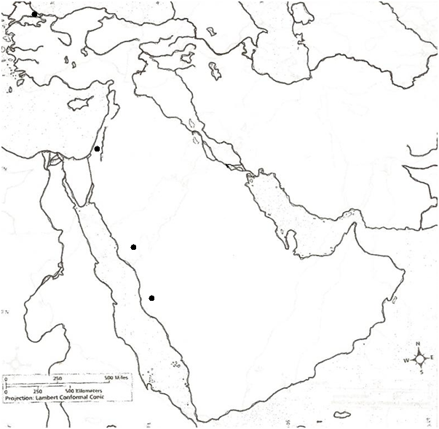
Map Courtesy of Holt, Rinehart and Winston

Identify the following on the map above:

Constantinople
Jerusalem
Mecca
Medina

Anatolia
Arabian Peninsula
Cyprus
Egypt
Iran
Mesopotamia

Mediterranean Sea
Persian Gulf
Red Sea

Euphrates River
Nile River
Tigris River

Document 11.1

