Modern World History

Unit 7 Materials

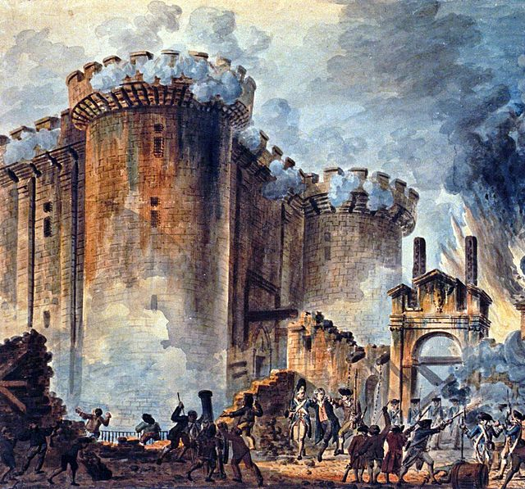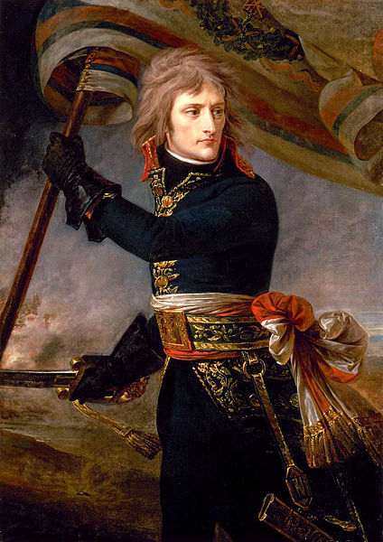

French Revolution and Napoleon

Terms List | Modern World History  Unit 7: French Revolution  & Napoleon

The French Revolution  The Old Regime  First, Second, and Third Estates  Which estates had privileges  such as tax exemptions?  French Support for American Revolution  French Financial Crisis  Assembly of Notables (1787)  Why was the Assembly of Notables convened?  Was it successful?  Estates General (1789)  Bourgeoisie  Abbe Sieyes (What is the Third Estate?)  Failure of the Estates General  “Doubling” the Third / Vote by Head  National Assembly  Tennis Court Oath  Storming of the Bastille ( July ___, 1789)  Great Fear (Peasant Revolt)  August 4 Decrees abolished “___________”  Declaration of the Rights of Man & Citizen  Classical Liberalism (Influence of)  Jean Jaques Rousseau (Influencer)  Civil Constitution of the Clergy  Swearing vs. Refractory Priests  What abuses of power did the Civil  Constitution of the Clergy seek to reform?  Was the Civil Constitution of the Clergy  a liberal reform of the Church? | Radicalization of the  French Revolution

PowerPoints, Class Notes, and Review Videos are available on my website!

From Abbe Sieyes, “What is the Third Estate?”
A Political Pamphlet Written in January, 1789

Document

7.1

CONTEXT: In 1789, Louis XVI called for a meeting of the Estates General. The Estates General, which had not met in 175 years, was organized around the three estates (clergy, nobility, and everyone else) with each estate having one vote. The Third Estate, which made up 75% of the population, could be overruled on any question where the First and Second Estates were in agreement. Sieyes, himself a member of the clergy, sought to challenge this unfair system.
The plan of this book is fairly simple. We must ask ourselves three questions:
Active Reading
What Is The Third Estate? Everything.
What Has It Been Until Now In The Political Order? Nothing.
What Does It Wish to Become? Something.
What is necessary that a nation should subsist and prosper?
Individual effort and public functions.

All individual efforts may be included in for classes:
1. [Agriculture] Since the earth and the waters furnish crude products for the needs of man, the first class, in logical sequence, will be that of all families which devote themselves to agricultural labor.
2. [Manufacturing/Production] Between the first sale of products and their consumption or use, a new manipulation, more or less repeated, adds to these products a second value more or less composite. In this manner human industry succeeds in perfecting the gifts of nature, and the crude product increases two-fold, ten-fold, one hundred-fold in value. Such are the efforts of the second class.
3. [Distribution] Between production and consumption, as well as between the various stages of production, a group of intermediary agents establish themselves, useful both to producers and consumer; these are the merchants and brokers: the brokers who, comparing incessantly the demands of time and place, speculate upon the profit of retention and transportation; merchants who are charged with distribution, in the last analysis, either at wholesale or at retail. This species of utility characterizes the third class.
4. [The Service Sector] Outside of these three classes of productive and useful citizens, who are occupied with real objects of consumption and use, there is also need in a society of a series of efforts and pains, whose objects are directly useful or agreeable to the individual. This fourth class embraces all those who stand between the most distinguished and liberal professions and the less esteemed services of domestics.
Such are the efforts which sustain society. Who puts them forth? The Third Estate.
Public functions may be classified equally well, in the present state of affairs, under four recognized heads; the sword, the robe, the church and the administration. It would be superfluous to take them up one by one, for the purpose of showing that everywhere the Third Estate attends to nineteen-twentieths of them, with this distinction; that it is laden with all that which is really painful, with all the burdens which the privileged classes refuse to carry. Do we give the Third Estate credit for this? That this might come about, it would be necessary that the Third Estate should refuse to fill these places, or that it should be less ready to exercise their functions. The facts are well known. Meanwhile they have dared to impose a prohibition upon the order of the Third Estate. They have said to it: "Whatever may be your services, whatever may be your abilities, you shall go thus far; you may not pass beyond!" …
… Is it not to be remarked that since the government has become the patrimony of a particular class, it has been distended beyond all measure; places have been created not on account of the necessities of the governed, but in the interests of the governing, etc., etc.? Has not attention been called to the fact that this order of things, which is basely and--I even presume to say--beastly respectable with us, when we find it in reading the History of Ancient Egypt or the accounts of Voyages to the Indies, is despicable, monstrous, destructive of all industry, the enemy of social progress; above all degrading to the human race in general, and particularly intolerable to Europeans, etc., etc? But I must leave these considerations, which, if they increase the importance of the subject and throw light upon it, perhaps, along with the new light, slacken our progress.
It suffices here to have made it clear that the pretended utility of a privileged order for the public service is nothing more than a chimera; that with it all that which is burdensome in this service is performed by the Third Estate; that without it the superior places would be infinitely better filled; that they naturally ought to be the lot and the recompense of ability and recognized services, and that if privileged persons have come to usurp all the lucrative and honorable posts, it is a hateful injustice to the rank and file of citizens and at the same a treason to the public.
Who then shall dare to say that the Third Estate has not within itself all that is necessary for the formation of a complete nation? It is the strong and robust man who has one arm still shackled. If the privileged order should be abolished, the nation would be nothing less, but something more. Therefore, what is the Third Estate? Everything; but an everything shackled and oppressed. What would it be without the privileged order? Everything, but an everything free and flourishing. Nothing can succeed without it, everything would be infinitely better without the others.
It is not sufficient to show that privileged persons, far from being useful to the nation, cannot but enfeeble and injure it; it is necessary to prove further that the noble order does not enter at all into the social organization; that it may indeed be a burden upon the nation, but that it cannot of itself constitute a nation….
What is a nation? A body of associates, living under a common law, and represented by the same legislature, etc.
Is it not evident that the noble order has privileges and expenditures which it dares to call its rights, but which are apart from the rights of the great body of citizens? It departs there from the common law. So its civil rights make of it an isolated people in the midst of the great nation. This is truly imperium in imperio.
In regard to its political rights, these also it exercises apart. It has its special representatives, which are not charged with securing the interests of the people. The body of its deputies sit apart; and when it is assembled in the same hall with the deputies of simple citizens, it is none the less true that its representation is essentially distinct and separate: it is a stranger to the nation, in the first place, by its origin, since its commission is not derived from the people; then by its object, which consists of defending not the general, but the particular interest.
The Third Estate embraces then all that which belongs to the nation; and all that which is not the Third Estate, cannot be regarded as being of the nation.
What is the Third Estate?
It is the whole.

The Declaration of the Rights of Man and the Citizen
August 26, 1789

Document

7.2

The History Guide: http://www.historyguide.org/intellect/declaration.html

The Representatives of the French people, organized in National Assembly, considering that ignorance, forgetfulness, or contempt of the rights of man are the sole causes of public miseries and the corruption of governments, have resolved to set forth in a solemn declaration the natural, inalienable, and sacred rights of man, so that this declaration, being ever present to all the members of the social body, may unceasingly remind them of their rights and duties...
In consequence, the National Assembly recognizes and declares, in the presence and under the auspices of the Supreme Being, the following rights of man and citizen:
Active Reading
1. Men are born free and remain free and equal in rights. Social distinctions can be based only on public utility.
2. The aim of every political association is the preservation of the natural and inalienable rights of man. These rights are liberty, property, security, and resistance to oppression.
3. The source of all sovereignty resides essentially in the nation; no body, no individual can exercise authority that does not proceed from it in plain terms.
4. Liberty consists in the power to do anything that does not injure others; accordingly, the exercise of the rights of each man has no limits except those that secure the enjoyment of these same rights to the other members of society. These limits can be determined only by law.
5. The law has only the rights to forbid such actions as are injurious to society...
6. Law is the expression of the general will. All citizens have the right to take part personally, or by their representatives, and its formation. It must be the same for all...
7. No man can be accused, arrested, or detained, except in the cases determined by the law and according to the forms it has prescribed...
10. No one should be disturbed on account of his opinions, even religious, provided their manifestation does not upset the public order established by law.
11. The free communication of ideas and opinions is one of the most precious of the rights of man; every citizen can then freely speak, write, and print, subject to responsibility for the abuse of this freedom in the cases is determined by law.
13. A general tax is indispensable for the maintenance of the public force and for the expenses of administration; it ought to be equally apportioned among all citizens according to their means.
15. Society has the right to call for an account of his administration by every public agent.
16. Any society in which the guarantee of the rights is not secured, or the separation of powers not determined, has no constitution at all.
17. Property being a sacred to and inviolable right, no one can be deprived of it, unless legally established public necessity evidently demands it, under the condition of a just and prior indemnity.

