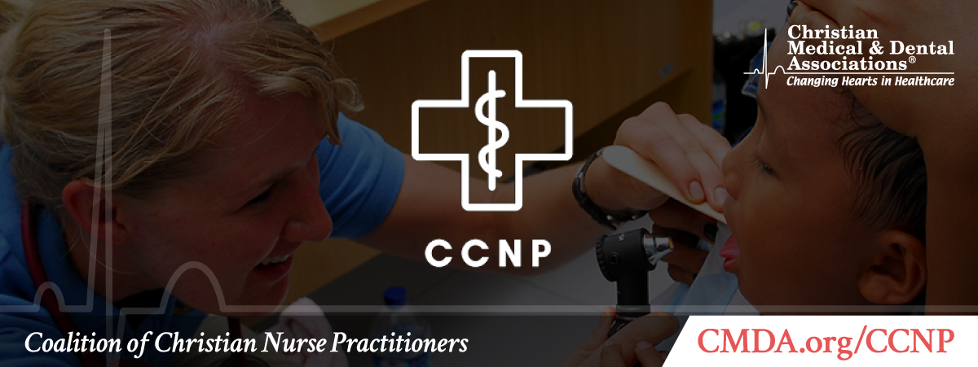
It’s National Nurse Practitioner Week! (November 8-14, 2020)

The Coalition of Christian Nurse Practitioners celebrates and thanks you for your service as a Nurse Practitioner!

As Christians who are nurse practitioners, we strive to serve the Lord by serving others in healthcare. We know we are placed in a unique and privileged position to be conduits of compassionate whole-person healing through faith, prayer and evidence-based medical care.

As you serve your patients in the name of Jesus, know that we are grateful for you!

The Coalition of Christian Nurse Practitioners is here to support you. Contact us with your questions, concerns or prayer requests at npsection@cmda.org. You can also visit us on our Facebook page.

Blessings,

Adrienne E. Thorne, DNP, MSN, AGACNP-BC, FNP-BC
Chairman, Coalition of Christian Nurse Practitioners

Sara Hellwege, MSN, RN, CNM
Secretary and Treasurer

Natalie Ali, ENP-C, FNP-BC
Community Outreach Coordinator

Carol McFarland, MN, RN, CNE
Community Outreach Associate
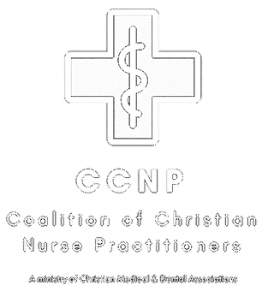
Coalition of Christian Nurse Practitioners
A Ministry of Christian Medical & Dental Associations
P.O. Box 7500 • Bristol, TN 37621 • 888-230-2637
www.cmda.org/ccnp • npsection@cmda.org

Email Preferences

