Modern World History

Unit 6 Materials

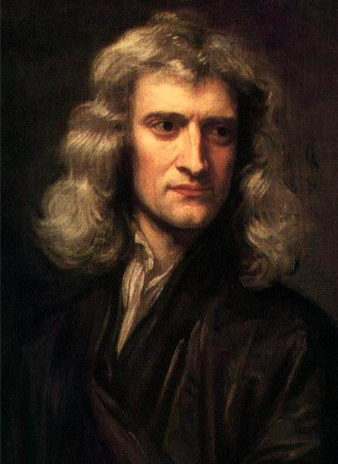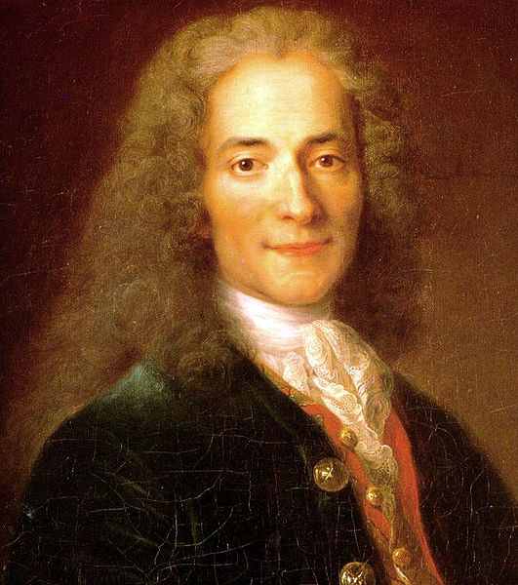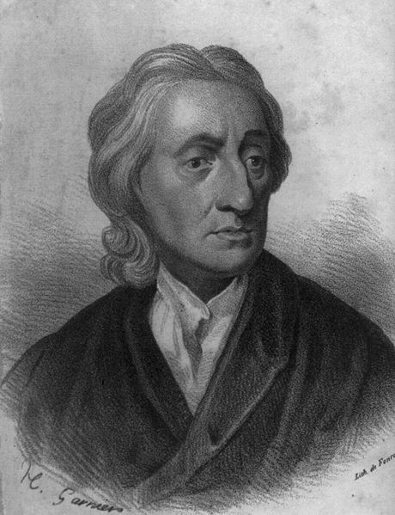

Scientific Revolution and Enlightenment

Terms List | Modern World History  Unit 6: Scientific Revolution  & Enlightenment

The Scientific Revolution  Rene Descartes  People should __________ all things at  least once in their life.  Know the relationships between these isms:  Rationalism, Empiricism,  Materialism, Dualism  Cogito Ergo Sum (__________________)  Cartesian Plane  Blaise Pascal  Pascal’s Triangle  Pascal’s Wager  Deductive and Inductive Reasoning  Aristotle  Deductive Reasoning (“Top Down” Logic)  Premise  A Certain Conclusion  Sir Francis Bacon  Inductive Reasoning (“Bottom Up” Logic)  Observation  A Probable Conclusion  What are the goals of deductive and inductive reasoning?  In what situations would you use deductive and inductive reasoning?  The Heliocentrism Debate  Cosmology  Ptolemy (Ancient Astronomer)  Geocentrism  Nicolaus Copernicus  Heliocentrism  Galileo Galilei  Johannes Kepler (_________ Orbits) | The Enlightenment  Kant, “What is Enlightenment?”  Escape from ____________  What does this mean?  Philosophe  Precursors (Influencers) of the Enlightenment:  Isaac Newton (Natural __________)  John Locke (Natural __________)  Voltaire  Advocate of ___________ Toleration  Popularizer of Science  Candide  Emilie du Chatelet (“Friend” of Voltaire)  Deism (Natural Religion)  Denis Diderot  Encyclopedie  Catherine the Great (Patroness)  Montesquieu  The Spirit of the Laws  Separation of __________  __________ and Balances  Rousseau  The Social Contract  Man is born _________, but everywhere…  General Will  Emile (On Education)  Kant  Critique of _________ Reason  Categorical Imperative (Ethics)  Adam Smith  Wealth of Nations / Invisible Hand / Selfishness  American Enlightenment  Jefferson, Franklin, Paine

PowerPoints, Class Notes, and Review Videos are available on my website!

From Rene Descartes, Principles of Philosophy

Document

6.1

Project Gutenberg: http://www.gutenberg.org/ebooks/4391

I. THAT in order to seek truth, it is necessary once in the course of our life, to doubt, as far as possible, of all things.
As we were at one time children, and as we formed various judgments regarding the objects presented to our senses, when as yet we had not the entire use of our reason, numerous prejudices stand in the way of our arriving at the knowledge of truth; and of these it seems impossible for us to rid ourselves, unless we undertake, once in our lifetime, to doubt of all those things in which we may discover even the smallest suspicion of uncertainty.
II. That we ought also to consider as false all that is doubtful.
Moreover, it will be useful likewise to esteem as false the things of which we shall be able to doubt, that we may with greater clearness discover what possesses most certainty and is the easiest to know.
III. That we ought not meanwhile to make use of doubt in the conduct of life.
In the meantime, it is to be observed that we are to avail ourselves of this general doubt only while engaged in the contemplation of truth. For, as far as concerns the conduct of life, we are very frequently obliged to follow opinions merely probable, or even sometimes, though of two courses of action we may not perceive more probability in the one than in the other… [and] the opportunity of acting would frequently pass away before we could free ourselves from our doubts.
IV. Why we may doubt of sensible things.
Accordingly, since we now only design to apply ourselves to the investigation of truth, we will doubt, first, whether of all the things that have ever fallen under our senses, or which we have ever imagined, any one really exist; in the first place, because we know by experience that the senses sometimes err, and it would be imprudent to trust too much to what has even once deceived us….
V. Why we may also doubt of mathematical demonstrations.
We will also doubt of the other things we have before held as most certain, even of the demonstrations of mathematics, and of their principles which we have hitherto deemed self-evident; in the first place, because we have sometimes seen men fall into error in such matters, and admit as absolutely certain and self-evident what to us appeared false….
VI. That we possess a free-will, by which we can withhold our assent from what is doubtful, and thus avoid error.
But meanwhile, whoever in the end may be the author of our being, and however powerful and deceitful he may be, we are nevertheless conscious of a freedom, by which we can refrain from admitting to a place in our belief aught that is not manifestly certain and undoubted, and thus guard against ever being deceived.
VII. That we cannot doubt of our existence while we doubt, and that this is the first knowledge we acquire when we philosophize in order.
While we thus reject all of which we can entertain the smallest doubt, and even imagine that it is false, we easily indeed suppose that there is neither God, nor sky, nor bodies, and that we ourselves even have neither hands nor feet, nor, finally, a body; but we cannot in the same way suppose that we are not while we doubt of the truth of these things; for there is a repugnance in conceiving that what thinks does not exist at the very time when it thinks. Accordingly, the knowledge, I THINK, THEREFORE I AM, is the first and most certain that occurs to one who philosophizes orderly.

Immanuel Kant, “What is Enlightenment?”

Document

6.2

Source: http://www.columbia.edu/acis/ets/CCREAD/etscc/kant.html

Enlightenment is man's emergence from his self-imposed nonage. Nonage is the inability to use one's own understanding without another's guidance. This nonage is self-imposed if its cause lies not in lack of understanding but in indecision and lack of courage to use one's own mind without another's guidance. Dare to know! (Sapere aude.) "Have the courage to use your own understanding," is therefore the motto of the enlightenment.
Laziness and cowardice are the reasons why such a large part of mankind gladly remain minors all their lives, long after nature has freed them from external guidance. They are the reasons why it is so easy for others to set themselves up as guardians. It is so comfortable to be a minor. If I have a book that thinks for me, a pastor who acts as my conscience, a physician who prescribes my diet, and so on--then I have no need to exert myself. I have no need to think, if only I can pay; others will take care of that disagreeable business for me. Those guardians who have kindly taken supervision upon themselves see to it that the overwhelming majority of mankind--among them the entire fair sex--should consider the step to maturity, not only as hard, but as extremely dangerous. First, these guardians make their domestic cattle stupid and carefully prevent the docile creatures from taking a single step without the leading-strings to which they have fastened them. Then they show them the danger that would threaten them if they should try to walk by themselves. Now this danger is really not very great; after stumbling a few times they would, at last, learn to walk. However, examples of such failures intimidate and generally discourage all further attempts.
Thus it is very difficult for the individual to work himself out of the nonage which has become almost second nature to him. He has even grown to like it, and is at first really incapable of using his own understanding because he has never been permitted to try it. Dogmas and formulas, these mechanical tools designed for reasonable use--or rather abuse--of his natural gifts, are the fetters of an everlasting nonage. The man who casts them off would make an uncertain leap over the narrowest ditch, because he is not used to such free movement. That is why there are only a few men who walk firmly, and who have emerged from nonage by cultivating their own minds.
It is more nearly possible, however, for the public to enlighten itself; indeed, if it is only given freedom, enlightenment is almost inevitable. There will always be a few independent thinkers, even among the self-appointed guardians of the multitude. Once such men have thrown off the yoke of nonage, they will spread about them the spirit of a reasonable appreciation of man's value and of his duty to think for himself. It is especially to be noted that the public which was earlier brought under the yoke by these men afterwards forces these very guardians to remain in submission, if it is so incited by some of its guardians who are themselves incapable of any enlightenment. That shows how pernicious it is to implant prejudices: they will eventually revenge themselves upon their authors or their authors' descendants. Therefore, a public can achieve enlightenment only slowly. A revolution may bring about the end of a personal despotism or of avaricious tyrannical oppression, but never a true reform of modes of thought. New prejudices will serve, in place of the old, as guide lines for the unthinking multitude.
This enlightenment requires nothing but freedom--and the most innocent of all that may be called "freedom": freedom to make public use of one's reason in all matters. Now I hear the cry from all sides: "Do not argue!" The officer says: "Do not argue--drill!" The tax collector: "Do not argue--pay!" The pastor: "Do not argue--believe!" Only one ruler in the world says: "Argue as much as you please, but obey!" We find restrictions on freedom everywhere. But which restriction is harmful to enlightenment? Which restriction is innocent, and which advances enlightenment? I reply: the public use of one's reason must be free at all times, and this alone can bring enlightenment to mankind….
A man may postpone his own enlightenment, but only for a limited period of time. And to give up enlightenment altogether, either for oneself or one's descendants, is to violate and to trample upon the sacred rights of man….
When we ask, “Are we now living in an enlightened age?” The answer is, “No, but we live in an age of enlightenment.” As matters now stand it is still far from true that men are already capable of using their own reason in religious matters confidently and correctly without external guidance. Still, we have some obvious indications that the field of working toward the goal [of religious truth] is now opened. What is more, the hindrances against general enlightenment or the emergence from self-imposed nonage are gradually diminishing. In this respect this is the age of the enlightenment and the century of Frederick [the Great].
A prince ought not to deem it beneath his dignity to state that he considers it his duty not to dictate anything to his subjects in religious matters, but to leave them complete freedom… [Frederick's Prussia] is a shining example that freedom need not cause the least worry concerning public order or the unity of the community. When one does not deliberately attempt to keep men in barbarism, they will gradually work out of that condition by themselves.
I have emphasized the main point of the enlightenment--man's emergence from his self-imposed nonage--primarily in religious matters, because our rulers have no interest in playing the guardian to their subjects in the arts and sciences. Above all, nonage in religion is not only the most harmful but the most dishonorable. But the disposition of a sovereign ruler who favors freedom in the arts and sciences goes even further: he knows that there is no danger in permitting his subjects to make public use of their reason and to publish their ideas concerning a better constitution, as well as candid criticism of existing basic laws. We already have a striking example [of such freedom], and no monarch can match the one whom we venerate.
But only the man who is himself enlightened, who is not afraid of shadows, and who commands at the same time a well disciplined and numerous army as guarantor of public peace--only he can say what [the sovereign of] a free state cannot dare to say: "Argue as much as you like, and about what you like, but obey!" Thus we observe here as elsewhere in human affairs, in which almost everything is paradoxical, a surprising and unexpected course of events: a large degree of civic freedom appears to be of advantage to the intellectual freedom of the people, yet at the same time it establishes insurmountable barriers. A lesser degree of civic freedom, however, creates room to let that free spirit expand to the limits of its capacity. Nature, then, has carefully cultivated the seed within the hard core--namely the urge for and the vocation of free thought. And this free thought gradually reacts back on the modes of thought of the people, and men become more and more capable of acting in freedom. At last free thought acts even on the fundamentals of government and the state finds it agreeable to treat man, who is now more than a machine, in accord with his dignity.

