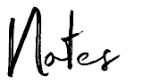
Notes
Topic/Date:
Date:

Questions/Cues | Notes
Summary

Notes

