AP European History

UNIT 7 MATERIALS

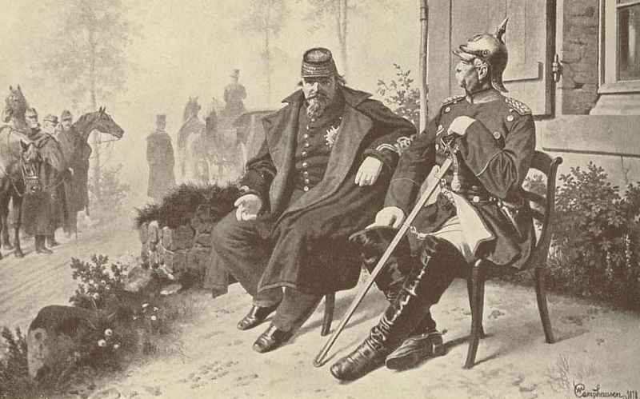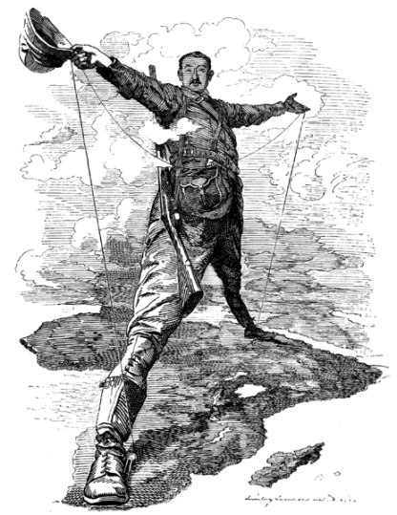

The Late Nineteenth Century

Modernization, Unification, and Imperialism
Unit Plan
and Pacing Guide
Unit 7
The Late 19th Century

PART ONE  The Second Industrial Revolution | Kagan, 717-720 OR Wood, 323-333  E-Lecture on YouTube: Part I Part II  Graphic Organizer
PART TWO  The Crimean War | Kagan, 687-690 OR Wood, 367-368  Document 7.1 (Charge of the Light Brigade)
PART THREE  German and Italian Unification | Kagan, 690-700 OR Wood, 369-375  Document 7.2 (German Unification)  German Unification E-Lecture on YouTube: Part I Part II Part III  Italian Unification: Paul Sargent E-Lecture on YouTube
PART FOUR  The New Imperialism | Kagan, Chapter 25 OR Wood, 397-403, 406-414, 417-422  AFRICA MAP (Fill Out In Color)  Document 7.3 (Cecil Rhodes, “Confession of Faith”)  Document 7.4 (The White Man’s Burden)  Document 7.5 (The Brown Man’s Burden)
PART FIVE  The Victorian Era | Kagan, 687-699, 830-833 OR Wood, 382-384
PART SIX  Art Movements | Kagan, OR Wood,
PART SEVEN  The Dreyfus Affair | Kagan, OR Wood,
Various Other Topics | Labor and Socialism (Kagan, 736-747 OR Wood,  Document 7.
ASSESSMENT | MULTIPLE CHOICE TEST  DBQ

Graphic Organizer
The Industrial Revolutions

Directions: Use this graphic organizer in conjunction with my video lecture on the
Second Industrial Revolution (click the link to open the lecture in YouTube).

 | 1st Industrial Revolution | 2nd Industrial Revolution
Time Frame
Methods of Production
Mass Production
Power Sources
New Engines
Inventions
Standard of Living

For more instructional materials, visit tomrichey.net!
Alfred, Lord Tennyson,
“The Charge of the Light Brigade” (1854)
National Center for Public Policy Research:
http://www.nationalcenter.org/ChargeoftheLightBrigade.html

Document

7.1

Half a league half a league,
Half a league onward,
All in the valley of Death
Rode the six hundred:
'Forward, the Light Brigade!
Charge for the guns' he said:
Into the valley of Death
Rode the six hundred.
'Forward, the Light Brigade!'
Was there a man dismay'd ?
Not tho' the soldier knew
Some one had blunder'd:
Theirs not to make reply,
Theirs not to reason why,
Theirs but to do & die,
Into the valley of Death
Rode the six hundred.
Cannon to right of them,
Cannon to left of them,
Cannon in front of them
Volley'd & thunder'd;
Storm'd at with shot and shell,
Boldly they rode and well,
Into the jaws of Death,
Into the mouth of Hell
Rode the six hundred.
Flash'd all their sabres bare,
Flash'd as they turn'd in air
Sabring the gunners there,
Charging an army while
All the world wonder'd:
Plunged in the battery-smoke
Right thro' the line they broke;
Cossack & Russian
Reel'd from the sabre-stroke,
Shatter'd & sunder'd.
Then they rode back, but not
Not the six hundred.
Cannon to right of them,
Cannon to left of them,
Cannon behind them
Volley'd and thunder'd;
Storm'd at with shot and shell,
While horse & hero fell,
They that had fought so well
Came thro' the jaws of Death,
Back from the mouth of Hell,
All that was left of them,
Left of six hundred.
When can their glory fade?
O the wild charge they made!
All the world wonder'd.
Honour the charge they made!
Honour the Light Brigade,
Noble six hundred!

German Unification Readings
History Man: http://www.historyman.co.uk/unification/index.html

Document

7.2

Johann Gottlieb Fichte: Address to the German Nation (1806)
"The first, original, and truly natural boundaries of states are beyond doubt their internal boundaries. Those who speak the same language are joined to each other by a multitude of invisible bonds by nature herself, long before any human art begins; they understand each other and have the power of continuing to make themselves understood more and more clearly; they belong together and are by nature one and an inseparable whole. Such a whole, if it wishes to absorb and mingle with itself any other people of different descent and language, cannot do so without itself becoming confused, in the beginning at any rate, and violently disturbing the even progress of its culture. From this internal boundary, which is drawn by the spiritual nature of man himself, the marking of the external boundary by dwelling place results as a consequence; and in the natural view of things it is not because men dwell between certain mountains and rivers that they are a people, but, on the contrary, men dwell together-and, if their luck has so arranged it, are protected by rivers and mountains-because they were a people already by a law of nature which is much higher.
Thus was the German nation placed-sufficiently united within itself by a common language and a common way of thinking, and sharply enough severed from the other peoples-in the middle of Europe, as a wall to divide races not akin ....
That things should remain thus did not suit the selfishness of foreign countries, whose calculations did not look more than one moment ahead. They found German bravery useful in waging their wars and German hands useful to snatch the booty from their rivals. A means had to be found to attain this end, and foreign cunning won an easy victory over German ingenuousness and lack of suspicion. It was foreign countries which first made use of the division of mind produced by religious disputes in Germany - Germany, which presented on a small scale the features of Christian Europe as a whole-foreign countries, I say, made use of these disputes to break up the close inner unity of Germany into separate and disconnected parts....
. . . They knew how to present each of these separate states that had thus arisen in the lap of the one nation-which had no enemy except those foreign countries themselves, and no concern except the common one of setting itself with united strength against their seductive craft a state must be perpetually on its guard. On the other hand, they knew how to make themselves appear to the German states as natural allies against the danger threatening them from their own countrymen-as allies with whom alone they would themselves stand or fall, and whose enterprises they must in turn support with all their might. It was only because of this artificial bond that all the disputes which might arise about any matter whatever in the Old World or the New became disputes of the German races in their relation to each other. Every war, no matter what its cause, had to be fought out on German soil and with German blood; every disturbance of the balance had to be adjusted in that nation to which the whole fountainhead of such relationships was unknown; and the German states, whose separate existence was in itself contrary to all nature and reason, were compelled, in order that they might count for something, to act as makeweights to the chief forces in the scale of the European equilibrium, whose movement they followed blindly and without any will of their own. Just as in many states abroad the citizens are designated as belonging to this or that foreign party, or voting for this or that foreign alliance, but no name is found for those who belong to the party of their own country, so it was with the Germans; for long enough they belonged only to some foreign party or other, and one seldom came across a man who supported the party of the Germans and was of the opinion that this country ought to make an alliance with itself.
Now, at last, let us be bold enough to look at the deceptive vision of a universal monarchy, which people are beginning to hold up for public veneration in place of that equilibrium which for some time has been growing more and more preposterous, and let us perceive how hateful and contrary to reason that vision is. Spiritual nature was able to present the essence of humanity in extremely diverse gradations in individuals and in individuality as a whole, in peoples. Only when each people, left to itself, develops and forms itself in accordance with its own peculiar quality, and only when in every people each individual develops himself in accordance with that common quality, as well as in accordance with his own peculiar quality-then, and then only, does the manifestation of divinity appear in its true mirror as it ought to be; and only a man who either entirely lacks the notion of the rule of law and divine order, or else is an obdurate enemy thereto, could take upon himself to want to interfere with that law, which is the highest law in the spiritual world! Only in the invisible qualities of nations, which are hidden from their own eyes-qualities as the means whereby these nations remain in touch with the source of original life-only therein is to be found the guarantee of their present and future worth, virtue, and merit. If these qualities are dulled by admixture and worn away by friction, the flatness that results will bring about a separation from spiritual nature, and this in its turn will cause all men to be fused together in their uniform and collective destruction."
Austro-Prussian War

Field Marshal Helmuth von Moltke (1866)
"The war of 1866 was entered on not because the existence of Prussia was threatened, nor was it caused by public opinion and the voice of the people; it was a struggle, long foreseen and calmly prepared for, recognized as a necessity by the Cabinet, not for territorial aggrandizement, for an extension of our domain, or for material advantage, but for an ideal end - the establishment of power. Not a foot of land was exacted from Austria, but she had to renounce all part in the hegemony of Germany….
Austria had exhausted her strength in conquests south of the Alps, and left the western German provinces unprotected, instead of following the road pointed out by the Danube. Its center of gravity lay out of Germany; Prussia's lay within it. Prussia felt itself called upon and strong enough to assume the leadership of the German races. "
Otto von Bismarck (1866)
"We had to avoid wounding Austria too severely; we had to avoid leaving behind in her any unnecessary bitterness of feeling or desire for revenge; we ought rather to reserve the possibility of becoming friends again with our adversary of the moment, and in any case to regard the Austrian state as a piece on the European chessboard. If Austria were severely injured, she would become the ally of France and of every other opponent of ours; she would even sacrifice her anti-Russian interests for the sake of revenge on Prussia….
The acquisition of provinces like Austria Silesia and portions of Bohemia could not strengthen the Prussian state; it would not lead to an amalgamation of German Austria with Prussia, and Vienna could not be governed from Berlin as a mere dependency….
Austria's conflict and rivalry with us was no more culpable than ours with her; our task was the establishment or foundation of German national unity under the leadership of the King of Prussia."

AP EUROPEAN HISTORY  MAP OF AFRICA | Name: __________________________

DIRECTIONS: Color code the following map by the colonial power that controlled each area. In addition, label the colonies listed to the right of the map:

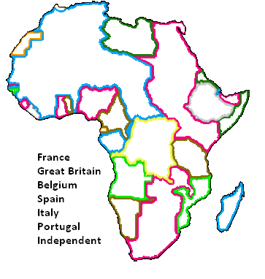 | LABEL:  Algeria  Angola  Belgian Congo  Egypt  Ethiopia  French West Africa  German East Africa  Ger. Southwest Africa  Liberia  Libya  Madagascar  Morocco  Mozambique  Nigeria  Rhodesia  Rio de Oro  South Africa  Spanish Morocco  Tunisia  TRANSFER THE ABOVE COLONIES TO THE GRAPHIC ORGANIZER BELOW

Great Britain | France | Belgium
Germany | Italy | Portugal
Independent Nations

Cecil Rhodes, “Confession of Faith” (1877)
Source: http://pages.uoregon.edu/kimball/Rhodes-Confession.htm

Document

7.3

Rhodes originally wrote this on June 2, 1877, in Oxford. Later, that year in Kimberley, he made some additions and changes. What follows is that amended statement.
It often strikes a man to inquire what is the chief good in life; to one the thought comes that it is a happy marriage, to another great wealth, and as each seizes on his idea, for that he more or less works for the rest of his existence. To myself thinking over the same question the wish came to render myself useful to my country. I then asked myself how could I and after reviewing the various methods I have felt that at the present day we are actually limiting our children and perhaps bringing into the world half the human beings we might owing to the lack of country for them to inhabit that if we had retained America there would at this moment be millions more of English living. I contend that we are the finest race in the world and that the more of the world we inhabit the better it is for the human race. Just fancy those parts that are at present inhabited by the most despicable specimens of human beings what an alteration there would be if they were brought under Anglo-Saxon influence, look again at the extra employment a new country added to our dominions gives. I contend that every acre added to our territory means in the future birth to some more of the English race who otherwise would not be brought into existence. Added to this the absorption of the greater portion of the world under our rule simply means the end of all wars, at this moment had we not lost America I believe we could have stopped the Russian-Turkish war by merely refusing money and supplies. Having these ideas what scheme could we think of to forward this object. I look into history and I read the story of the Jesuits I see what they were able to do in a bad cause and I might say under bad leaders.
At the present day I become a member of the Masonic order I see the wealth and power they possess the influence they hold and I think over their ceremonies and I wonder that a large body of men can devote themselves to what at times appear the most ridiculous and absurd rites without an object and without an end.
The idea gleaming and dancing before ones eyes like a will-of-the-wisp at last frames itself into a plan. Why should we not form a secret society with but one object the furtherance of the British Empire and the bringing of the whole uncivilised world under British rule for the recovery of the United States for the making the Anglo-Saxon race but one Empire. What a dream, but yet it is probable, it is possible. I once heard it argued by a fellow in my own college, I am sorry to own it by an Englishman, that it was good thing for us that we have lost the United States. There are some subjects on which there can be no arguments, and to an Englishman this is one of them, but even from an American’s point of view just picture what they have lost, look at their government, are not the frauds that yearly come before the public view a disgrace to any country and especially their’s which is the finest in the world. Would they have occurred had they remained under English rule great as they have become how infinitely greater they would have been with the softening and elevating influences of English rule, think of those countless 000’s of Englishmen that during the last 100 years would have crossed the Atlantic and settled and populated the United States. Would they have not made without any prejudice a finer country of it than the low class Irish and German emigrants? All this we have lost and that country loses owing to whom? Owing to two or three ignorant pig-headed statesmen of the last century, at their door lies the blame. Do you ever feel mad? do you ever feel murderous. I think I do with those men. I bring facts to prove my assertion. Does an English father when his sons wish to emigrate ever think of suggesting emigration to a country under another flag, never—it would seem a disgrace to suggest such a thing I think that we all think that poverty is better under our own flag than wealth under a foreign one.
Put your mind into another train of thought. Fancy Australia discovered and colonised under the French flag, what would it mean merely several millions of English unborn that at present exist we learn from the past and to form our future. We learn from having lost to cling to what we possess. We know the size of the world we know the total extent. Africa is still lying ready for us it is our duty to take it. It is our duty to seize every opportunity of acquiring more territory and we should keep this one idea steadily before our eyes that more territory simply means more of the Anglo-Saxon race more of the best the most human, most honourable race the world possesses.
To forward such a scheme what a splendid help a secret society would be a society not openly acknowledged but who would work in secret for such an object.
I contend that there are at the present moment numbers of the ablest men in the world who would devote their whole lives to it. I often think what a loss to the English nation in some respects the abolition of the Rotten Borough System has been. What thought strikes a man entering the house of commons, the assembly that rule the whole world? I think it is the mediocrity of the men but what is the cause. It is simply—an assembly of wealth of men whose lives have been spent in the accumulation of money and whose time has been too much engaged to be able to spare any for the study of past history. And yet in hands of such men rest our destinies. Do men like the great Pitt, and Burke and Sheridan not now to exist. I contend they do. There are men now living with I know no other term the [Greek term] of Aristotle but there are not ways for enabling them to serve their Country. They live and die unused unemployed. What has the main cause of the success of the Romish Church? The fact that every enthusiast, call it if you like every madman finds employment in it. Let us form the same kind of society a Church for the extension of the British Empire. A society which should have members in every part of the British Empire working with one object and one idea we should have its members placed at our universities and our schools and should watch the English youth passing through their hands just one perhaps in every thousand would have the mind and feelings for such an object, he should be tried in every way, he should be tested whether he is endurant, possessed of eloquence, disregardful of the petty details of life, and if found to be such, then elected and bound by oath to serve for the rest of his life in his Country. He should then be supported if without means by the Society and sent to that part of the Empire where it was felt he was needed….

Document 7.4

Rudyard Kipling, The White Man’s Burden (1899)
Modern History Sourcebook: http://www.fordham.edu/halsall/mod/kipling.asp

Take up the White Man's burden--
Send forth the best ye breed--
Go bind your sons to exile
To serve your captives' need;
To wait in heavy harness,
On fluttered folk and wild--
Your new-caught, sullen peoples,
Half-devil and half-child.
Take up the White Man's burden--
In patience to abide,
To veil the threat of terror
And check the show of pride;
By open speech and simple,
An hundred times made plain
To seek another's profit,
And work another's gain.
Take up the White Man's burden--
The savage wars of peace--
Fill full the mouth of Famine
And bid the sickness cease;
And when your goal is nearest
The end for others sought,
Watch sloth and heathen Folly
Bring all your hopes to nought.
Take up the White Man's burden--
No tawdry rule of kings,
But toil of serf and sweeper--
The tale of common things.
The ports ye shall not enter,
The roads ye shall not tread,
Go mark them with your living,
And mark them with your dead.
Take up the White Man's burden--
And reap his old reward:
The blame of those ye better,
The hate of those ye guard--
The cry of hosts ye humour
(Ah, slowly!) toward the light:--
"Why brought he us from bondage,
Our loved Egyptian night?"
Take up the White Man's burden--
Ye dare not stoop to less--
Nor call too loud on Freedom
To cloke your weariness;
By all ye cry or whisper,
By all ye leave or do,
The silent, sullen peoples
Shall weigh your gods and you.
Take up the White Man's burden--
Have done with childish days--
The lightly proferred laurel,
The easy, ungrudged praise.
Comes now, to search your manhood
Through all the thankless years
Cold, edged with dear-bought wisdom,
The judgment of your peers!

Document 7.5

Henry Labouchère, The Brown Man’s Burden (1899)
Source: http://www.swans.com/library/art8/xxx074.html

Pile on the brown man's burden
To gratify your greed;
Go, clear away the "n****rs"
Who progress would impede;
Be very stern, for truly
'Tis useless to be mild
With new-caught, sullen peoples,
Half devil and half child.
Pile on the brown man's burden;
And, if ye rouse his hate,
Meet his old-fashioned reasons
With Maxims up to date.
With shells and dumdum bullets
A hundred times made plain
The brown man's loss must ever
Imply the white man's gain.
Pile on the brown man's burden,
compel him to be free;
Let all your manifestoes
Reek with philanthropy.
And if with heathen folly
He dares your will dispute,
Then, in the name of freedom,
Don't hesitate to shoot.
Pile on the brown man's burden,
And if his cry be sore,
That surely need not irk you--
Ye've driven slaves before.
Seize on his ports and pastures,
The fields his people tread;
Go make from them your living,
And mark them with his dead.
Pile on the brown man's burden,
Nor do not deem it hard
If you should earn the rancor
Of those ye yearn to guard.
The screaming of your Eagle
Will drown the victim's sob--
Go on through fire and slaughter.
There's dollars in the job.
Pile on the brown man's burden,
And through the world proclaim
That ye are Freedom's agent--
There's no more paying game!
And, should your own past history
Straight in your teeth be thrown,
Retort that independence
Is good for whites alone.
Pile on the brown man's burden,
With equity have done;
Weak, antiquated scruples
Their squeamish course have run,
And, though 'tis freedom's banner
You're waving in the van,
Reserve for home consumption
The sacred "rights of man"!
And if by chance ye falter,
Or lag along the course,
If, as the blood flows freely,
Ye feel some slight remorse,
Hie ye to Rudyard Kipling,
Imperialism's prop,
And bid him, for your comfort,
Turn on his jingo stop.

