

EASY
Self Service Washing Bays

EASY 1
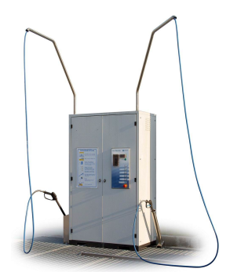

EASY 2

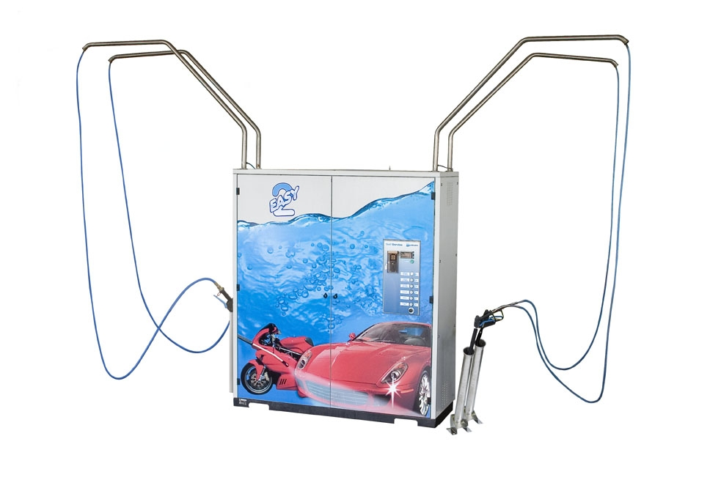

EASY 1

Self-service compact, high-pressure hot water washer for 1 self service bay only, with chemical products (shampoo/wax) dosing pumps.
After the insertion of a coin or a token the operator may wash his vehicle through the selection of 5 washing phases.
The unit is encased in a stainless steel cabinet; doors are painted, pre-galvanized carbon steel.

Washing phases
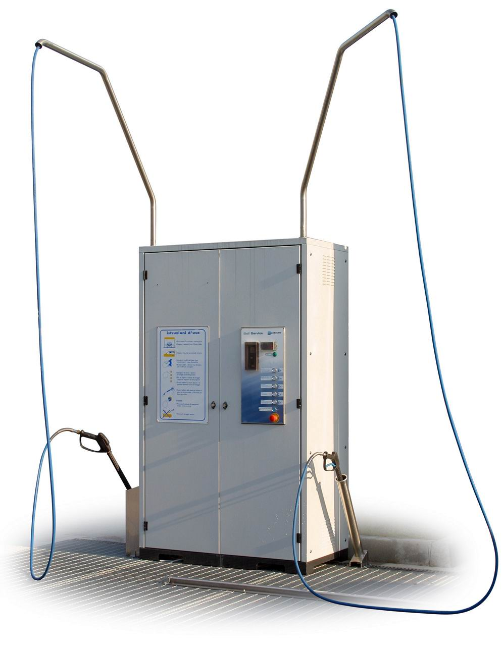

- Pre-wash – with detergent, hot softened water at high pressure
- Brush/Foam - Washing with brush and foam (option)
- Wash – with cold water at high pressure
- Wax – with wax at medium pressure and with cold water
- Final rinse – with cold de-mineralized water at high pressure

* Time of duration of the token is electronically set by software.

Main Components

- Hot-galvanised and painted single-bay technical cabinet with internal electrical heating with temperature control, equipped with holes for transport by lift and clamps to fix on the ground
- High pressure pump 100Bar 12l/minute, 140 Kw, mod. “INTERPUMP”
- 4-8 pole, 2,2 W motor/s, 100LA HP3 220/380 50 Hz motor. IP 55 cable shaft
- Electric dosing pumps (shampoo and wax)
- IP 55 electric system
- Frost protection device, wiping lance (to avoid ice through pipes)
- Inner independent frost protection device equipped with electrical resistor and control thermostat
- Containers for chemical products
- Electric panel with PLC for multifunction control
- Osmosis group with a production of 200l/h and a 100-litre container for the osmosis water with softener group (optional)
- Electric water heater 4,8 kW
- 360° rotating boom to support and bear high-pressure pipe and spray-gun

Machine command panel complete with:

- Token or Coin Acceptor
- Time/token display
- Lit program selection buttons
- Emergency stop button
- Lit network pilot light
- Lit “Out of service” pilot light
- Internal Token/coin collection container

Technical features

- Water supply pressure: 0,08÷0,25 Mpa (0,8÷2,5 bar)
- Mains water connection: 3/4 "
- Supply voltage: 400/230V ± 10% 50 Hz, 3/N/PE
- Installed electric power: 8 kW
- Absorbed current (400V): 12A
- Water consumption: 12 litres/min
- Dimensions in mm: 1245 x 650 x 2100
- Load-less weight: 300 Kg

Water treatment with softener and osmosis (option)

- Water softener resin type, ionic exchange
- Salt tank capacity: 20 Kg
- Water consumption: 200 lt/h
- Tank capacity: lt. 40
- Standard osmotic production: 210 lt/h at 1,4 MPa (14 bar)

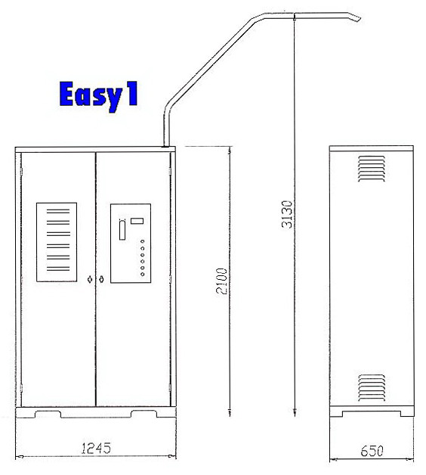

EASY 2

Self-service compact, high-pressure hot water washer for 2 self service bays, with chemical products (shampoo/wax) dosing pumps .
After the insertion of a coin or a token the operator may wash his vehicle through the selection of 5 washing phases.
The unit is encased in a stainless steel cabinet; doors are painted, pre-galvanized carbon steel.

Washing phases

- Pre-wash – with detergent, hot softened water at high pressure
- Brush/Foam - Washing with brush and foam (option)
- Wash – with cold water at high pressure
- Wax – with wax at medium pressure and with cold water
- Final rinse – with cold de-mineralized water at high pressure

* Time of duration of the token is electronically set by software.

Main Components

- Hot-galvanised and painted single-bay technical cabinet with internal electrical heating with temperature control, equipped with holes for transport by lift and clamps to fix on the ground
- High pressure pump 100Bar 12l/minute, 140 Kw, mod. “INTERPUMP”
- 4-8 pole, 2,2 W motor/s, 100LA HP3 220/380 50 Hz motor. IP 55 cable shaft
- Electric dosing pumps (shampoo and wax)
- IP 55 electric system
- Frost protection device, wiping lance (to avoid ice through pipes)
- Inner independent frost protection device equipped with electrical resistor and control thermostat
- Containers for chemical products
- Electric panel with PLC for multifunction control
- Osmosis group with a production of 200l/h and a 100-litre container for the osmosis water with softener group (optional)
- Electric water heater 4,8 kW
- 360° rotating boom to support and bear high-pressure pipe and spray-gun

Machine command panel complete with:

- Token or Coin Acceptor
- Time/token display
- Lit program selection buttons
- Emergency stop button
- Lit network pilot light
- Lit “Out of service” pilot light
- Internal Token/coin collection container

Technical features

- Water supply pressure: 0,08÷0,25 Mpa (0,8÷2,5 bar)
- Mains water connection: 3/4 "
- Supply voltage: 400/230V ± 10% 50 Hz, 3/N/PE
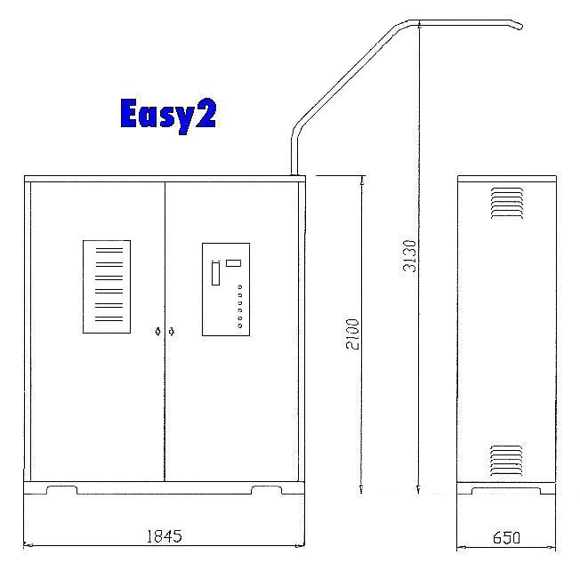
- Installed electric power: 8 kW
- Absorbed current (400V): 12A
- Water consumption: 12 litres/min
- Dimensions in mm: 1245 x 650 x 2100
- Load-less weight: 300 Kg

Water treatment with softener and osmosis (option)

- Water softener resin type, ionic exchange
- Salt tank capacity: 20 Kg
- Water consumption: 200 litri/h
- Tank capacity: lt. 40
- Standard osmotic production: 210 lt/h at 1,4 MPa (14 bar)



