WORLD HISTORY (to 1300)

UNIT 2.2 Materials

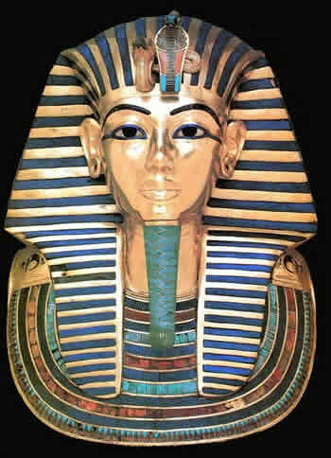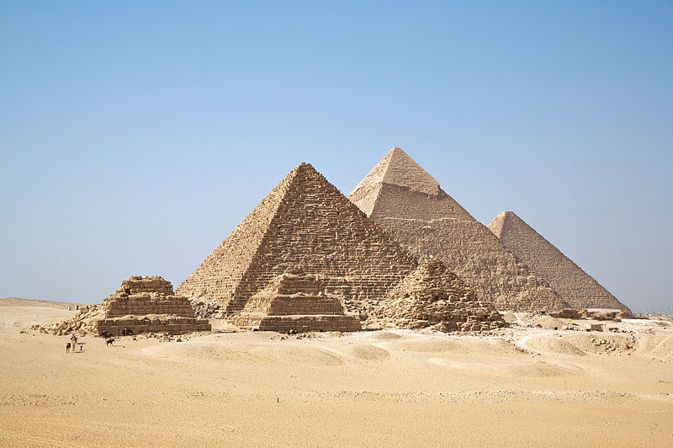

Cradles of Civilization:
Ancient Egypt

WORLD HISTORY (to 1300)
TERMS LISTS

UNIT 2.2
Ancient Egypt

GEOGRAPHY | POLITICS, SOCIETY, AND ACHIEVEMENTS
Map of Egypt (Map 2.2)  The Nile River (and its impact on Egyptian life)  Nile Delta  Upper and Lower Egypt  RELIGION  The Myth of Osiris and Isis (Doc 2.5)  Usurper  Depose  Incarnation  Ethical Religion  DISCUSSION QUESTION:  What is the relationship between religion and ethics? (Doc 2.6)  The Declaration of Innocence (Doc 2.7)  Mummification  Ankh  The Heart (as the center of one’s being)  Deities  Amun-Ra  Osiris  Isis  Horus  Set  Ma’at  Anubis  Sobek | Pharaoh  Double Crown  Egyptian Values (Order and Stability)  Deification  Old Kingdom  Memphis (as capital)  Great Pyramid of Giza  Surveyors  Hyksos  Bronze Age  Diffusion  New Kingdom  Thebes (as capital)  Valley of the Kings  Monotheism  Aten  Amarna  Battle of Kadesh  Treaty  Pharaohs  Narmer [as unifier]  Khufu [Great Pyramid]  Hatshepsut  Thutmose III  Akhenaten  Nefertiti (wife)  Tutankhamun  Ramesses II [the Great]  Papyrus  Rosetta Stone  Hieroglyphics  Egyptology

Map 2.2 Name: _________________________
Ancient Egypt

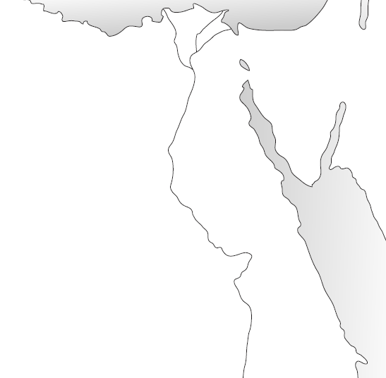
Source: http://fivejs.com/outline-maps-ancient-egypt-and-greece

Locate the following on the map above:

Mediterranean Sea
Nile River
Nile Delta
Upper Egypt
Lower Egypt
Red Sea
Sinai Peninsula
Memphis
Thebes
Amarna
Africa
Asia
Nile Floodplain [Shade or Color In]
Sahara Desert

The Myth of Osiris and Isis
Document

2.5

From Plutarch’s Moralia
Source: sacred-texts.com

Characters: | Osiris: Mythical god-king of Egypt  Isis: Sister and wife of Osiris | Set: Brother of Osiris and Isis  ACTIVE  READING  Horus: Son of Osiris and Isis

When Osiris reigned over the Egyptians he made them reform their destitute and bestial mode of living, showing them the art of cultivation, and giving them laws, and teaching them how to worship the gods. Afterwards he travelled over the whole earth, civilizing it; far from requiring arms, he tamed mankind through persuasion and reasoning joined with song of all kinds and music which he brought over… Set, during his absence, did not rebel, because Isis was on her guard, and able to keep watch upon him vigorously; but after Osiris returned, Set laid a plot against him, having taken seventy and two men into the conspiracy, and having for helper a queen coming out of Ethiopia… That she secretly measured the body of Osiris, and made to the size a handsome and highly ornamented coffer which he carried into the banqueting room. And as they were all delighted with its appearance and admired it; Set promised in sport that whoever should lie down within it, and should exactly fit, he would make him a present of the chest; and after the others had tried, one by one, and nobody fit into it; then Osiris got in, and laid himself down, thereupon the conspirators running up shut down the lid, and fastened it with spike-nails from the outside, and poured melted lead over them, and so carried it out to the River, and let it go down down into the sea…
When Isis heard the news, she cut off a lock of her hair and put on a mourning robe… As she wandered about everywhere, not knowing what to do, she met no one without speaking to him… even when she fell in with little children, she inquired of them about the coffer; these last chanced to have seen it, and told her the branch of the River through which Set's accomplices had let the chest drift into the sea…
Proceeding thence, she learnt by inquiry that the chest had been washed up by the sea at a place called Byblus… They tell how Isis having learnt all this by the divine breath of fame, came to Byblus, and sitting down by the side of a spring all dejected and weeping spoke not a word to any other persons…
The coffin she clasped in her arms, and wailed… and putting the coffer on board a ship, put to sea…
As soon as ever she obtained privacy, and was left by herself, having opened the coffer and laid her face upon the face of the corpse, she wailed and wept…
But when Isis had gone to see her son Horus… and had put the coffer away, Set being out a hunting by moonlight came upon it, and recognizing the corpse, tore it into fourteen pieces, and scattered them abroad. Isis having heard of this, sought after the fragments, passing over the swamps in a papyrus boat; for which cause such as sail in papyrus boats are never injured by the crocodiles, because they either fear or respect the goddess, from this circumstance there are many places called "Tombs of Osiris" all over Egypt, because she, whenever she came upon a fragment of the body, there celebrated a funeral… Of the members of Osiris the only one [was] Isis was unable to find… and that Isis in its stead made a model and consecrated it… in honor whereof the Egyptians hold a festival.
Afterwards Osiris came from the shades to Horus, and trained and exercised him for war, and then asked him "What is the finest thing possible?" and when he replied "to avenge one's father and mother when ill-treated…”

“Do we need religion to be ethical?”
Document

2.6

Thomas G. Plante, Ph.D.
Psychology Today [Online]: http://www.psychologytoday.com/blog/do-the-right-thing
Do we need religion to be ethical or to be good? Most people (including moral philosophers) would say no...yet it can be helpful. Obviously, people can certainly maintain ethical perspectives and subscribe to ethical principles and behavior without engagement in religious or spiritual beliefs, institutions, or practices. However, there are very few secular forums that can offer the guidance, fellowship, support, models, organizational structure, and engagement that the religious institutions can offer.
Religious organizations have a wide variety of comprehensive services, programming, groups, lectures, readings, models, and so forth that can regularly impart, support, and provide corrective feedback about ethical principles and guidelines to their members. The secular community just doesn't seem to have the organizational structure to do so. There are some exceptions of course. For example, the Boy Scouts are technically a secular organization not affiliated with one particular religious tradition. They offer a clear set of ethical principles that tend to use a virtue approach to ethics (e.g., Scouts are loyal, courteous, kind, thrifty, reverent...). Perhaps self help groups based on the Alcoholic Anonymous (AA) model does the same. While not affiliated with any particular religious tradition, the 12 steps of AA are spiritually focused with numerous references to God and His will. AA offers ethical principles that highlight virtues such as honesty, integrity, and responsibility. So, it appears that one doesn't have to be religious or spiritual to be ethical but it might help having the organizational structure that religion offers to encourage and reinforce ethical principles and behavior.
Religious engagement and practices encourages and supports "clean living." Research has consistently found that religious people are less likely to engage in criminal behavior, marital infidelity, alcoholism, unprotected sexual activity as well as being more likely to engage in pro social behaviors such as volunteerism and charity. Thus, those who tend to report being spiritual, religious, or both tend to behave themselves pretty well. In a nutshell, people in the church choir usually don't rob banks. Check out Harold Koenig's Handbook of Religion and Health as well as his Handbook of Religion and Mental Health for excellent reviews if interested in the scholarly support for this.
Religion and spirituality encourages ethical behavior in their sacred scripture readings, in their models or exemplars for behavior (not only well known religious figures such as saints and founding members of religious traditions but also among religious elders, pastors, teachers, and congregants).
My point really is that overall, research supports the view that spiritual and religious practices (e.g., meditation, Church sponsored social justice ministries, religious service attendance) have certain physical, mental, community health, and ethical benefits.
Of course there are many examples of religious beliefs and practices being terribly harmful to self and others and of course there are many examples of outstanding non religious and completely secular organizations and individuals who are outstanding models for ethical behavior, community engagement, and physical and mental health. So, there are exceptions to these general principles for sure but the overall trend suggests that religion does assist and support people in living more ethically.
So, to answer the question, "do we need religion to be ethical?" The answer appears to be no but it could be helpful under the right circumstances.
What do you think?
- What is the author’s thesis? | - To what extent do you agree? Explain.

Excerpt from the Egyptian Book of the Dead
Document

2.7

Tour Egypt: http://www.touregypt.net/bod3.htm

The Negative Confession - Chapter 125

Introduction
What should be said when arriving at the Hall of Justice, of Two Truths, purging N [the deceased] of all the forbidden things he has done, and seeing the faces of all the Gods.

Spell for descending to the broad hall of Two Truths:
N shall say:

Hail to you, great God, Lord of Justice! I have come to you, my lord, that you may bring me so that I may see your beauty, for I know you and I know your name, and I know the names of the forty-two gods of those who are with you in this Hall of Justice, who live on those who cherish evil and who gulp down their blood on that day of the reckoning… Behold the double son of the Songstresses; Lord of Truth is your name. Behold I have come to you, I have brought you truth, I have repelled falsehood for you.

I have not done falsehood against men…
I have not impoverished my associates…
I have done no wrong in the Place of Truth…
I have done no evil…
I have not deprived the orphan of his property…
I have not done what the gods detest…
I have not slandered a servant to his master…
I have not caused pain…
I have not made hungry…
I have not made to weep…
I have not killed…
I have not turned anyone over to a killer…
I have not caused anyone’s suffering…
I have not been unchaste…
I have not increased nor diminished the measure…
I have not added to the balance weights…
I have not tempered with the plumb bob of the balance…
I have not taken milk from a child’s mouth…
I have not driven small cattle from their herbage…
I have not built a dam against flowing water…
I have not quenched a fire in its time…
I have not blocked the God at his processions…

I am Pure. I am pure. I am pure. I am pure. My purity is the purity of this great Phoenix that is in Heracleopolis, because I am indeed the nose of the Lord of Wind who made all men live on that day of completing the Sacred Eye in Heliopolis in the 2nd month of winter last day, in the presence of the lord of this land. I am he who saw the completion of the Sacred Eye in Heliopolis, and nothing evil shall come into being against me in this land in this Hall of Justice, because I know the names of these gods who are in it.

