Modern World History

Unit 2 Materials

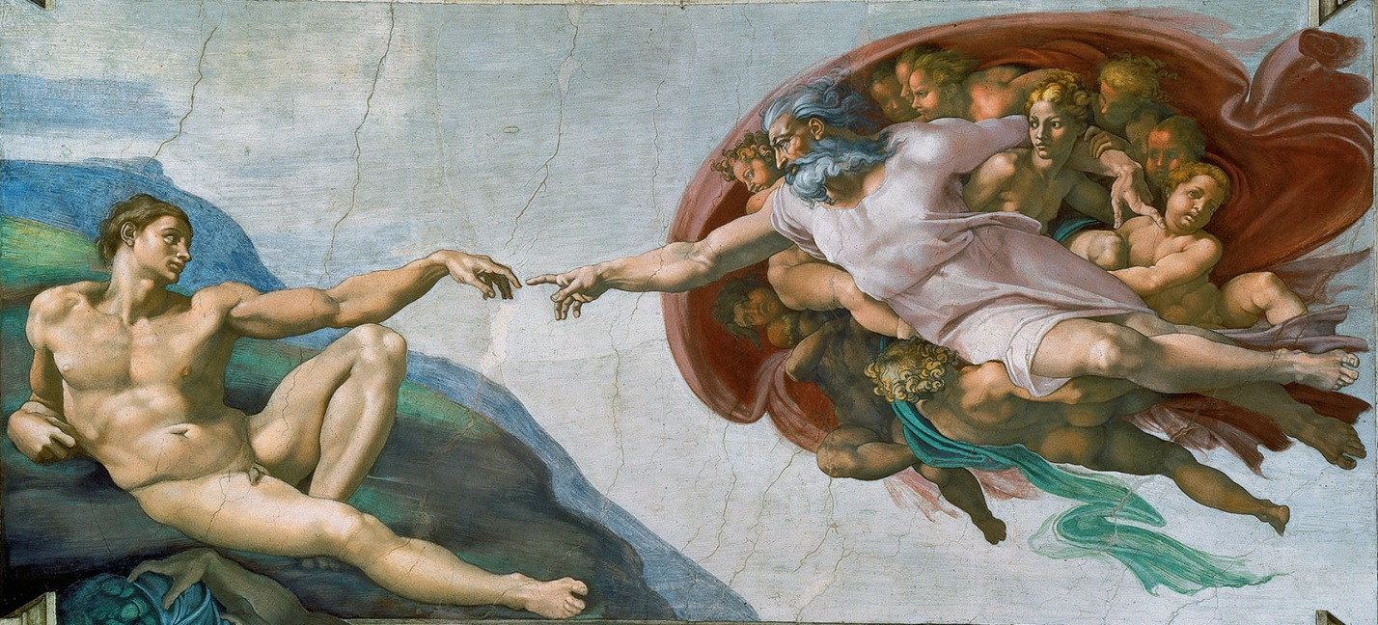

The Renaissance
& Age of Exploration

Terms List | Modern World History  Unit 2: The Renaissance

The Italian Renaissance | Renaissance Art
What does Renaissance mean? _______________  The “High Renaissance” ( _______ - ________ )  Where did the Renaissance begin? ____________  Values of the Renaissance:  _____________ ____________ ____________  HUMANISM: The Study of _____________  Classical Literature:  _____________ ____________ ____________  Thomas Aquinas / Summa Theologica  Aristotle (as Medieval Authority)  Petrarch (Father of Humanism)  How did Petrarch’s approach to the classics differ from that of Christian theologians from the late classical and medieval periods?  Fall of Constantinople (Impact on Renaissance)  Classical Authors (Plato / Cicero)  Lorenzo Valla (Textual Criticism)  Pico della Mirandola (Syncretism)  How did Pico challenge prevailing ideas  about the Great Chain of Being?  Civic Humanism (Castiglione & Machiavelli)  The Medici Family  Usury  Banking & Patronage (of the arts & philosophy)  Printing Press, Trade, & Commerce | Medieval Art vs. Renaissance Art  Characteristics of Renaissance Art:  - _____________________  - _____________________  - _____________________  - _____________________  Art Techniques: (contrapposto, chiaroscuro)  Renaissance Masters:  (Leonardo Da Vinci, Michaelangelo,  Raphael, Donatello)  Notable Works of Art (Name & Artist):  The School of Athens, Creation of Adam, Pieta  David [Donatello & Michelangelo], Last Judgment, Last Supper  Renaissance Architecture
 | Northern Renaissance
Compare/Contrast Northern Renaissance and Italian Renaissance

Thomas More (Utopia)
Erasmus (The Praise of Folly)
 | New Monarchs
What were the goals of the New Monarchs?
Spain (Ferdinand & Isabella)

Reconquista / Columbus / Expulsion / Inquisition

England (Henry VII)

War of the __________ (________ vs. _________)
Henry Tudor vs. Richard III

PowerPoints, Class Notes, and Review Videos are available on my website!

From Giovanni Pico della Mirandola,
Oration on the Dignity of Man (1486)

Document

2.1

Retrieved from: http://www.cscs.umich.edu/~crshalizi/Mirandola/

TO STUDENTS: Pico della Mirandola’s Oration on the Dignity of Man has been called the “Manifesto of the Renaissance” due to its articulation of the core values held by many humanists. In this preface to his 900 theses on religion and philosophy, Pico employs syncretism (the fusion of the Christian and classical traditions) in his praise of man and of man’s free will.
Most esteemed Fathers, I have read in the ancient writings of the Arabians that Abdala the Saracen on being asked what, on this stage, so to say, of the world, seemed to him most evocative of wonder, replied that there was nothing to be seen more marvelous than man. And that celebrated exclamation of Hermes Trismegistus, ``What a great miracle is man, Asclepius'' confirms this opinion.
… Why, I asked, should we not admire the angels themselves and the beatific choirs more? At long last, however, I feel that I have come to some understanding of why man is the most fortunate of living things and, consequently, deserving of all admiration; of what may be the condition in the hierarchy of beings assigned to him, which draws upon him the envy, not of the brutes alone, but of the astral beings and of the very intelligences which dwell beyond the confines of the world….
God the Father, the Mightiest Architect, had already raised, according to the precepts of His hidden wisdom, this world we see, the cosmic dwelling of divinity, a temple most august. He had already adorned the supercelestial region with Intelligences, infused the heavenly globes with the life of immortal souls and set the fermenting dung-heap of the inferior world teeming with every form of animal life. But when this work was done, the Divine Artificer still longed for some creature which might comprehend the meaning of so vast an achievement, which might be moved with love at its beauty and smitten with awe at its grandeur. When, consequently, all else had been completed (as both Moses and Timaeus testify), in the very last place, He bethought Himself of bringing forth man. Truth was, however, that there remained no archetype according to which He might fashion a new offspring, nor in His treasure-houses the wherewithal to endow a new son with a fitting inheritance, nor any place, among the seats of the universe, where this new creature might dispose himself to contemplate the world. All space was already filled; all things had been distributed in the highest, the middle and the lowest orders. Still, it was not in the nature of the power of the Father to fail in this last creative élan; nor was it in the nature of that supreme Wisdom to hesitate through lack of counsel in so crucial a matter; nor, finally, in the nature of His beneficent love to compel the creature destined to praise the divine generosity in all other things to find it wanting in himself.
At last, the Supreme Maker decreed that this creature, to whom He could give nothing wholly his own, should have a share in the particular endowment of every other creature. Taking man, therefore, this creature of indeterminate image, He set him in the middle of the world and thus spoke to him:
``We have given you, O Adam, no visage proper to yourself, nor endowment properly your own, in order that whatever place, whatever form, whatever gifts you may, with premeditation, select, these same you may have and possess through your own judgment and decision. The nature of all other creatures is defined and restricted within laws which We have laid down; you, by contrast, impeded by no such restrictions, may, by your own free will, to whose custody We have assigned you, trace for yourself the lineaments of your own nature. I have placed you at the very center of the world, so that from that vantage point you may with greater ease glance round about you on all that the world contains. We have made you a creature neither of heaven nor of earth, neither mortal nor immortal, in order that you may, as the free and proud shaper of your own being, fashion yourself in the form you may prefer. It will be in your power to descend to the lower, brutish forms of life; you will be able, through your own decision, to rise again to the superior orders whose life is divine.''
Oh unsurpassed generosity of God the Father, Oh wondrous and unsurpassable felicity of man, to whom it is granted to have what he chooses, to be what he wills to be!

