**WORLD HISTORY (to 1300)**

**UNIT 7**

***Ancient Greece (Test II)***

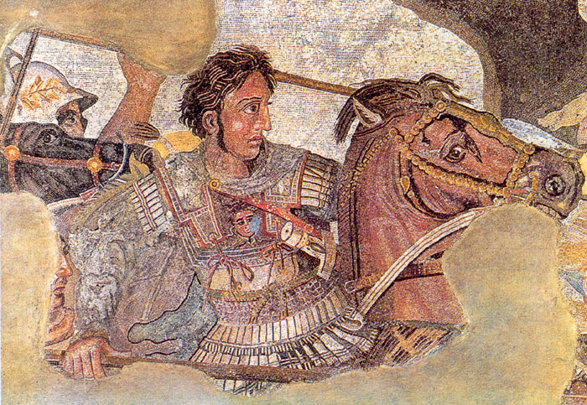



***Sparta, Women, Wars, Alexander, and Philosophy***

**WORLD HISTORY TO 1300 (HONORS)**

**TERMS LISTS**

*Sparta, Women, Wars,   
& Alexander*

|  |  |  |
| --- | --- | --- |
| **Meet the Spartans** | **Sparta** *(Continued)* | **The Persian Empire** |
| Peloponnesus  Sparta  Eurotas R.  Laconia  Messenia  Helots  Perioikoi  Lycurgus  Institutions  Principles of Spartan Gov.  Mixed Government  Separation of Powers  Checks and Balances | Gerousia  Gerontocracy  Apella  Diarchy  Ephors  Eugenics  Agoge  Krypteia  Spartan Marriage  Spartan Women  *Compare to Athenian Women* | Cyrus the Great  Darius the Great  King Xerxes  Royal Road  Cyrus’ Cylinder  Zoroastrianism  Zoroaster  Ahura Mazda  Dualism  Temples of Fire  Religious Toleration |

|  |  |  |
| --- | --- | --- |
| **The Persian Wars** | **The Peloponnesian War** | **Alexander the Great** |
| Persian Empire  Hoplon  Hoplite  Phalanx  **Battle of Marathon**  Pheidippides  Spartathlon Race  Nike  Marathon Race  Herodotus  Xerxes  Immortals  **Battle of Thermopylae**  Leonidas  Oracle at Delphi  **Battle of Salamis**  Naval Warfare in Greece  **Battle of Plataea** | Peloponnesian War  Delian League  Peloponnesian League  Pericles  Siege of Athens  Herodotus  Thucydides | Philip II  Demosthenes  Philippic  Alexander the Great  Bucephalus  Companion Cavalry  Gordian Knot  Lighthouse of Alexandria  Library of Alexandria  Battle of Gaugamela  Appropriate Technologies  Hellenism  Alexander’s Empire  Seleucid Empire  Ptolemaic Empire |

|  |  |
| --- | --- |
| UNIT PLAN | **ANCIENT GREECE: PART II**  ***Spartans, Women, War, & Alexander*** |

|  |  |  |
| --- | --- | --- |
|  | Assignments and Materials | |
| DAY ONE  *Meet the Spartans* |  | |
| DAY TWO *Spartan Women & the Persian Empire* | **Document 7.2** (Plutarch, “Sayings of Spartan Women”)  **Graphic Organizer 7.2**(Plutarch, “Sayings of Spartan Women”) | |
| DAY THREE *The Persian Wars* | **QUIZ** **Map 7.1** | |
| DAY FOUR  *The Persian & Peloponnesian Wars* | **Document 7.3** (Plutarch, “Sayings of Spartan Women”) | |
| DAY FIVE *Alexander the Great* | **QUIZ** **Map 7.2** | |
| ASSESSMENT | **MULTIPLE CHOICE TEST** |  |

Map 7.1

***Sparta and Greek Warfare***

**Name: _____________**

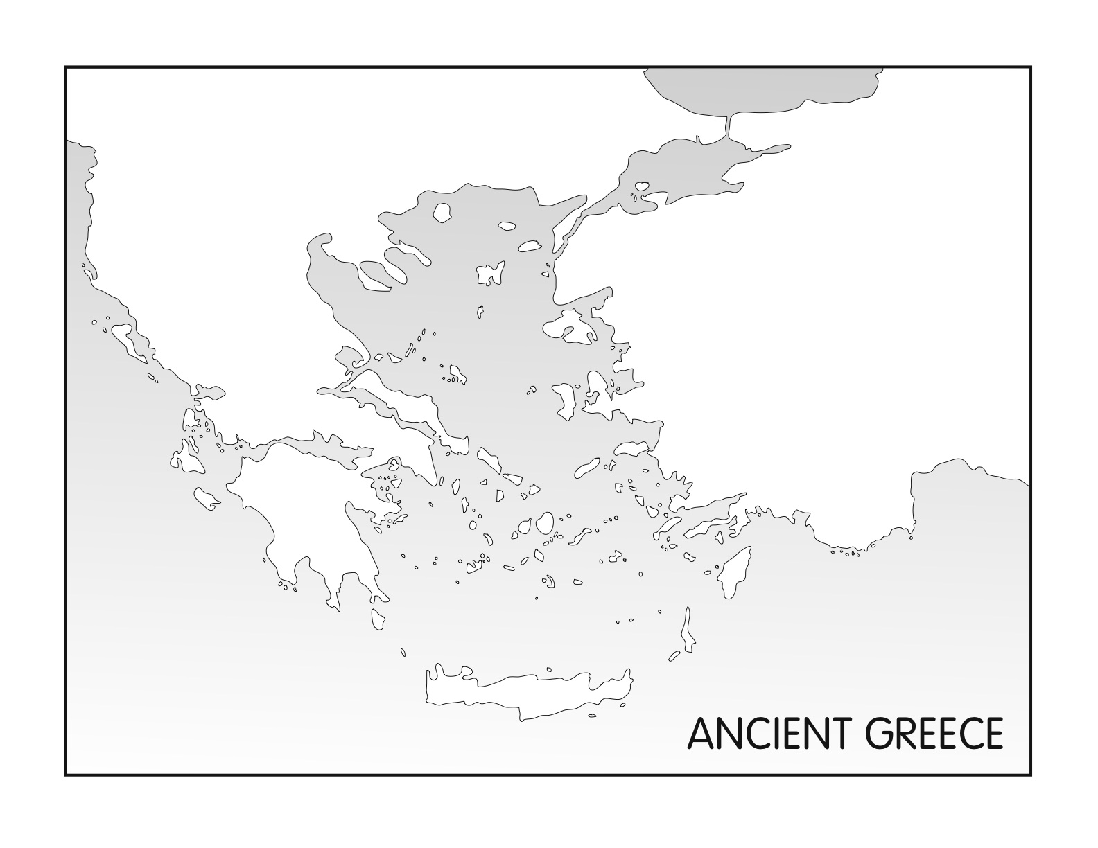

**Source:** <http://fivejs.com/wp-content/uploads/2008/08/ancient-greece.jpg>

|  |  |  |  |
| --- | --- | --- | --- |
| **Sparta** | **Bodies of Water** | **Persian Wars** | **Peloponnesian War** |
| Peloponnese  Sparta  Eurotas River (Draw)  Laconia  Messenia | Aegean Sea  Hellespont  Ionian Sea  Mediterranean Sea | Asia Minor (Ionia)  Marathon  Plataea  Salamis  Thermopylae | Athens  Sparta (should already be labeled)  Delos  *Note which areas were part of the*  ***Delian League*** *and the* ***Peloponnesian League****.* |

Map 7.2

**Cities**

Alexandria (Nile Delta)

Babylon

Jerusalem

Persepolis

Sardis

Susa

**Battles**

Issus

Gaugamela

Granicus

**Regions**

Asia Minor

Egypt

Greece

Macedon

Media

Mesopotamia

Persia

**Bodies of Water**

Black Sea

Caspian Sea

Euphrates River

Indian Ocean

Indus River

Mediterranean Sea

Nile River

Persian Gulf

Red Sea

Tigris River

**Misc**

**Royal Road** (Draw)

**The Persian Empire and the   
Conquests of Alexander the Great**

**Name: __________________**

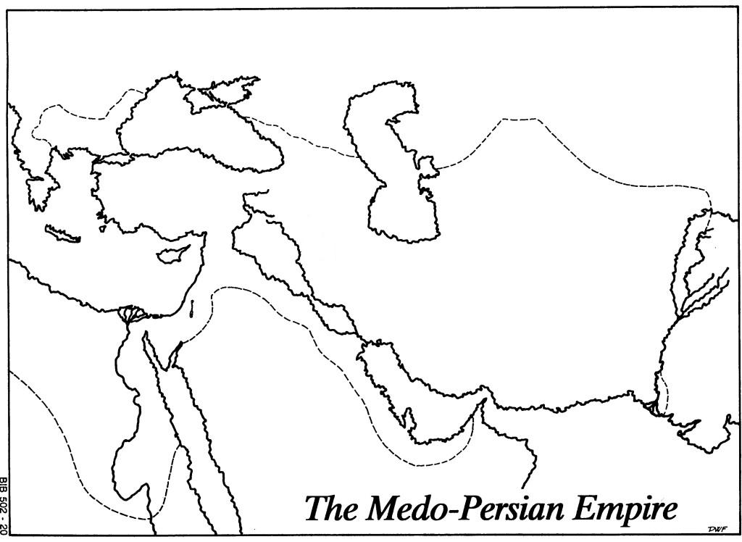

**Source:** <http://ot103.files.wordpress.com/2010/10/outlinemap007.jpg>

**From Plato’s *Republic*, Book V**

## Document

## 7.1

**Source:** <http://classics.mit.edu/Plato/republic.6.v.html>

Such is the scheme… according to which the guardians of our State are to have their wives and families in common….

Shall we try to find a common basis by asking of ourselves what ought to be the chief aim of the legislator in making laws and in the organization of a State, --what is the greatest good, and what is the greatest evil, and then consider whether our previous description has the stamp of the good or of the evil?

*By all means.*

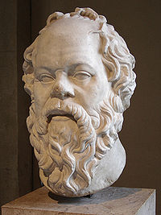

Most of Plato’s works were written in the form of *dialogues* between Socrates and other individuals.

Note the use of the *Socratic* method, which features one speaker asking questions of another. In many cases, the “questions” are simply statements phrased as leading questions, with which the other participants in the dialogue can simply agree.

***The Socratic Method***

Can there be any greater evil than discord and distraction and plurality where unity ought to reign? or any greater good than the bond of unity?

*There cannot.*

And there is unity where there is community of pleasures and pains --where all the citizens are glad or grieved on the same occasions of joy and sorrow?

*No doubt.*

Yes; and where there is no common but only private feeling a State is disorganized --when you have one half of the world triumphing and the other plunged in grief at the same events happening to the city or the citizens?

*Certainly.*

Such differences commonly originate in a disagreement about the use of the terms 'mine' and 'not mine,' 'his' and 'not his.'

*Exactly so.*

And is not that the best-ordered State in which the greatest number of persons apply the terms 'mine' and 'not mine' in the same way to the same thing?

*Quite true.*

Or that again which most nearly approaches to the condition of the individual –as in the body, when but a finger of one of us is hurt, the whole frame… feels the hurt and sympathizes all together with the part affected, and we say that the man has a pain in his finger…

*Very true… and I agree with you that in the best-ordered State there is the nearest approach to this common feeling which you describe.*

Then when any one of the citizens experiences any good or evil, the whole State will make his case their own, and will either rejoice or sorrow with him?

*Yes… that is what will happen in a well-ordered State….*

Everyone whom they meet will be regarded by them either as a brother or sister, or father or mother, or son or daughter, or as the child or parent of those who are thus connected with him….

Then the community of wives and children among our citizens is clearly the source of the greatest good to the State?

*Certainly….*

They will not tear the city in pieces by differing about 'mine' and 'not mine;' each man dragging any acquisition which he has made into a separate house of his own, where he has a separate wife and children and private pleasures and pains; but all will be affected as far as may be by the same pleasures and pains because they are all of one opinion about what is near and dear to them, and therefore they all tend towards a common end.

*Certainly…*

And as they have nothing but their persons which they can call their own, suits and complaints will have no existence among them; they will be delivered from all those quarrels of which money or children or relations are the occasion.

**From Aristotle’s *Politics*, Book II**

**Source:** <http://www.constitution.org/ari/polit_02.htm>

But, **even supposing that it were best for the community to have the greatest degree of unity**, this unity is by no means proved to follow from the fact 'of all men saying "mine" and "not mine" at the same instant of time,' which, according to Socrates, is the sign of perfect unity in a state. For the word 'all' is ambiguous. If the meaning be that every individual says 'mine' and 'not mine' at the same time, then perhaps the result at which Socrates aims may be in some degree accomplished; each man will call the same person his own son and the same person his wife, and so of his property and of all that falls to his lot. This, however, is not the way in which people would speak who had their wives and children in common; they would say 'all' but not 'each.' In like manner their property would be described as belonging to them, not severally but collectively.

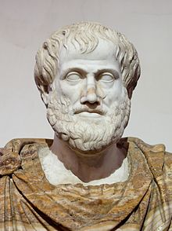

**Aristotle** begins by questioning Plato’s ***premise*** that it is best for a community to be united in all things before proceeding point out several logical fallacies in his teacher’s arguments.

Aristotle’s ***premise*** that people think of themselves first and foremost influences his ***conclusion*** that the collectivist state theorized in Plato’s *Republic* is impracticable.

***Deductive Reasoning***

There is an obvious fallacy in the term 'all'… That all persons call the same thing mine in the sense in which each does so may be a fine thing, but it is impracticable… For that which is common to the greatest number has the least care bestowed upon it. **Everyone thinks chiefly of his own, hardly at all of the common interest;** and only when he is himself concerned as an individual. For besides other considerations, everybody is more inclined to neglect the duty which he expects another to fulfill… Each citizen will have a thousand sons who will not be his sons individually but anybody will be equally the son of anybody, and will therefore be neglected by all alike….

Which is better -- for each to say 'mine' in this way, making a man the same relation to two thousand or ten thousand citizens, or to use the word 'mine' in the ordinary and more restricted sense? For usually the same person is called by one man his own son whom another calls his own brother or cousin or kinsman -- blood relation or connection by marriage either of himself or of some relation of his, and yet another his clansman or tribesman; and **how much better is it to be the real cousin of somebody than to be a son after Plato's fashion!**

Nor is there any way of preventing brothers and children and fathers and mothers from sometimes recognizing one another; for children are born like their parents, and they will necessarily be finding indications of their relationship to one another. Geographers declare such to be the fact; they say that in part of Upper Libya, where the women are common, nevertheless the children who are born are assigned to their respective fathers on the ground of their likeness.

**“Sayings of Spartan Women”**

## Document

## 7.2

**From Plutarch’s *Moralia***

**Source:** [http://penelope.uchicago.edu/Thayer/E/Roman/Texts/Plutarch/Moralia/Sayings_of_Spartan_Women*.html](http://penelope.uchicago.edu/Thayer/E/Roman/Texts/Plutarch/Moralia/Sayings_of_Spartan_Women*.html)

Active Reading

**Argileonis**

Argileonis, the mother of Brasidas, when her son had met his death, and some of the citizens asked if her son had met his death honorably and in a manner worthy of Sparta. And when they proceeded to tell of his greatness, and declared that he was the best of all the Spartans in such enterprises, she said, "Sirs, my son was a good and honorable man, but Sparta has many a man better than him."

**Gorgo [Wife of Leonidas]**

1 Gorgo, daughter of king Cleomenes, when Aristagoras of Miletus was urging her father to enter upon the war against the Persian king in behalf of the Ionians, promising a vast sum of money, and, in answer to Cleomenes' objections, making the amount larger and larger, said, "Father, the miserable foreigner will be your ruin if you don't get him out of the house pretty soon!"

2 Once when her father told her to give some grain to a man by way of remuneration, and added, "It is because he showed me how to make the wine taste good," she said, "Then, father, there will be more wine drunk, and the drinkers will become more intemperate and depraved."

3Being asked by a woman from Attica, "Why is it that you Spartan women are the only women that lord it over your men," she said, "Because we are the only women that are mothers of men."

6 As she was encouraging her husband Leonidas, when he was about to set out for Thermopylae, to show himself worthy of Sparta, she asked what she should do; and he said, "Marry a good man, and bear good children."

**Gyrtias**

1 Gyrtias, when on a time Acrotatus, her grandson, in a fight with other boys received many blows, and was brought home for dead, and the family and friends were all wailing, said, "Will you not stop your noise? He has shown from what blood he was sprung." And she said that people who were good for anything should not scream, but should try to find some remedy.

2 When a messenger came from Crete bringing the news of the death of Acrotatus, she said, "When he had come to the enemy, was he not bound either to be slain by them or to slay them? It is more pleasing to hear that he died in a manner worthy of myself, his country, and his ancestors than if he had lived for all time a coward."

**Other Spartan Women to Fame Unknown**

1 Another Spartan woman made away with her son, who had deserted his post, on the ground that he was unworthy of his country, saying, "Not mine the scion." This is the epigram referring to her:

Off to your fate through the darkness, vile scion, who makes such a hatred,

So the Eurotas flow not e'en for the timorous deer.

Worthless whelp that you are, vile remnant, be off now to Hades;

Off! for never I bore Sparta's unworthy son.

2 Another, hearing that her son had fallen on the field of battle, said:

"Let the poor cowards be mourned, but, with never a tear do I bury

You, my son, who are mine, yea, and are Sparta's as well."

7 One woman sent forth her sons, five in number, to war, and, standing in the outskirts of the city, she awaited anxiously the outcome of the battle. And when someone arrived and, in answer to her inquiry, reported that all her sons had met death, she said, "I did not inquire about that, you vile varlet, but how fares our country?" And when he declared that it was victorious, "Then," she said, "I accept gladly also the death of my sons."

8 Another was burying her son, when a commonplace old woman came up to her and said, "Ah the bad luck of it, you poor woman." "No, by Heaven," said she, "but good luck; for I bore him that he might die for Sparta, and this is the very thing that has come to pass for me."

10 Another, hearing about her son that he was conducting himself badly in a foreign land, wrote to him, "Ill report is spread about ye; pit this from ye or else stop your living."

12 Another, when her son was being tried for some offence, said to him, "My child, either rid yourself of the charges, or rid yourself of life."

16 Another, as she handed her son his shield, exhorted him, saying, “Return with this or upon this."

17 Another, as her son was going forth to war, said, as she gave the shield into his hands, "This shield your father kept always safe for you; do you, therefore, keep it safe, or cease to live."

19 Another, hearing that her son had been slain fighting bravely in the line of battle, said, "Yes, he was mine." But learning in regard to her other son that he had played the coward and saved his life, she said, "No, he was not mine."

21 Another, engaged in conducting a solemn public procession, heard that her son was victorious on the field of battle, but that he was dying from the many wounds he had received. She did not remove the garland from her head, but with a proud air said to the women near her, "How much more noble, my friends, to be victorious on the field of battle and meet death, than to win at the Olympic games and live!"

23 A man sent to a Spartan woman to ask if she were inclined to look with favor upon seduction; she replied, "When I was a child I learned to obey my father, and made that my practice. Then when I became a married woman, my husband took that place. So if the man's proposal is honorable, let him lay the matter before my husband first."

24 A poor girl, being asked what dowry she brought to the man who married her, said, "The family virtue."

25 A Spartan woman, being asked if she had made advances to her husband, said, "No, but my husband has made them to me."

27 A Spartan woman who was being sold as a slave, when asked what she knew how to do, said, "To be faithful."

28 Another, taken captive, and asked a similar question, said, "To manage a house well."

30 Another who was being sold as a slave, when the crier inquired of her what she knew how to do, said, "To be free."

|  |  |
| --- | --- |
| Graphic Organizer 7.2  **“Sayings of Spartan Women”**  **From Plutarch’s *Moralia*** | **Name: ______________________** |

*Complete the following graphic organizers as you read the “Sayings of Spartan Women.”*

|  |  |
| --- | --- |
| What did Spartan women ***admire***? | What did Spartan women ***disdain***? |
|  |  |

*Compare and contrast Spartan mothers and American mothers:*

|  |  |
| --- | --- |
| Spartan Mothers | American Mothers |
| **Differences** |  |
| **Similarities** | |

**From Thucydides, *History of the Peloponnesian War***

## Document

## 7.3

**Source:** <http://classics.mit.edu/Thucydides/pelopwar.html>

**BACKGROUND:** *A Greek historian and Athenian general, Thucydides has been called the father of “scientific history” because of his strict standards of evidence based historical accounts. However, there has been a debate over the accuracy of the* History of the Peloponnesian War *because of his role in the war as an Athenian general.*

***Active Reading***

Having now given the result of my inquiries into early times, I grant that there will be a difficulty in believing every particular detail.  The way that most men deal with traditions, even traditions of their own country, is to receive them all alike as they are delivered, without applying any critical test whatsoever.

There are many other unfounded ideas current among the rest of the **Hellenes[1]**... So little pains do the **vulgar** take in the investigation of truth, accepting readily the first story that comes to hand. On the whole, however, the conclusions I have drawn from the proofs quoted may, I believe, safely be relied on. Assuredly they will not be disturbed either by the colorful words of a poet displaying the exaggeration of his craft, or by the compositions of the chroniclers that are attractive at truth's expense; the subjects they cover being out of the reach of evidence, and time having robbed most of them of historical value by enthroning them in the region of legend. Turning from these, we can rest satisfied with having proceeded upon the clearest data, and having arrived at conclusions as exact as can be expected in matters of such antiquity.

To come to this war: despite the known disposition of the actors in a struggle to overrate its importance, and when it is over to return to their admiration of earlier events, yet an examination of the facts will show that it was much greater than the wars which preceded it.

With reference to the speeches in this history, some were delivered before the war began, others while it was going on; some I heard myself, others I got from various quarters; it was in all cases difficult to carry them word for word in one's memory, so my habit has been to make the speakers say what was in my opinion demanded of them by the various occasions, of course adhering as closely as possible to the general sense of what they really said. And with reference to the narrative of events, far from permitting myself to derive it from the first source that came to hand, I did not even trust my own impressions, but it rests partly on what I saw myself, partly on what others saw for me, the accuracy of the report being always tried by the most severe and detailed tests possible. My conclusions have cost me some labour from the lack of coincidence between accounts of the same occurrences by different eye-witnesses, arising sometimes from imperfect memory, sometimes from undue partiality for one side or the other.

The absence of romance in my history will, I fear, detract somewhat from its interest; but if it be judged useful by those inquirers who desire an exact knowledge of the past as an aid to the interpretation of the future, which in the course of human events must resemble if it does not reflect it, I shall be content. …I have written my work, not as an essay which is to win the applause of the moment, but as a possession for all time.

1. Greeks (The Ancient Greeks referred to the Greek peninsula as *Hellas*)