Quantum Space Products’ new Dielectric Resonator Antennas

In order to be efficient, an antenna’s length needs to be a significant fraction of the wavelength it transmits at. Dielectric Resonator Antennas (DRAs) reduce the length of an antenna by the square root of their material’s dielectric constant (k). Quantum Space Product’s proprietary material maintains its k of 40,000 from DC to 900 Mhz. This is an extremely high k that extends to much higher frequency than commercially available materials, and allows us to shrink the size of an antenna to 1/200 the size a metallic antenna would be. We consider the market from 30-900 Mhz as that which would most significantly benefit. The longer the wavelength, the more mass and volume will be saved by using our material. Since we provide a revolutionary savings in mass and size, we optimize this benefit through mobile applications.

DRAs are primarily transmit (TX) antennas. Miniaturizing the receive (RX) function is problematic, since there is less RF energy then available. However, TX and RX antennas are often separate for good reasons, since TX requires more power than RX, and RX antennas can be more sensitive when optimized for lower power handling. Using separate TX and RX antennas also enables simultaneous communications.

Applications for our technology span the breadth of UHF radar and communications and even replace microwave frequencies. Half wave antennas from 30-900 Mhz would be just 2.5 cm to 0.8 mm in length. This ability to miniaturize antennas is important, as is the power savings when switching from higher frequencies to UHF. A 900 Mhz radar or communications system transmitting the same amplitude as 9 Ghz requires just one tenth the power, allowing a full order magnitude power reduction not just in the antenna, but in the power system. This has special advantages in spacecraft where available power is always limited.
DRA’s look like this:
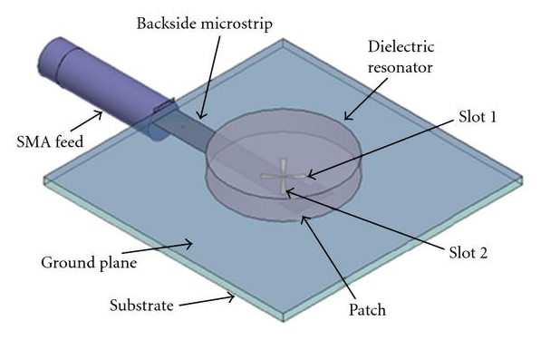

. . .and have interesting and useful far-field radiation patterns that look like this:

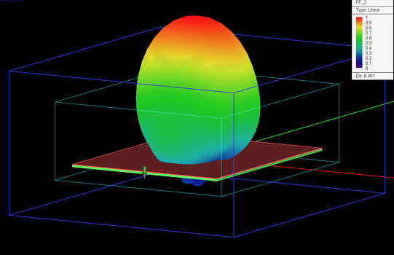

UHF frequencies also offer special capabilities microwave does not, including Foliage Penetration and Over The Horizon applications. Long range, wearable, secure communications can now be built into helmets, and foliage penetrating radar can be small enough to clip onto a soldier’s belt. For the first time, Over The Horizon radar tracking can be built not only into aircraft, but into air to air missiles. Utilizing “higher mode” functions of these antennas can enable the same antenna to project both lower frequencies for OTH, but also harmonics capable of higher resolution and more precise shorter range tracking. Extremely long range communications capable of transmitting several channels of high definition video, can be transmitted across cis-lunar space with just a few watts of power, and all that space down to the surface of the Earth can be monitored for communications, missile launches, and Near Earth Objects, from the Earth-Moon Lagrangian Points, and so fulfill the mandate by congress to both NASA and DOD.

Our proprietary material has been characterized to have a k of 40,000, from DC to 900 Mhz, and from 150-300*K. We will be further characterizing it to at least 400*K. The material also has a dielectric loss tangent that in one thermal bandwidth can be as high as 0.1%, but normally is 0.01%, making its losses insignificant compared to those of any power system it would be integrated with or antenna it would replace.

We see a large market for improving more than 30 identified applications, especially where size and mass of a TX antenna and its power system need to be optimized around mobility.

