The largest aquatic beetle in the UK found at Crossness
While carrying out habitat work on Crossness Nature Reserve, myself and volunteer, Reg, stumbled across this huge and incredibly impressive Great Silver Water Beetle (Hydrophilus piceus). This member of the
Hydrophilidae family, was found wandering along a terrestrial footpath, near adjacent water at the southern end of the Protected Area.
While this huge beetle, measuring 35-65mm in length, is the second largest in the UK – with the terrestrial Stag Beetle (Lucanus cervus) taking first place – it is Britain’s largest aquatic beetle. It is also very rare and threatened. Most are confined to the Somerset Levels; however they are found elsewhere in the UK in grazing marsh habitat and ditches. Records since 1980 (Sutton, 2008) are for South and North Somerset, East Sussex, East and West Kent, South and North Essex, East Suffolk, East Norfolk, and Monmouth.
The larvae of this beetle favour water bodies that are choked with vegetation such as Ivy-leaved Duckweed (Lemna triscula) and fringed by Common Reed (Phragmites australis), whilst the adults favour recently
cleared ditches (Foster, 2010).
The Great Silver Water Beetle gets its name from the fact that bubbles of air that are trapped on its underside whilst swimming, look somewhat silvery. This gives the impression that the beetle is silver in colour despite
the fact that it is a shiny black beetle with a greenish sheen.
The adult beetle feeds on decaying aquatic vegetation, whilst the young larvae – before also turning to plant debris – are initially carnivourous, consuming aquatic snails and tadpoles, and occasionally turning on each other! Their presence can by implied from the characterstic biting marks found on empty snail shells.
As with the adult, the larvae are not lacking in size: found in weedy ponds, they are long, thin and light brown in colour, with a fully-grown larvae measuring up to a staggering 70mm in length – think the size of a slug!
The scarcity of Hydrophilus piceus – which can live up to 3 years, although most die off after breeding in their first year – is thought to be linked with loss of traditional grazing marsh, and also the destruction of drainage ditches. Foster (2010) states that drainage of the Cambridgeshire Fens and the London Marshes in the 19th Century must have resulted in the greatest reductions in this species in Britain, indicating the potential for
further decline.
In terms of current management practices and conservation of this threatened beetle, conditions favouring an abundance of large molluscs are essential for successful breeding, while piecemeal clearance of drainage ditches by hand is better than large-scale clearance using heavy plant.
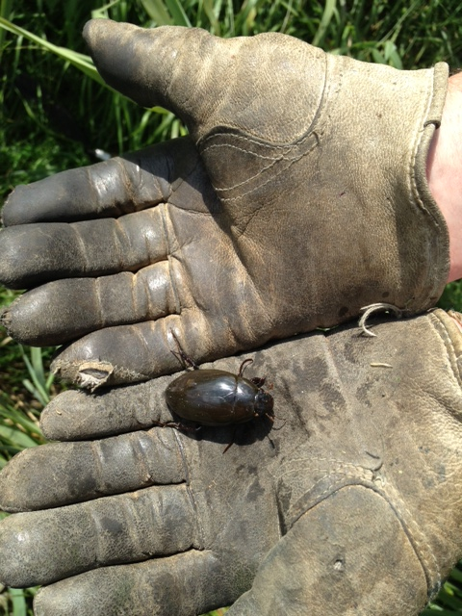 | 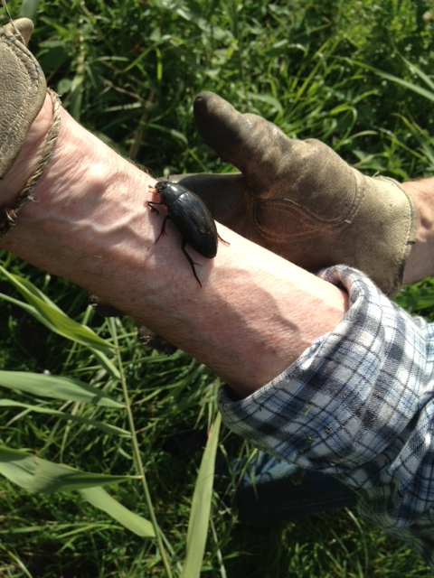 |  | 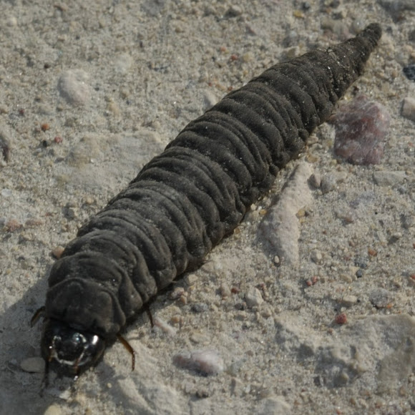
Crossness volunteer, Reg Northam, holds the Great Silver Water Beetle to demonstrate its huge  size. Photos by Karen Sutton |  |  | The Great Silver Water Beetle larvae. Photo not taken at Crossness. Source unknown

