World History (to 1300)

UNIT 12
The Christian Empire

Empires of Monotheism, Part I

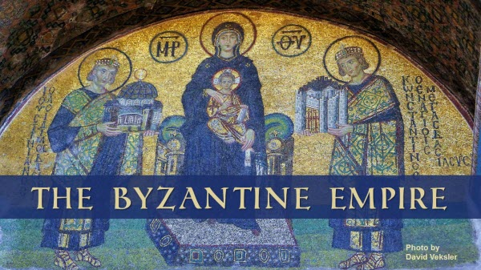

WORLD HISTORY (to 1300)
TERMS LISTS
UNIT 12
The Christian Empire

Title
Text

Map 12.1

The “Byzantine” Empire

Name: ___________________

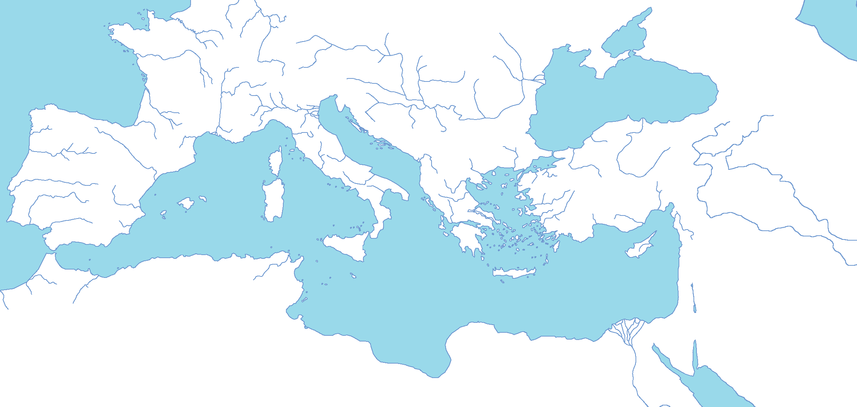
Map Credit: ColdEel
Identify the following places on the map:

Document 12.1

The Edict of Milan (313 A.D.)
Source: http://gbgm-umc.org/umw/bible/ce.html
When I, Constantine Augustus, as well as I, Licinius Augustus, fortunately met near Mediolanurn (Milan), and were considering everything that pertained to the public welfare and security, we thought, among other things which we saw would be for the good of many, those regulations pertaining to the reverence of the Divinity ought certainly to be made first, so that we might grant to the Christians and others full authority to observe that religion which each preferred; whence any Divinity whatsoever in the seat of the heavens may be propitious and kindly disposed to us and all who are placed under our rule. And thus by this wholesome counsel and most upright provision we thought to arrange that no one whatsoever should be denied the opportunity to give his heart to the observance of the Christian religion, of that religion which he should think best for himself, so that the Supreme Deity, to whose worship we freely yield our hearts) may show in all things His usual favor and benevolence. Therefore, your Worship should know that it has pleased us to remove all conditions whatsoever, which were in the rescripts formerly given to you officially, concerning the Christians and now any one of these who wishes to observe Christian religion may do so freely and openly, without molestation. We thought it fit to commend these things most fully to your care that you may know that we have given to those Christians free and unrestricted opportunity of religious worship. When you see that this has been granted to them by us, your Worship will know that we have also conceded to other religions the right of open and free observance of their worship for the sake of the peace of our times, that each one may have the free opportunity to worship as he pleases; this regulation is made we that we may not seem to detract from any dignity or any religion.
Moreover, in the case of the Christians especially we esteemed it best to order that if it happens anyone heretofore has bought from our treasury from anyone whatsoever, those places where they were previously accustomed to assemble, concerning which a certain decree had been made and a letter sent to you officially, the same shall be restored to the Christians without payment or any claim of recompense and without any kind of fraud or deception, Those, moreover, who have obtained the same by gift, are likewise to return them at once to the Christians. Besides, both those who have purchased and those who have secured them by gift, are to appeal to the vicar if they seek any recompense from our bounty, that they may be cared for through our clemency. All this property ought to be delivered at once to the community of the Christians through your intercession, and without delay. And since these Christians are known to have possessed not only those places in which they were accustomed to assemble, but also other property, namely the churches, belonging to them as a corporation and not as individuals, all these things which we have included under the above law, you will order to be restored, without any hesitation or controversy at all, to these Christians, that is to say to the corporations and their conventicles: providing, of course, that the above arrangements be followed so that those who return the same without payment, as we have said, may hope for an indemnity from our bounty. In all these circumstances you ought to tender your most efficacious intervention to the community of the Christians, that our command may be carried into effect as quickly as possible, whereby, moreover, through our clemency, public order may be secured. Let this be done so that, as we have said above, Divine favor towards us, which, under the most important circumstances we have already experienced, may, for all time, preserve and prosper our successes together with the good of the state. Moreover, in order that the statement of this decree of our good will may come to the notice of all, this rescript, published by your decree, shall be announced everywhere and brought to the knowledge of all, so that the decree of this, our benevolence, cannot be concealed.

