Duty to God > how we orient ourselves toward Him with courage, consciousness and authenticity.

Preliminary remarks, as an aside >
Re: Egypt 2011 > Egyptian Revolution of 2011, locally known as the January 25 Revolution
Du’a only – ultimately outcome is a matter of Qadr & Egyptian people
Our concern/focus – what outcome do we foresee >
- issues pertain to all Muslims communities
- Exigencies of running modern nation state
- International & domestic implications
- Immediate/mid-term/long terms needs of all citizens Muslim & non-Muslims
- Aspirations > foundational? Cultural?
- Responsibility to future generations
- Cautionary tale: Afghanistan
- Historical trends > compatibility

“Duty to God: courage, consciousness and authenticity”

Relevance of “courage, consciousness and authenticity” to concept/notion of “Duty to God”?

May discuss/approach from variety of perspectives: [5:00]
- What does Muslim owe to Allah?
- Linear priority of religious obligations > e.g. وَلِلَّهِ عَلَى النَّاسِ حِجُّ الْبَيْتِ hajj – visit to the House is duty to Allah owed by every Muslim
But for present purposes > matters at the heart of the heart of the matter – core – lubb لب

“Duty” . meaning of word > [dictionary meanings; synonyms] “moral or legal obligation or responsibility to engage en, , adhere to, refrain from, uphold a commitment to a task; act; doctrine, injunction” [6:00]

Source of duty?
- Source of duty to Allah emanates from SHUKR; gratefulness or thankfulness [???] the delivery by, execution of, fulfillment by the slave
  - The obligation to utilize, apply, direct everything he has been given by God for the purpose he was given
  - That is definition of gratitude/gratefulness
- Source of duty to society – INSCRIPTION
  - Katab’Allaha ihsana alaa kulli shayin
  - Allah has inscribed ihsan on every single thing
    - Every single thing with ihsan inscribed onto it is pointing towards Allah [7]
    - Every single thing with ihsan inscribed onto it has an expectation from the slave that he treats it with ihsan [spiritual excellence] –
      - “kulli shay’in” [7:20] …”particle of general reference” meaning “all-inclusive, every single thing without exception
    - Every single thing has inscribed on it a particular way in which the slave must deal with it which dictates our relationship with that thing that we encounter in the world whatever it may be.

Consciousness [7:45]
This is an aspect and duty that infuses enter discussion because consciousness is the first duty that is imposed on every single human being.
Taklif is for responsible adult; not just responsible adult Muslim but every adult person
- The discourse of the Qur’an is directed to the entirety of mankind
Consciousness is first obligation – prioritized by Allah 
- The very first obligation is maa’rifat/gnosis – to know Allah
- “Knowing” in contradistinction to “knowledge”
- Knowing is a state of being imbibed from the meanings contained in the facts of knowledge
  - Apprehension of facts is a first step in knowing
  - But knowing is not just about data, or the amount of data I have in my pocket to sling at you when we get into a ‘showdown’ [9:40]
- This type of knowing that leads to maa’rifat lead to two things; two types of knowing Allah 
  - Conviction [yaqeen?] or what aqida is all about
  - Consciousness or hudhur [حضور]

Hudhur means “presence of heart in the presence of Allah”
- Allah is here but are you with Him?
- Are we awake to that?
- Are we maintaining consciousness of the ‘hereness’ of Allah  [10:38]

Consciousness as presence of heart entails a reified, non-contextualized, intimate relationship with Allah  in real time [10:50] … just as His “hereness” is immediate at every moment. … Allah  is not ‘in time; he is the creator of time …this real time intimacy becomes the stage for responsiveness to the Divine Writ, to taqwa, or for taqwa., responsiveness to munajat—the intimate conversation with Allah ; and also this consciousness of hudhur becomes the stage for imara [11:30] in your salat. … what is imara? … it is to populate a space, to fill it with something; … when you fully populate a faith; you fill it with something; you fill it with [12:06] yourself; you will it with meaning and you fill it with life … you fill your prayer with life when you do it with hudhur. [12:25]. presence of heart in the presence of Allah. This consciousness, this reified, real-time intimacy with Allah  is what populates your prayer.

Without this consciousness, religious experience does not go beyond conceptualized experience; not actual experience but concept of experience. [13:00] We are left with concepts, with ideas but not with realities. This hudhur, this consciousness … is also the crossing at the ford, where philosophy or philosophical theology can have actualized encounters with reality and vice versa [13:30] … “where the rubber meets the road” … where things become actual and not just cerebral … that’s consciousness.

Courage,
Our second core duty is courage. [13:51]
Two types of courage: Applied courage & Courage of concepts
- Applied courage – courage on battlefield or on streets when streets become battlefield; courage in the concrete jungle or in classroom;
- Courage of concepts –
  - courage of principles ideals & courage to uphold them and stick to them or even to have any at all; courage to have unique, or native concepts of one’s own.
  - So courage in relation to God is the courage to have a conceptual system that may be different to, or stand out from other conceptual systems competing in the same market place
  - Requires courage and courage requires confidence—informed confidence, not over-confidence–difference between ilm and taqleed in aqeedah; difference between knowledge in aqeedah and taqleed (unquestioning observance of doctrinal points) in aqeedah. Muhammad ibn Yusuf as-Sanussi RA “not sufficient for adult of sound faculties to merely follow the statements of others vis à vis aqeedah. He must have knowledge & evidence, if he has the capacity to do so [to decipher rules]
  - Informed confidence to have our own conceptual system
  - Informed means to do it with rigor, and to do it having accounted for the problems of our context
    - Rigor to maintain faithfulness to our foundational principles
    - Accounting meaning that your native conceptual scheme accounts for the challenges and problems that have been identified by your particular intellectual landscape or generational cohort, i.e. what are the people of your time dealing with right now.
  - Courage also means a duty to maintain a commitment to a metaphysical stance; to have a position on metaphysics and you maintain a position vis à vis metaphysics with that confidence and courage
    - What does it mean to engage with the world from a standpoint of being an ensouled body?
    - Sheikh Abdur Rahman as-Shaghouri RA used to say “Anta bi’r ruhi la bi jismi insanun - you are by your soul, not by your body, a human being.” What does that tell us about the meaning of being human? About our humanity, about the humanity of others? What does it mean to maintain a consciousness of concurrent architectures of noetic or intelligible dimensions of reality that are contemporaneous with our own?[18:36] Al mulk wa’l malakut kathak’il jabarut fa kulluha nu’ut wa’th thaakir mu’samma –The Realm of Dominion, the Angelic Realm, the Divine Realm—the Realm of Majesty—what does it mean to recognize the natural world as a site or a horizon for the disclosure or unveiling of the activity of the Divine Names?
أَلَمْ تَرَ إِلَىٰ رَبِّكَ كَيْفَ مَدَّ الظِّلَّ
Alam’tara illa Rabbik kayfa madda’d dal
“Do you not see your Lord how He extends/lengthens the shade?
Note: wording: nothing in the Quran happens by chance: He did not say “Do you not see the shade as Your Lord extends it?”; He said, “Do not see Your Lord as He extends/lengthens the shadows/shade?”
    - Arabic poetry recited “A full moon rising from beyond the tree branch in glorious manifestation! Transcendent is the One who created it. // These worlds are the horizon of His sunrise; captivating at once the eye and the heart.” [20:15]
    - What does this tell us about the environment as we struggle to comprehend the unceasing conversation of an environmental hermeneutics? [20:25]

Authenticity
Authenticity is a duty to God to maintain your own social, cultural & intellectual identity, or at least your own native criteria for filtering the manifold conceptual systems that compete in the marketplace of ideas in a way that reflects your own roots; who you are; from what conceptual region that you approach the dialogicaltable, for example, non-reductive physicalism [21:05] gives too much ground to naturalism and ends up being a form of soft reductionism.
These are concepts that other theological communities have thought, worked … from the scientific community, or naturalists in physicalism [21:32]…so they essentially sold out their own principles in order to adopt something that they thought might appease another group. [21:40] This is a lack of courage

Authenticity however is different from mere opposition or resistance—that is essentially just being stubborn—[??]
.., we go back to the informed confidence that we talked about … but instead “authenticity” means [22:04] to chart your own course through the ocean, launching from the harbor of your own roots, and guided by your own stars—
wa bi najmihim yah’tadoon [22:16]—while using a confident yet informed—meaning “a rigorous and accounting”—cartography.”… [22:25]
[22:28] Allah  inna lillahi ya ibaadun fatana
tallaqqud dunya makhaafata fitana
nazaru-l fiha fa’lamma aa’limu annaha
laysat li’hayyin watana
ja’aluha lujjatan
fat’takhazu fa bi hal a’amali fiha suffuna/suqquna
Verily Allah has perspicacious , intelligent slaves
[tallaqqud dunya] they divorced themselves from the world
out of fear of fitna
[nazaru-l fiha] they looked, [23:07] they investigated it
and when they came to the realization that this is no place [23:12] for a living soul
[ja’aluha lujjatan] they made it an ocean [23:17]
and took righteous deeds as their ship
to get to the other side. [23:25]
So authenticity means to chart your own course through this ocean, using your own sextant, using your own astrolabe; cartography of your own crafting [23:41] being very conscious at the same time of the circumstances that you are dealing with [23:46].

So I said “consciousness, courage and authenticity” but I wanted to just add a small fourth to these core duties [23.57] as opposed to linear duties to God. [24:00] And that is ziyada, the duty of “increase”, and increase is a duty to God. Meaning that within the time and space continuum allotted to every person, he or she [24:16] strives for a qualitative increase in their relationship with the Divine Presence [24:24]…Increase, Ziyada to expand, to swell, to escalate, intensify, augment, multiply, elevate, amplify … all of these are meanings of ziyada. And where is the ziyada, supposed to take place? [24:43] Right in that moment of intimacy, that consciousness between you and Allah  .

The duty here is to make a commitment that you will do your very best [24:57] to ensure that every day, and the envelope of every moment and every breath has some ziyada [25:05] in it because faith is given to ziyada and nuqsan—wa’l ayaaz billah—decrease. [25:16]

And there is a difference of opinion in the schools of tauheed on this.One school says “No. faith does not increase [25:28] or decrease at all.” You are either a believer or not a believer. Khalaas. That’s it. You either have faith or you don’t have faith. [25:39] Another school, the majority school, says that “Yes, faith does increase and decrease.” And speaking of this … Lakaani says
Wa-r rujji’hat ziyadatu-l imaani bima tazeedu ta’atu-l insaani
Wa naqsuhu bi naqsiha wa qilla la qalfun … wa qilla qalfun qaza qad nuqila
So there are three opinions on this: one is that iman does not increase or decrease; the second is that it does increase and decrease [26:12]; and the third position which is really our position is that actually, there is no difference [26:16] because the one school that says there is no increase or decrease is saying that the step from non-faith into faith is one step [26:29], but once inside there is always room for increase [26:33]; and that’s the commitment to make ziyada. Dr. Mahmud Nusri said that its like a dynamic
Wa naqsuhu bi naqsiha wa qilla la
and where it is said
bima tazeedu ta’atu-l insaani
“and faith increases with that which increases the obedience [26:52]; the devotional obedience,” meaning acts of devotion; in works of obedience [26:59]; works of goodness are what give increase to faith and its decrease is when one is losing out [27:09] in those actions. Faith goes down until it withers away—al ayaaz billah—to nothing.

So the duty for ziyada is the last of these core duties [27:22] that I wanted to highlight.

And now I want to go into some of the problematics of the idea of duty.

There remain a number of problematic challenges on the question of duty that must be answered. If we are going to supply this alternative worldview for this generation of which spoke at the beginning when speaking about the situation going on in Egypt, and Tunis [27:47] and other countries and all other experiences in this blackboard jungle and the various concrete jungles across our western Muslim existence [27:58]; if there is going to be a relevant new world view that will address this. [28:04] There are certain problematic challenges for the question of duty that must be answered by a thorough-going contemporary Islamic view on the issue. They are inherent to the question of duty and, I believe, a particular relevance to the engagement of an Islamic theology with the contemporary environment. [28:24]

The first: the potential for self-centeredness that is involved in every human interaction, because it is in reality an interaction with a right owed to God, [28:39] and not to the other person in the interaction. This is a question that if put to the Islamic conception of duty, how will we answer it? [28:51] Because it creates a situation, or it has the potential to create a situation where other people become merely stage props [29:00] or obstacles to be surmounted.

I would say that a beginning of an answer to this would be that when the Muslim, in order to avoid treating others as objects, would be that when the believer interacts with another person; he is not merely witnessing, or beholding the circumstances of the interaction. But he is also beholding that this is another ensouled human being, and that he is witnessing that soul and he realizes the status of souls [29:43]

The second problem: is each required duty only delivered because it is required by God; is that the only reason for our duty? In Islam? The only reason why we deliver up rights to others because God required it? Or is it because it is something that should or shouldn’t be done in its own right? [30:15] So that when taqwa leaves the picture—
- either because of blatant disregard;
- or because of an overwhelming mash’had of the Divine Ghufran, the Divine Forgiveness—some people are so overwhelmed with the ocean of Allah’s Forgiveness that they forget to be careful, to be obedient; “Why did you sin on My slave?” “Because the breadth and length of Your Forgiveness made me forget Your Punishments.” [30:50] … that’s for some people …;.
- Or is it the incomplete comprehension of the application of a principle to all human beings—this probably is sometimes more likely [31:00] than the first one;
- Or is it being overwhelmed by the commanding nafs or commanding ego;
and in this situation when taqwa leaves the picture for whatever reason; will right action, right treatment, honesty, etc., go right out the door with it [31:20] in all of our public interactions? That’s what we are facing and someone needs to answer this question. Insha’Allah, Sheikh Faraz will touch on this for us.

How do we answer this question without ourselves descending into a position of e’tidaal.
That becomes the question. [31:53]

The third [question] is with a principal or principial doctrinal approach to duty: is Islam, or a Muslim capable of a personal or emotive inspiration toward our relationships with others [32:16] or must it only be principial duty and nothing else? The answer to this is in whether or not the Prophet  was able to relate in sentimental ways to other human beings. [32:32] We have his example of how he  treated Anas  who served him  since he was a young boy and, he said “in the entire time I served the Prophet Muhammad , he  never said to me ‘Why did you do that?’ or “Why didn’t you do that?’” The Prophet Muhammad ,did not want to break the heart of Anas .[32:55]

Does that mean that we as parents should not be saying to our children “Why did you do that?” or “Why don’t you do that?” … Well, in a way, yes; but also if the Prophet Muhammad  had said that you, it would crush you.[33:13] And he  was conscious of that; he  was sensitive to that. Whenever he  would [receive] a large amount of food, he  would send a gift of it to the friends of his first wife Khadija رضي الله عنها . That attachment is coming from a sentiment in the heart [33.32].

The Jewish boy who used to work for the Prophet  was dying of some disease and the Prophet  said:
“Say, أَشْهَدُ أنْ لا إلَٰهَ إِلَّا اللهُ وَحْدَهُ لَا شَرِيْكَ لَهُ وَأشْهَدُ أنَّ مُحَمَّدًا عَبْدُهُ وَرَسُولُهُ “
In his last breaths of life; he turned to his father, and his father said, “Obey Abu’l Qasim.” []

The Prophet  was moved by sensitivity.

The servant of the masjid, the old black woman [34:09]; he  looked up and did not see her.
“What happened to the woman who sweeps here?”
Someone said, “Oh, she died.”
“Where is she? Why did you not tell me?” [He  asked.]
“We buried her. We did not want to disturb you. “[34:21]
But he  was disturbed and he  got up immediately and went to the Baqi and prayed over her, .
He  had an emotional attachment to things. The mountain of Uhud is a mountain.
“We love it and it loves us.”[He  said].
Trying to lift the spirit of the young boy Umayr  who was upset because his bird had died, and he  wanted to lift the spirits and make him laugh and he  said
“Ya Umayr, maa tha fa’ala – what did Nughayr go off and do? What did he do?” [35:16]
He  wanted to lift the spirits of a young boy.

If we didn’t have this sensitivity; if we didn’t this compassion; if we were incapable of having an emotive response’ well then everything would be a cold stoicism and Umayr  would just have to deal with it. Because that’s the way the dunya is.

The hadith of Umar . Was walking with his servant boy to receive the keys to the city of Jerusalem after it was captured by his army, and it was with the servant boy that they would rotate; one person rides while the other person walks, and when they got close to Jerusalem, it was the boy’s turn to ride, and he said, “Maybe I better get down now. You get up here because we are about to go in.” And he [Umar ] said, “No. It’s your turn and that is not going to change.”

Sensitivity.

The answer regarding right and wrong, in and of itself, … whether or not it is a duty to be delivered to God with no thought whatsoever [36.45] to the human being in that interaction, such that were a person for some reason were not to realize that there is a duty that is due to God here in this situation; or for some reason was to be forgetful of Allah ; then our society would become one where people cheat and steal and undercut each other for whatever reason, [37:09] because God, Allah is for the masjid and we’re in the cubicle right now. So what is it? [???] rules …

So one approach is to say, “No. This has nothing to do with the other person. This a duty to God. It has nothing to do with the other person. “ and we descend into this situational problem.[37:38]

The other extreme is I’tidal and many people in our time now, are digging into the manuscripts of the Mu’tazila and republishing them [37:52] because they feel this is the only thing that speak to the human condition. But we don’t need to see it that way.

There’s a third option. Tajuddin as Subki et al are very clear on the issue of Al husnu wa’l qabha [38:12] “Good and Bad being divinely ordained according to the Sunni school” but this is a legalistic point, a legal term on what we are beholden to by law of right and wrong, and the creation, the crafting of jurisprudence and ijtihad. But Subki is very clear in his exegesis [38:46] but at the same time though there can be room for social, cultural conceptions of dhawq, of taste; and right and wrong, correct and incorrect, good treatment, foul treatment—is also a case of social and cultural taste, as well as having a legalistic side to it when it comes to the crossing of law, and this is what we are asking for, that when people are unaware of the hukm that we can still have a society where people know that some things are just not done. [39:24] And it is especially important, or this rigidity that we are trying to dispel here is especially a problem where fiqh is being gerrymandered; where people are making what Sheikh Muhammad Shuqaar a’heela ala-s sharaa,[39:46] another heela for the shara. What is a heela? A ruse [39:55] a trick, a manoeuver on the Shari’a, over the Shari’a [40:02]; as opposed to a manoeuver to move forward with what the Shari’a is trying to accomplish in the world. So when we get into this gerrymandering of fiqh; so we actually don’t have to do that. But socially it will be unacceptable not to, just because the letter of the law … we don’t see non-Muslims in Europe or North America arguing over the letter of the law … but just because the letter of the law says you can get away with this, that this is OK; it doesn’t mean that it’s not bad adab , that there’s not bad adab [40:42]. So what we have from Subki … so what we have is fitan which is a confection of jamaal; husn, goodness and qabha which is literally ‘ugliness’ … so on the Sunni school, right and wrong, goodness and badness is delivered la hukma qabla wurudi shara, “there is no judgment until the Shari’a comes. It is not something we can craft up rationally, but there’s three different levels of jamaal; there’s ultimate duty [41:18] ultimate Jamaal; and this is Allahu jameel wa yuhibbu’l jamaal. That is the ultimate confection of Jamaal.

And then there is a kind of confection of Jamaal, that’s what makes this building, despite the name, the most tasteful building on the [???] site. … There are principles of kindness and beauty [41:45]

And then there is [? temporal?] jamaal which is social and cultural taste and that type of beauty is there .

So in closing with this dilemma of duty; we need a confection of duty. This is very important because it enables us to deliver on principles even when self-interest apparently ceases to come into play. [42:10] We are all serious about the project when we’re getting something out of it, but as soon as we are not, and we speak in these lofty, selfless, terms of sacrifice and “that’s why I’m here and I want to save humanity” but as soon as we get to the core, and the self-interest aspect is gone; all of a sudden, “Yah, I got things to do. … I gotta study for an exam” … something like that. … So we need this confection of duty that this is the right thing and we have got to carry on; we have to sacrifice.
I believe that they can be a confection of altruism in Islam. It must however account for the problem of exclusion of human persons from an individualized relationship of responsibility. Next it must allow for, if not empower a real emotive human relationships or a caring attachment, an authentic caring attachment that is not reducible to mere emotionalism being driven by or guided by or led by the nose by our emotions … it will also enable us to fill out or humanize the doubts that obtain from the mechanization of jurisprudence or fiqh. You can call this the contextual wisdom element [43:44] because contextualization alone is just social science. Whereas wisdom is time transcendent, so contextual wisdom then constitutes the temporal link between the timeless and the time bound.
Thank you all very much. Baarak’Allah fee kum, Ahsanullah ilaykum As salaam alaykum.

Notes:
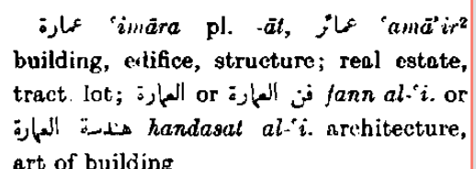  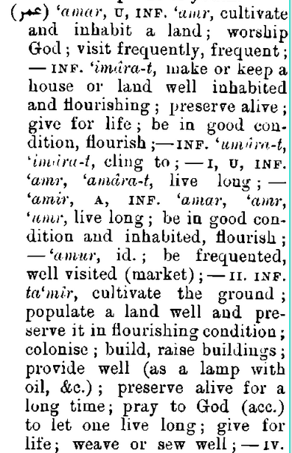 | 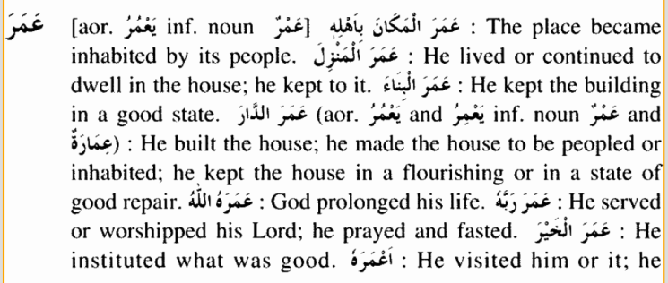  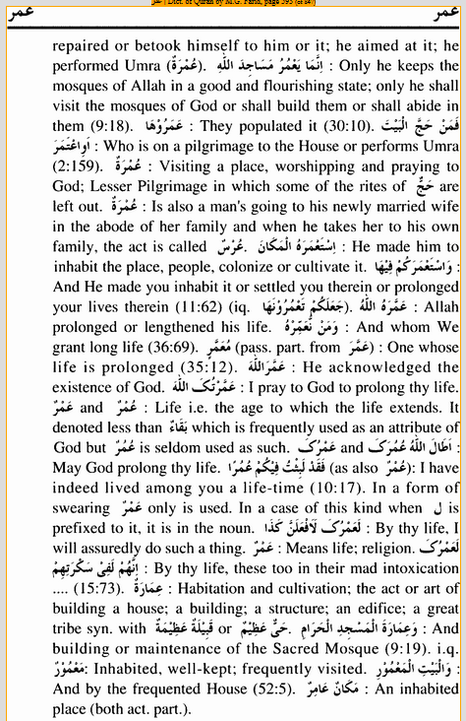
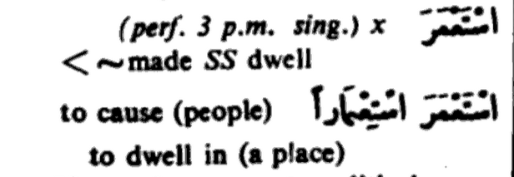 | 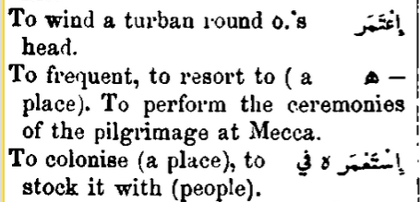
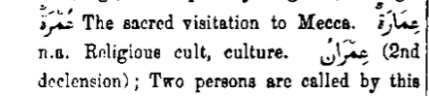 | 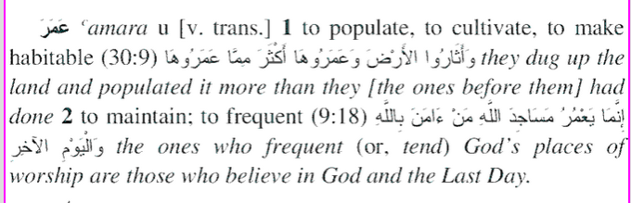

Scene [مشهد, مسرح, موقع, مكان وقوع الأحداث, المشهد السينمائي, ثورة غضب]
Panorama [بانوراما, منظر شامل, مشهد, نظرة شاملة إلى موضوع ما, منظر ]
Scenery [ مشهد, ديكور, منظر, زخرفة ]
Sight [مشهد, رؤية, بصر, نظر, مدى النظر, بصيرة ]
Spectacle [مشهد, مسرحية, كل ما يشبه النظارة]
Show [عرض, إظهار, معرض, مسرحية, حفلة ساهرة, مشهد]
View [ معاينة, رأي, رؤية, منظر, مشهد, فكرة]
Perspective [منظور, رسم منظوري, وجهة نظر, مشهد, فن الرسم المنظوري ]
Prospect [احتمال, إمكانية, أمل, أفق, أفاق, مشهد]

-Society is PLURAL/interdependent > Arabia in 6th century radically different – fall of Ottoman’s mechanization/modern warfare/information revolution/industrial revolution/ travel/jet-age / global village > international law - treaties
Surah Al-Imran 003:097
Every single thing without exception
Reify: verb - to convert into or regard as a concrete thing; reification, noun. Examples for reify: They have reified the idea of universal friendship, but they didn't invent it. It reified categories of race, ethnicity and privilege that were not accurate in the first place. Without a fully reified plan, the health care debate has come to a stalemate of talking points
??? عِمارة - frequent a place? إِنَّمَا يَعْمُرُ مَسَاجِدَ اللَّهِ مَنْ آمَنَ بِاللَّهِ وَالْيَوْمِ الْآخِرِ وَأَقَامَ الصَّلَاةَ وَآتَى الزَّكَاةَ وَلَمْ يَخْشَ إِلَّا اللَّهَ ۖ فَعَسَىٰ أُولَٰئِكَ أَنْ يَكُونُوا مِنَ الْمُهْتَدِينَ The mosques of Allah should only be frequented/maintained by those who have iman in Allah and the Last Day and establish salat and pay zakat, and fear no one but Allah. They are the ones most likely to be guided. [Surah Taubah 9:18
? ? Shaykh Abu ‘Abdullah Muhammad Ibn Yusuf As-Sanusi RA 895 A.H.[ca. 1488/89 CE] contemporary of Sheikh Ahmed Zarruq RA? http://www.asharis.com/creed/articles/axxnv-muhammad-bin-yusuf-as-sanusi-al-ashari-d-895h-quoting-poetry-from-ibn-taymiyyah-.cfm https://sunnism.wordpress.com/timeline/
“Metaphysics is a traditional branch of philosophy concerned with explaining the fundamental nature of being and the world that encompasses it, although the term is not easily defined. Traditionally, metaphysics attempts to answer two basic questions in the broadest possible terms: (1) What is ultimately there? (2) What is it like? … The metaphysician attempts to clarify the fundamental notions by which people understand the world, e.g., existence, objects and their properties, space and time, cause and effect, and possibility. A central branch of metaphysics is ontology, the investigation into the basic categories of being and how they relate to each other. Another central branch of metaphysics is cosmology, the study of the origin, fundamental structure, nature, and dynamics of the universe. Some include Epistemology as another central focus of metaphysics, but this can be questioned.”
Surah Al Furqan 25:14
Noun, ( used with a singular verb) the science of interpretation, especially of the Scriptures; the branch of theology that deals with the principles of Biblical exegesis. hermeneutics. (n.d.). Online Etymology Dictionary. Retrieved March 31, 2015, from Dictionary.com website: http://dictionary.reference.com/browse/hermeneutics]. Also defined as: “Hermeneutics is the theory of text interpretation, especially the interpretation of biblical texts, wisdom literature, and philosophical texts. Hermeneutics was initially applied to the interpretation, or exegesis, of scripture. It emerged as a theory of human understanding in the late eighteenth and early nineteenth centuries through the work of Friedrich Schleiermacher and Wilhelm Dilthey. Modern hermeneutics includes both verbal and nonverbal communication as well as semiotics, presuppositions, and preunderstandings. The terms "hermeneutics" and "exegesis" are sometimes used interchangeably. Hermeneutics is a wider discipline which includes written, verbal, and nonverbal communication. Exegesis focuses primarily upon texts. Hermeneutic, as a singular noun, refers to some particular method of interpretation (see, in contrast, double hermeneutic).”
Adjective - 1. of, relating to, or characterized by dialogue. 2. participating in dialogue. dialogical. (n.d.). Dictionary.com Unabridged. Retrieved April 01, 2015, from Dictionary.com website: http://dictionary.reference.com/browse/dialogical
Noun - 1. a doctrine associated with logical positivism and holding that every meaningful statement, other than the necessary statements of logic and mathematics, must refer directly or indirectly to observable properties of spatiotemporal things or events. physicalism. (n.d.). Dictionary.com Unabridged. Retrieved April 01, 2015, from Dictionary.com website: http://dictionary.reference.com/browse/physicalism
Noun - Meaning in Philosophy: “ 1. The view of the world that takes account only of natural elements and forces, excluding the supernatural or spiritual. 2. The belief that all phenomena are covered by laws of science and that all teleological explanations are therefore without value. Meaning in Theology: 1. The doctrine that all religious truth is derived from a study of natural processes and not from revelation. 2. The doctrine that natural religion is sufficient for salvation. naturalism. (n.d.). Online Etymology Dictionary. Retrieved April 01, 2015, from Dictionary.com website: http://dictionary.reference.com/browse/naturalism
Noun - 1.the theory that every complex phenomenon, especially in biology or psychology, can be explained by analyzing the simplest, most basic physical mechanisms that are in operation during the phenomenon. 2. the practice of simplifying a complex idea, issue, condition, or the like, especially to the point of minimizing, obscuring, or distorting it. reductionism. (n.d.). Dictionary.com Unabridged. Retrieved April 01, 2015, from Dictionary.com website: http://dictionary.reference.com/browse/reductionism
Noun - an astronomical instrument used to determine latitude and longitude at sea by measuring angular distances, especially the altitudes of sun, moon, and stars. sextant. (n.d.). Dictionary.com Unabridged. Retrieved April 01, 2015, from Dictionary.com website: http://dictionary.reference.com/browse/sextant
Noun - 1. an astronomical instrument for taking the altitude of the sun or stars and for the solution of other problems in astronomy and navigation: used by Greek astronomers from about 200 B.C. and by Arab astronomers from the Middle Ages until superseded by the sextant. It consists of a graduated circular disc with a movable sighting device. astrolabe. (n.d.). Online Etymology Dictionary. Retrieved April 01, 2015, from Dictionary.com website: http://dictionary.reference.com/browse/astrolabe
??? زيادة ???
??? مَشْهَدِ – witnessing ??? scene, scpectacle ???
??? Stopping? Standstill?? Easing off?? Pedal of gas???
Adjective - original, elementary. principial (n.d.) (n.d.). Collins English Dictionary - Complete & Unabridged 10th Edition. Retrieved April 01, 2015, from collinsdictionary.com website, http://www.collinsdictionary.com/dictionary/english/principial#examples_box
1) Narrated Anas : The Prophet  said, "This is a mountain that loves us and is loved by us." حَدَّثَنِي نَصْرُ بْنُ عَلِيٍّ، قَالَ أَخْبَرَنِي أَبِي، عَنْ قُرَّةَ بْنِ خَالِدٍ، عَنْ قَتَادَةَ، سَمِعْتُ أَنَسًا ـ رضى الله عنه ـ أَنَّ النَّبِيَّ صلى الله عليه وسلم قَالَ ‏ "‏ هَذَا جَبَلٌ يُحِبُّنَا وَنُحِبُّهُ ‏"‏‏.‏ Sahih al-Bukhari 4083; In-book reference: Book 64, Hadith 127; USC-MSA web (English) reference: Vol. 5, Book 59, Hadith 409 2) Anas b. Malik  reported Allah's Messenger  as saying: "Uhud is a mountain which loves us and which we love." حَدَّثَنَا عُبَيْدُ اللَّهِ بْنُ مُعَاذٍ، حَدَّثَنَا أَبِي، حَدَّثَنَا قُرَّةُ بْنُ خَالِدٍ، عَنْ قَتَادَةَ، حَدَّثَنَا أَنَسُ، بْنُ مَالِكٍ قَالَ قَالَ رَسُولُ اللَّهِ صلى الله عليه وسلم ‏ "‏ إِنَّ أُحُدًا جَبَلٌ يُحِبُّنَا وَنُحِبُّهُ ‏"‏ ‏.‏ Sahih Muslim 1393 a; In-book reference: Book 15, Hadith 576; USC-MSA web (English) reference: Book 7, Hadith 3208
NOTE: Could not follow or understand the reference. However, it appears that the following references may be found in some books of Hadith: - Anas  says, "Rasul’Allah  used to associate with us and joke. I had a younger brother. Rasul’Allah  said to him, "Aba Umayr, what happened to the Nughayr?" حَدَّثَنَا هَنَّادُ بْنُ السَّرِيِّ، قَالَ‏:‏ حَدَّثَنَا وَكِيعٌ، عَنْ شُعْبَةَ، عَنْ أَبِي التَّيَّاحِ، عَنْ أَنَسِ بْنِ مَالِكٍ، قَالَ‏:‏ إِنْ كَانَ رَسُولُ اللهِ صلى الله عليه وسلم، لَيُخَالِطُنَا حَتَّى يَقُولَ لأَخٍ لِي صَغِيرٍ‏:‏ يَا أَبَا عُمَيْرٍ، مَا فَعَلَ النُّغَيْرُ‏؟‏ Shama’il Muhamadiyah of Tirmidhi; English reference: Book 35, Hadith 226; Arabic reference: Book 36, Hadith 236 - Anas  said, "The Prophet  came in and saw a son of Abu Talha's called Abu 'Umayr. He had a sparrow which he used to play with." He said , "Abu 'Umayr, what happened to the little sparrow?'" حَدَّثَنَا مُوسَى، قَالَ‏:‏ حَدَّثَنَا سُلَيْمَانُ بْنُ الْمُغِيرَةِ، عَنْ ثَابِتٍ، عَنْ أَنَسٍ قَالَ‏:‏ دَخَلَ النَّبِيُّ صلى الله عليه وسلم فَرَأَى ابْنًا لأَبِي طَلْحَةَ يُقَالُ لَهُ‏:‏ أَبُو عُمَيْرٍ، وَكَانَ لَهُ نُغَيْرٌ يَلْعَبُ بِهِ، فَقَالَ‏: ‏ يَا أَبَا عُمَيْرٍ، مَا فَعَلَ أَوْ، أَيْنَ، النُّغَيْرُ‏؟‏‏.‏ Al-Adab Al-Mufrad 384; In-book reference: Book 20, Hadith 13; English translation: Book 20, Hadith 384
????
See: http://www.masud.co.uk/ISLAM/misc/tsubki.htm
??? حيلة trick, stratagem, ploy, ruse????
???? شرا evil ???; ??? شرائع rules ???? شريعة Shari’a

