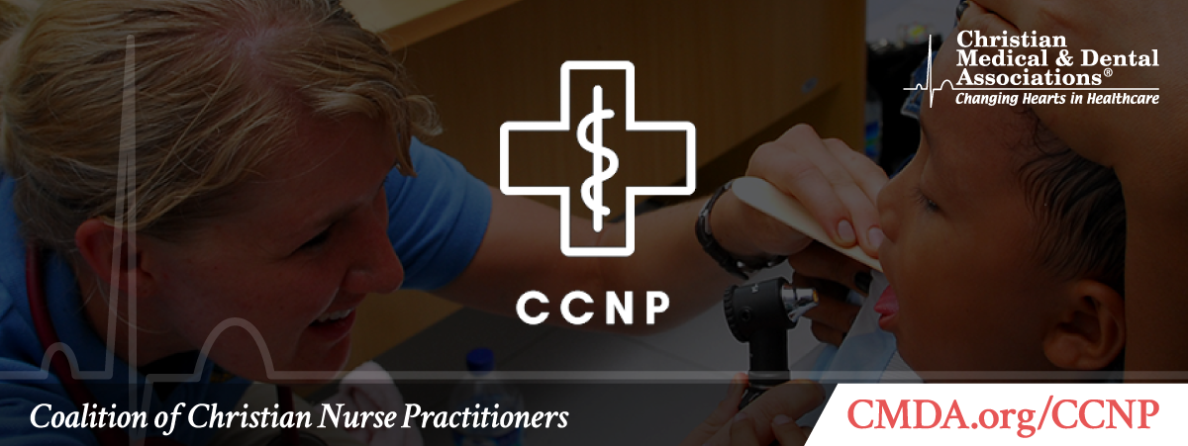
Winter 2021
Edition 1 | Volume 1

Contents
- Chairman’s Chat
- Hot Topic
- Upcoming Events
- Lifestyle Challenge
- Your Feedback Requested

💬 Chairman’s Chat

Hello and welcome to the CCNP e-newsletter! We are excited to be able to share current topics and upcoming events with you. With 2020 being an extraordinary year, we hope this finds you well. I think I speak for a majority of us when I say it has felt exceedingly difficult to remain connected last year. Even with the amazing technology we have to utilize for meetings, conferences and even birthday celebrations, I still feel we are missing a great deal of interaction with colleagues, friends and family. We plan to use this e-newsletter to get our section members connected and form a community of like-minded, Christ-following practitioners.

I challenge you over the next few months to try to connect with those who you may have lost contact with. Reach out to a friend, a church member, a family member or a coworker to inquire how they are doing and if there is anything you can do to help during this time. One thing I recently did was use Facebook to ask my friends for their favorite Scripture. I then wrote each Scripture on a week inside my personal planner. At the end of each week, I read the Scripture and pray for the person who shared it with me. This has made me feel more connected to those who I have not been able to see or spend time with.

I pray we all lean on Christ even more in the upcoming year and use His guidance and grace to make it through the days ahead.

God bless,

Adrienne E. Thorne, DNP, MSN, AGACNP-BC, FNP-BC
Chairman, Coalition of Christian Nurse Practitioners
CMDA Board of Trustees Member

📢 Hot Topic: SARS-CoV-2 Vaccine

by Shelia Talbott, DNP, FNP-C

According to the World Health Organization, a substantial amount of the world’s population will need to be vaccinated against SARS-CoV-2 to safely achieve herd immunity (2020). There are currently two vaccines in the United States that have been approved for use, yet 39 percent of Americans polled say they would not get the vaccine if offered (Pew Research Center, 2020). In 2020, nurses were ranked the most trusted position with Americans rating our ethical standards and honesty as “high” or “very high” (SAAD, 2020). Nurse practitioners are in a unique position to be a driving force behind immunization as our patients trust us and listen to our recommendations. Knowing this, there are some things we need to do in order to encourage our patients to be vaccinated.
- Do your research: Our patients are being bombarded daily with information from “Dr. Google” and social media, much of it inaccurate. Be ready to discuss immunization with your patients and make sure you understand the history and development of mRNA vaccines. Be prepared to combat some of the misinformation being pushed by anti-vaccine groups. Look at the source data from the Moderna and Pfizer studies so you’re ready to answer their questions with evidence based information. CMDA has a number of articles that will help you address any ethical concerns.
- Acknowledge their fears: 2020 has been a scary year for many of us, and 2021 is already in competition. A lot of our patients are anxious and uncertain. Be supportive and honest. I admit to my patients I was uncertain about the vaccine and worried about the speed of development until I really looked into it and realized that the technology had been in the works for many years and the data behind it showed the vaccine to be safe and effective.
- Set the example: Get your vaccine and let your patients know you did. Many of them are worried about potential side effects, so be ready to reassure them that it is safe and most people have limited or no side effects. Talk about the immune response and what it means when you get some chills and aches after the second shot.
- Respect patient autonomy: Ultimately, this is the patient’s decision and they need to be comfortable with it. Be ready to direct your patients to evidenced-based information about the vaccine from reputable sources such as the CDC and your local health departments for them to continue their research.
Working together with our patients, nurse practitioners can make a real difference in the fight against COVID-19.

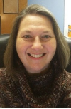
Shelia Talbott, DNP, FNP-C, is a family nurse practitioner working at a federally qualified health center (FQHC) in Farmville, Virginia. She loves teaching and mentoring new APRNs and is adjunct faculty at Old Dominion University, where she received her MSN and DNP. She has a passion for medical missions, leading teams to Honduras for the last 12 years. She and her husband Bob live in the river community of Scottsville, Virginia in their 1790s Virginia farmhouse.

References
Funk, C., & Tyson, A. (2020). Intent to Get a COVID-19 Vaccine Rises to 60% as Confidence in Research and Development Process Increases. Pew Research Center Science & Society. https://www.pewresearch.org/science/2020/12/03/intent-to-get-a-covid-19-vaccine-rises-to-60-as-confidence-in-research-and-development-process-increases/

Saad, L. (2020). U.S. Ethics Ratings Rise for Medical Workers and Teachers. Gallup. https://news.gallup.com/poll/328136/ethics-ratings-rise-medical-workers-teachers.aspx

World Health Organization. (2020). Coronavirus disease (COVID-19): Herd immunity, lockdowns and COVID-19. https://www.who.int/news-room/q-a-detail/herd-immunity-lockdowns-and-covid-19

📆 Upcoming Events

CCNP Virtual Meet and Greet | Sunday, February 21 at 8 p.m. ET
Join us via Zoom for a meet and greet with our section members. We will use this time to fellowship, get to know each other and meet others in your area. Please use the Zoom link below to join us!

Join the Zoom Meeting Here

CMDA and DTS Dialogues: Healthcare and Theology Learning Together | Wednesday, February 10 at 12:30 p.m. ET
A quarterly webinar series hosted by Christian Medical & Dental Associations and The Hendricks Center at Dallas Theological Seminary
“Engaging the Beginning of Human Life”
with Dr. Darrell Bock, Jeff Barrows, DO, MA (Ethics), and Mary Beth Jewell, MD
Click here for more information and to register.

Clinical Perspectives on the Transgender Movement | Saturday, February 27, 9:30 a.m. – noon ET
Part 2 in our series on Healthcare Professionals, The Church & The Transgender Movement. Our presenter is, Dr. Paul Hruz, MD, PhD – Associate Professor of Pediatrics, Endocrinology and Diabetes at Washington University, St Louis.

Click here for more information and to register.

⭐ Lifestyle Challenge: Making Amends

A new year brings about new opportunities and a fresh new outlook. The challenge for this quarter of the year is to make amends. Life can bring troubles and heartache that may be self-inflicted, but also could come from someone we love. This challenge focuses on showing the love of Christ today, in this moment, and reconciling with someone by making contact. Do not put off to tomorrow what can be done today. Tell them you forgive them and ask for their forgiveness in return.

“Then Peter came up and said to him, ‘Lord, how often will my brother sin against me, and I forgive him? As many as seven times?’ Jesus said to him, ‘I do not say to you seven times, but seventy-seven times.’” – Matthew 18:21-22, ESV

Your Feedback Requested

📝 Your Feedback Requested

We want to know more about you! Would you take a few minutes to complete this online form so we can learn who is in the CCNP section? Let us know how we can best serve you!

Get Started

If you would like to contribute to the e-newsletter, please submit inquiries to npsection@cmda.org.
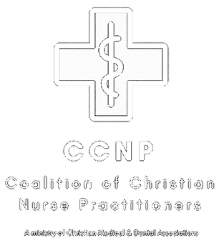
Coalition of Christian Nurse Practitioners
A Ministry of Christian Medical & Dental Associations
P.O. Box 7500 • Bristol, TN 37621 • 888-230-2637
www.cmda.org/ccnp • npsection@cmda.org

Email Preferences

