World History to 1300

UNIT Materials & Documents

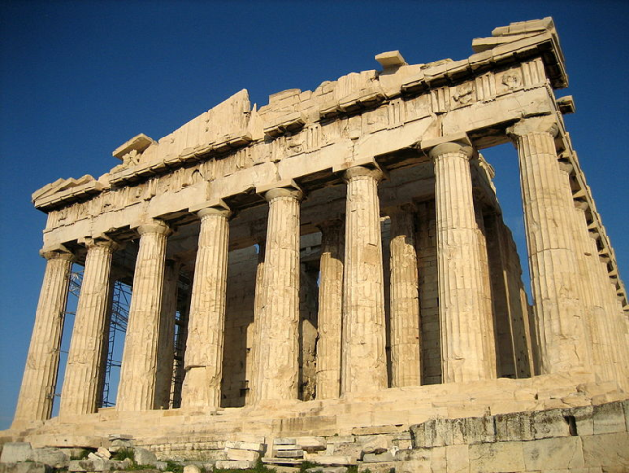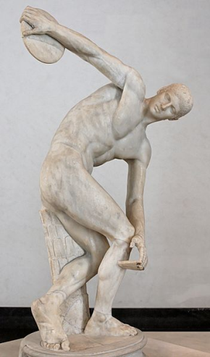

Ancient Greece Part I
Mythology, Literature, Government, and Athens

WORLD HISTORY (to 1300)
TERMS LISTS

UNIT 6
Ancient Greece (Test I)

Minoan and Mycenaean Greece | Greek Mythology
Atlantis  Minoans  Veneration  Sir Arthur Evans  Minos  Minotaur  Labyrinth  Theseus  Mycenaeans  Comparisons with Minoans  Greek Dark Ages  Homer  Iliad  Odyssey  Classical Greece | Polytheistic  Anthropomorphic  Uranus  Gaia  Cronus  Zeus  Poseidon  Hades  Apollo  Hera  Athena  Aphrodite  Prometheus  Epimetheus  Pandora

Homer and the Trojan War | Athenian Government
Homer  Epic Poem  The Iliad  The Odyssey  Heinrich Schliemann  The Judgment of Paris  Characters:  Helen of Troy  Priam  Hector  Paris  Achilles  Odysseus  Agamemnon  Menelaus  Virgil  The Aeneid  Trojan Horse | Aristotle  General Interest  Special Interest  Kingship  Tyranny  Aristocracy  Solon  Areopagus  Oligarchy  Draco  Draconian  Capital Offense  Polity  Citizenship  Balanced Government  Democracy  Cleisthenes  Socrates  Ostracism  Demagogue
The Olympics
Gymnasium
Olympia
Olympics
Leveling
Pankration

Map 6.1

Ancient Greece and the Aegean

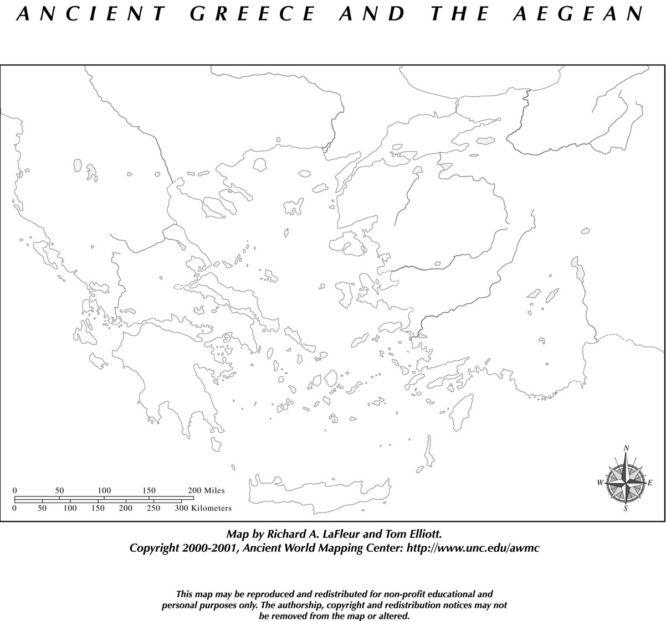

Locate the following on the map above:

Aegean Sea
Ionian Sea
Mediterranean Sea

Asia Minor
Attica
Crete
Macedon
Peloponnese

Athens
Knossos
Mycenae
Olympia
Sparta
Troy

Delphi
Mount Olympus
Hellespont (Dardanelles)

A Brief Summary of the Trojan War

Document

6.1
NOTE: This source was adapted from a text that was once available at a webpage hosted by Stanford University (stanford.edu/~plomio/history.html). That link is now dead and some additions and amendments have been made, but I have not wish to take credit for primary authorship of this summary.

Goddesses | Achaeans (Greeks) | Trojans
Hera  Athena  Aphrodite  Thetis | Menelaus  Achilles  Odysseus | Priam  Paris  Hector  Helen  Aeneas

The Apple of Discord and the Judgment of Paris
The Trojan War has its roots in the marriage between Peleus and Thetis, a sea-goddess. Peleus and Thetis had not invited Eris, the goddess of discord, to their marriage and the outraged goddess stormed into the wedding banquet and threw a golden apple onto the table. The apple belonged to, Eris said, whomever was the fairest.
Hera, Athena, and Aphrodite each reached for the apple. Zeus proclaimed that Paris, prince of Troy and thought to be the most beautiful man alive, would act as the judge.
Hermes went to Paris, and Paris agreed to act as the judge. Hera promised him power, Athena promised him wealth, and Aphrodite promised the most beautiful woman in the world.
Paris chose Aphrodite, and she promised him that Helen, wife of Menelaus, would be his wife. Paris then prepared to set off for Sparta to capture Helen…
In Sparta, Menelaus, husband of Helen, treated Paris as a royal guest. However, when Menelaus left Sparta to go to a funeral, Paris abducted Helen (who perhaps went willingly) and also carried off much of Menelaus' wealth…
Greek Armament
Menelaus, however, was outraged to find that Paris had taken Helen. Menelaus then called upon all of Helen's old suitors, as all of the suitors had made an oath long ago that they would all back Helen's husband to defend her honor.
Many of the suitors did not wish to go to war. Odysseus pretended to be insane but this trick did not work out quite as well as some of his other tricks. Achilles, though not one of the previous suitors, was sought after because a seer had stated that Troy would not be taken unless Achilles would fight….
The Greek fleet assembled, under Agamemnon's inspection, in Aulis….

Embassy to Priam
Odysseus, known for his eloquence, and Menelaus were sent as ambassadors to Priam. They demanded Helen and the stolen treasure be returned. Priam refused, and Odysseus and Menelaus returned to the Greek ships with the announcement that war was inevitable.
The War
The Greeks launched a navy of “a thousand ships” full of warriors who sought to avenge the abduction of Helen. Although they won many battles, the legendary walls of Troy could not be breached.
The climax of the Iliad is the duel between Achilles and Hector, Prince of Troy. Enraged at Hector for slaying his dear friend, Patroclus, Achilles challenged him to single combat. After defeating Hector, Achilles intended to deny him a proper burial, dragging the Trojan’s body behind his chariot back to his camp. Priam visited Achilles under the cover of darkness and begged Achilles for his son’s body, moving the enraged hero to tears. Priam brought Hector’s body back to Troy to receive burial.
But the war went continued. Even after ten years of fighting, the Greeks still could not break down the walls of Troy.

NOTE: What follows is not found in Homer’s Iliad, which ends with Achilles returning Hector’s body to Priam. The most prominent account of the Trojan Horse is found in Virgil’s Aeneid, a Roman epic poem that begins with the hero, Aeneas, escaping from the burning city of Troy.

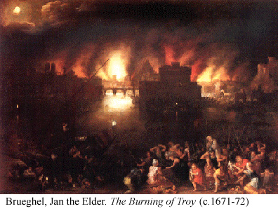
The Trojan Horse
Still seeking to gain entrance into Troy, clever Odysseus (some say with the aid of Athena) ordered a large wooden horse to be built. Its insides were to be hollow so that soldiers could hide within it.
Once the statue had been built…a number of the Greek warriors, along with Odysseus, climbed inside. The rest of the Greek fleet sailed away, so as to deceive the Trojans.
Only two people… spoke out against the horse, but they were ignored. The Trojans celebrated what they thought was their victory, and dragged the wooden horse into Troy.
That night, after most of Troy was asleep or in a drunken stupor, the Greek warriors came out from the horse and slaughtered the Trojans. Priam was killed as he huddled by Zeus' altar.
After the War
Aeneas, a Trojan prince, managed to escape the destruction of Troy, and Virgil's Aeneid tells of his flight from Troy.
The surviving Trojan women were divided among the Greek men along with the other plunder. The Greeks then set sail for home, which, for some (e.g., Odysseus)., proved as difficult and took as much time as the Trojan War itself.

Handout 6.1

Greek Religion and Mythology

NAME: ___________________

Vocabulary:

Polytheistic
Anthropomorphic
Uranus
Gaia
Cronus
Zeus
Poseidon
Hades
Apollo
Hera
Athena
Aphrodite
Prometheus
Epimetheus
Pandora

GREEK MYTHOLOGY FAMILY TREE:

Uranus  “Father __________” |  | Gaia  “Mother __________”

The Cyclopes  Father ______________  (plural of Cyclops) | The Titans  Leader:  _____________

Sons of Cronus:

_____________ | _____________ | _____________

The Olympians

God/Goddess | God[dess] of… | Interesting Facts and Traits
Aphrodite
Apollo
Athena
Hades
Hera
Poseidon
Zeus

Selections from Aristotle’s Politics

Document

6.2

Ancient History Sourcebook: http://www.fordham.edu/halsall/ancient/aristotle

From Book I:
The Purpose of Government
Active Reading
Every state is a community of some kind, and every community is established with a view to some good; for people always act in order to obtain that which they think good. But, if all communities aim at some good, the state or political community, which is the highest of all, and which embraces all the rest, aims at good in a greater degree than any other, and at the highest good.
From Book II:
The Size and Scope of Government
Our purpose is to consider what form of political community is best of all for those who are most able to realize their ideal of life. Three alternatives are conceivable: The members of a state must either have (1) all things or (2) nothing in common, or (3) some things in common and some not. That they should have nothing in common is clearly impossible, for the constitution is a community, and must at any rate have a common place---one city will be in one place, and the citizens are those who share in that one city. But should a well ordered state have all things, as far as may be, in common, or some only and not others? For the citizens might conceivably have wives and children and property in common, as Socrates proposes in the Republic of Plato. Which is better, our present condition, or the proposed new order of society?
Private Property Rights
Property should be in a certain sense common, but, as a general rule, private; for, when everyone has a distinct interest, men will not complain of one another, and they will make more progress, because everyone will be attending to his own business. And yet by reason of goodness, and in respect of use, 'Friends,' as the proverb says, "will have all things common." Even now there are traces. For, although every man has his own property, some things he will place at the disposal of his friends, while of others he shares the use with them. Again, how immeasurably greater is the pleasure, when a man feels a thing to be his own; for surely the love of self is a feeling implanted by nature and not given in vain, although selfishness is rightly censured. No one, when men have all things in common, will any longer set an example of liberality or do any liberal action; for liberality consists in the use which is made of property. Such legislation may have a specious appearance of benevolence; men readily listen to it, and are easily induced to believe that in some wonderful manner everybody will become everybody's friend, especially when someone is heard denouncing the evils now existing in states, suits about contracts, convictions for perjury, flatteries of rich men and the like, which are said to arise out of the possession of private property. These evils, however, are due to a very different cause---the wickedness of human nature.

From Book III:
Citizenship
He who would inquire into the essence and attributes of various kinds of governments must first of all determine "What is a state?" A state is composite, like any other whole made up of many parts; these are the citizens, who compose it. It is evident, therefore, that we must begin by asking, who is the citizen, and what is the meaning of the term? …He who is a citizen in a democracy will often not be a citizen in an oligarchy… A citizen is not a citizen because he lives in a certain place, for resident aliens and slaves share in the place; nor is he a citizen who has no legal right except that of suing and being sued; for this right may be enjoyed under the provisions of a treaty. But the citizen whom we are seeking to define is a citizen in the strictest sense… and his special characteristic is that he shares in the administration of justice, and in offices. He who has the power to take part in the deliberative or judicial administration of any state is said by us to be a citizen of that state; and, speaking generally, a state is a body of citizens sufficing for the purposes of life.
Like the sailor, the citizen is a member of a community. Now, sailors have different functions, for one of them is a rower, another a pilot, and a third a look-out man...Similarly, one citizen differs from another, but the salvation of the community is the common business of them all. This community is the constitution; the virtue of the citizen must therefore be relative to the constitution of which he is a member. A constitution is the arrangement of [the government]… The government is everywhere sovereign in the state, and the constitution is in fact the government. For example, in democracies the people are supreme, but in oligarchies, the few…
First, let us consider what is the purpose of a state, and how many forms of government there are by which human society is regulated… Man is by nature a political animal. And therefore, men, even when they do not require one another's help, desire to live together; not but that they are also brought together by their common interests in proportion as they severally attain to any measure of well-being. This is certainly the chief end, both of individuals and of states. And also for the sake of mere life… mankind meet together and maintain the political community....
Forms of Government
The words constitution and government have the same meaning, and the government, which is the supreme authority in states, must be in the hands of one, or of a few, or of the many. The true forms of government, therefore, are those in which the one, or the few, or the many, govern with a view to the [general] interest; but governments which rule with a view to the [special] interest[s], whether of the one or of the few, or of the many, are perversions. Of forms of government in which one rules, we call that which regards the [general] interests, monarchy; that in which more than one, but not many, rule, aristocracy (and it is so called, either because the rulers are the best men, or because they have at heart the best interests of the state and of the citizens). But when the citizens at large administer the state for the [general] interest, the government is called a polity. And there is a reason for this use of language.
Of the above-mentioned forms, the perversions are as follows: of monarchy, tyranny; of aristocracy, oligarchy; of polity, democracy. For tyranny is a kind of monarchy which has in view the interest of the monarch only; oligarchy has in view the interest of the wealthy; democracy, of the needy: none of them the common good of all. Tyranny, as I was saying, is monarchy exercising the rule of a master over the political society; oligarchy is when men of property have the government in their hands; democracy, the opposite, when the poor, and not the men of property, are the rulers....

Handout 6.2

Understanding Aristotle’s Politics

NAME: ____________________

VOCABULARY:

State
Community
Private Property
Censure
Specious
Perjury
Citizen
Sovereignty
Constitution
General Interest
vs. Special Interest(s)
Monarchy
Aristocracy
Polity
Tyranny
Oligarchy
Democracy

- According to Aristotle, what is the purpose of government?

_____________________________________________________________________________________
_____________________________________________________________________________________

Human Nature  Circle the number below that best expresses your general assessment of “human nature.” | “If men were angels, no government would be necessary.”  – Federalist 51 (Madison) | 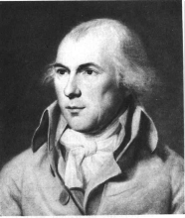

0 | 1 | 2 | 3 | 4 | 5 | 6 | 7 | 8 | 9 | 10

AWFUL NEUTRAL AWESOME

Circle the number below that best describes your reaction when you hear the word, “selfishness.”

0 | 1 | 2 | 3 | 4 | 5 | 6 | 7 | 8 | 9 | 10

A Bad Thing NEUTRAL A Good Thing

- What is a state and how would you distinguish a state from other communities?
_____________________________________________________________________________________
_____________________________________________________________________________________
_____________________________________________________________________________________

- Aristotle claimed that “Property should be… as a general rule, private.” Why is it beneficial to society for people to own and control their own property?

_____________________________________________________________________________________
_____________________________________________________________________________________

The Size and Scope  of Government  Using the organizer below, identify functions of government that you believe are appropriate and inappropriate. | 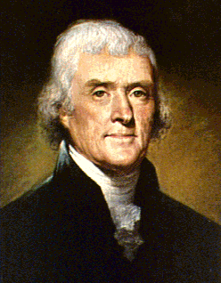 | “Sometimes it is said that man cannot be trusted with the government of himself. Can he, then, be trusted with the government of others? Or have we found angels in the forms of kings to govern him?”  -- Thomas Jefferson, First Inaugural Address

Appropriate  Functions of Government | Inappropriate  Functions of Government
Government should… | Government should NOT…

- Identify a situation in which it would be appropriate for the government to regulate or control someone’s use of their own private property.

_____________________________________________________________________________________
_____________________________________________________________________________________

- How does Aristotle define a citizen?

_____________________________________________________________________________________
_____________________________________________________________________________________

- How does Aristotle define a constitution?

_____________________________________________________________________________________
_____________________________________________________________________________________

Aristotle identifies six types of government that can exist. Place each one of them into appropriate place in the graphic organizer:

Government  by the… | Governing in the  General Interest | Governing on behalf of  Special Interest(s)
ONE
FEW
MANY

- Why did Aristotle consider democracy to be a corrupt form of government?

_____________________________________________________________________________________
_____________________________________________________________________________________

The Tyranny of the Majority

Document

6.3

From Alexis de Tocqueville, Democracy in America
University of Virginia: http://xroads.virginia.edu/~HYPER/DETOC/1_ch15.htm

Alexis de Tocqueville was a French diplomat who visited the United States in the 1830s. His book, Democracy in America, is one of the best sources we have about the politics and culture in America at that time. Although he admired the American system of government, he saw risks inherent in the United States’ political institutions growing more and more democratic.
ACTIVE READING

I hold it to be an impious and detestable maxim that, politically speaking, the people have a right to do anything; and yet I have asserted that all authority originates in the will of the majority. Am I, then, in contradiction with myself? ....
A majority taken collectively is only an individual, whose opinions, and frequently whose interests, are opposed to those of another individual, who is styled a minority. If it be admitted that a man possessing absolute power may misuse that power by wronging his adversaries, why should not a majority be liable to the same reproach? Men do not change their characters by uniting with one another; nor does their patience in the presence of obstacles increase with their strength. For my own part, I cannot believe it; the power to do everything, which I should refuse to one of my equals, I will never grant to any number of them....
Unlimited power is in itself a bad and dangerous thing. Human beings are not competent to exercise it with discretion. God alone can be omnipotent, because his wisdom and his justice are always equal to his power. There is no power on earth so worthy of honor in itself or clothed with rights so sacred that I would admit its uncontrolled and all-predominant authority. When I see that the right and the means of absolute command are conferred on any power whatever, be it called a people or a king, an aristocracy or a democracy, a monarchy or a republic, I say there is the germ of tyranny, and I seek to live elsewhere, under other laws.
In my opinion, the main evil of the present democratic institutions of the United States does not arise, as is often asserted in Europe, from their weakness, but from their irresistible strength. I am not so much alarmed at the excessive liberty which reigns in that country as at the inadequate securities which one finds there against tyranny. An individual or a party is wronged in the United States, to whom can he apply for redress? If to public opinion, public opinion constitutes the majority; if to the legislature, it represents the majority and implicitly obeys it; if to the executive power, it is appointed by the majority and serves as a passive tool in its hands... However iniquitous or absurd the measure of which you complain, you must submit to it as well as you can....
I do not say that there is a frequent use of tyranny in America at the present day; but I maintain that there is no sure barrier against it, and that the causes which mitigate the government there are to be found in the circumstances and the manners of the country more than in its laws.

Handout 6.2

Forms of Government
and Athenian Democracy

NAME: ___________________

Ideal Forms | Government by ONE | Corrupt Forms

_________________ | _________________
Notes: | Notes:

Government by FEW

_________________ | _________________
Notes: | Notes:
________________, an aristocratic leader, replaced Draco’s laws with laws that were more friendly to the poor while still allowing aristocrats to dominate politics.  The ________________ was a law court in Athens dominated by aristocrats. Paul the Apostle addressed the body in the first century A.D. | ________________, who gave Athens its first written code of laws, is often associated with oligarchy.  The term, ________________, is used today to refer to harsh rules, laws, and punishments.

Government by MANY

_________________ | _________________
Notes: | Notes:
What is a citizen?  ______________ government is arranged so that no single group of people controls it. | ________________ is known as the “father of Athenian democracy.”  ________________ was put to death by a vote of an Athenian jury for “corrupting the youth” and questioning the gods of the state.

Notes on Athenian Government:

Peleus and Thetis were the parents of Achilles.
A man who seeks a woman’s hand in marriage
Someone known for receiving prophetic visions

