PROVISIONAL CHECKLIST AND ACCOUNT OF THE MAMMALS OF THE LONDON BOROUGH OF BEXLEY

Chris Rose BSc (Hons), MSc. Version 3. October 2015.

INTRODUCTION

WHY PROVISIONAL?

Bexley’s mammal fauna would appear to be little studied, at least in any systematic way, and its distribution is incompletely known. It would therefore be premature to suggest that this paper contains a definitive list of species and an accurate representation of their actual abundance and geographical range in the Borough. It is hoped, instead, that by publishing a ‘provisional list’ which pulls together as much currently available information as can readily be found, it will stimulate others to help start filling in the gaps, even in a casual way, by submitting records of whatever wild mammals they see in our area. For this reason the status of species not thought to currently occur, or which are no longer found in Bexley is given.

Mammals are less easy to study than some other groups of species, often being small, nocturnal and thus inconspicuous. Detecting equipment is needed for the proper study of Bats. Training in the live-trapping of small mammals is recommended before embarking on such a course of action, and because Shrews are protected in this regard, a special licence should be obtained first in case any are caught. Live traps can be borrowed for a small fee from the Mammal society http://www.mammal.org.uk/trap_loan_scheme
Dissection of Owl pellets and the identification of field signs such as Water Vole droppings can help fill in some of the gaps. Perhaps this document will be picked up by local students who may be looking for a project to do as part of their coursework, and who will be able to overcome these obstacles.

NEW MAMMAL ATLASES IN PREPARATION

Now is a good time to be making mammal records given that at the time of writing the Mammal Society http://www.mammal.org.uk is working on the first mammal distribution atlas for some 20 years, the previous one being Arnold, H. (1993) ‘Atlas of mammals in Britain’. Institute of Terrestrial Ecology. HMSO. London.

The Mammal Society has recently completed a project called Mammal Watch South East (MaWSE),
http://www.mammal.org.uk/mawse which was funded by the Heritage Lottery Fund. This aimed to increase public involvement in discovering and monitoring mammal species in the six South East counties of Hampshire, Surrey, West Sussex, East Sussex, Kent (including the Vice-county of West Kent which encompasses the London Borough of Bexley) and the Isle of Wight. The aim of the project was to develop a South East Mammal Atlas (which will also contribute to the national atlas) by early 2015 through encouraging record submissions and developing surveys that help people get out there and look for mammals. This has now been completed and can be downloaded from the MAWSE webpage URL cited above.

At the London level P.A. Morris in ‘London’s mammals’, written for the London Natural History Society’s 150th anniversary conference and published in the Society’s Journal ‘The London Naturalist’ No. 88, 2009, lamented – in a review of knowledge at the time - the fact that London’s mammals had never been comprehensively mapped, and that there had been little enthusiam for their study in the capital since a flourish in the 1960s.

There is a strong bias in the mammal records which do exist for Bexley towards the two larger and more obvious species , namely Foxes and Rabbits, and protected species of conservation concern which include all Bats and also Water Voles, as these have to be surveyed for if there is any risk of a ‘development’ having a negative impact upon them. Bats are relatively straightforward to survey for with the right detectors, and Water Vole presence can be determined by surveying for latrines and feeding stations, even if the animals themselves usually stay out of sight.
The low-profile nature of many mammal species no doubt accounts for the fact that there has been little in the way of public mammal-related events in Bexley, apart from a number of Bat walks after dark with detectors at sites such as Bexley Park Woods, Hall Place, Footscray Meadows, Southmere Lake and Erith Marshes/Crossness, and a Harvest Mouse nest hunt at the latter in late 2014.

CONSERVATION STATUS OF MAMMALS AND OUTLOOK

British mammals are subject to mixed fortunes, with the Wild Cat in serious danger ofextinction and the Pine Marten struggling to survive in England and Wales, but with a re-introduction and population-boosting programme now underway using Scottish animals. The Otter, on the other hand, is now back in every county in England, with Kent being the last of these to be re-colonised, and the Polecat is also starting to make a comeback. Seals have increased. The Fox has adapted marvellously well to urbanisation and thrives in places like Bexley, but the Hedgehog is in big trouble where once it was widespread in suburbia. Further afield large carnivores in Europe are making comebacks and showing themselves able to co-exist with humans given the right conditions http://www.wildlifeextra.com/go/news/european-carnivores.html Wild Boar and Beavers have been returned to the wild in the UK (in part by ‘accident’), and the Wolf re-introduction issue bubbles away in the background whilst the Lynx is seen as a more ‘acceptable’ carnivore to restore for the time being. Much of the debate is now around the benefits these animals would bring in terms of re-establishing fully functional ecosytems, and the beneficial habitat changes that would result, including through the potential for the natural control of herbivores like Deer. Will there be (fairly) free-roaming Wolves in the UK in my lifetime, or before a person lands on Mars? We shall see, and I hope so ......

PRINCIPAL SOURCES OF INFORMATION (some others are cited in the body of this document):

General

- My own records.
- Verbal and written notes from a number of reliable wildlife observers in the Borough.
- Green Space Information for Greater London (the London biodiversity records centre) data as at October 2014.
- Recent Mammals in Kent. J. F. D. Frazer. The Transactions of the Kent Field Club Volume 3, Part 1. Maidstone 1965. Includes that part of west Kent now in London.
- Journal of the London Natural History Society, ‘The London Naturalist’, No. 88, 2009.
- Mammal Society website http://www.mammal.org.uk/
- British Wildlife Centre website http://www.britishwildlifecentre.co.uk/planyourvisit.html
- Vincent Wildlife Trust website http://www.vwt.org.uk/

Bexley sites survey work

- The 2004 and 2013 Bexley Sites of Imprtance for Nature Conservation reviews and site citations http://www.bexley.gov.uk/index.aspx?articleid=12495
- ‘Bexley Woods. Extended Phase I habitat survey bat survey report, and preliminary management recommendations’. London Wildlife Trust. November 2010. Two dusk and one dawn bat transect surveys of the site were carried out in June and August to assess use of the site by bats. Bat activity data was collected using heterodyne and frequency division BatBox Duet detectors, bat calls were recorded onto a hand held recorder (Edirol R09 or R09HR) and the species verified using Batsound Software. All surveys were supervised by a licensed bat ecologist and followed guidance set out in Bat Surveys; Good Practice Guidelines (Bat Conservation Trust, 2007). In addition, trees with moderate to high bat roosting potential were accurately mapped to inform possible habitat management such as coppicing work which, due to a negative reaction by some local residents to any possibility of tree-felling, never took place.
- Friends of Crossness Newsletter (FoCN) nos. 24, 25, 26, 27. Newsletters downloadable from http://www.thameswater.co.uk/about-us/6245.htm

- Crossness species list information obtained from nature reserve Site Manager Karen Sutton, and from Friends of Crossness Nature Reserve Newsletters produced by her.
- Reports of Crossness Barn Owl pellet analyses. Karen Sutton, nature reserve Site Manager, provided a spreadsheet of results for a project looking at 2005-2007 pellets, and a copy of ‘Investigation into the diet of Barn Owls at Crossness Sewage Works’ by Hoi-Yee Lam, Graduate Placement Student (University ofGreenwich), November 2012-March 2013. Skeletal remains of small mammals were recovered from dissection of the regurgitated pellets of Barn Owls resident on the site and identified by the two students, one whose name is not known (pellets from January, April, November and December 2005, January 2006, January and February 2007) and Hoi-Yee Lam (pellets from January 2011 to February 2012). Although it cannot be proven that all food items came from within the site, or elsewhere in Bexley, the built up nature of the surrounding areas, and the fact that the hunting range of individual owls is normally about 1km (approx. ½ mile) in the breeding season and 3km (approx. 2 miles) in winter (Barn Owl Trust information leaflet No. 33, 2008), suggests that most probably did so.
- ‘Erith Quarry, Bexley, Greater London - Ecological Assessment Interim Report’. Ecology Solutions Limited. 2014. Survey report in support of a planning application – which Bexley Council granted - to build on three quarters of one of the largest wildlife sites in the Borough and a Grade 1 SINC.
- Marriott, St. J. ‘British Woodlands as illustrated by Lesnes Abbey Woods’. George Routledge and Sons. 1925. The precise period during which the mammal records were obtained is not stated, but from the dates given for other species groups would appear to be sometime between 1915 and 1924, and certainly no earlier than 1907 or 1909. Thanks to Tristan Boulton for bringing this important work to my attention.
Species
- London Bat Group http://www.londonbats.org.uk/
- Bat Conservation Trust http://www.bats.org.uk/index.php
- ‘British Wildlife’. Vol. 25. No. 5. June 2014. Cetaceans report.
- The British Deer Society http://www.bds.org.uk/index.html
- British Trust for Ornithology ‘The state of Britain’s hedgehogs 2011’ report.
- http://www.telegraph.co.uk/earth/wildlife/6574709/Mouse-and-rabbits-among-non-native-species.html
- The Mammal Society Research Report No. 2. The National Yellow-Necked Mouse Survey. Aidan Marsh, March 1999.
- London Bird Club wiki http://londonbirders.wikia.com/wiki/LatestNews
- ‘Water Vole activity and distribution on the River Cray and Shuttle Riverway and suggestions for future management’. London Wildlife Trust. October 2005.

UK AND BEXLEY MAMMALS IN NUMBERS

UK total: As of December 2014 the Mammal Society listed 101 species found in and around the British Isles, including migratory, vagrant and introduced species [http://www.mammal.org.uk/full_species_list]. The introduced species are terrestrial mammals brought here since the UK was cut off from the continent around 8,000 years ago, as the ice retreated after the last glaciation and re-opened the North Sea and English Channel.

According to the Society the UK mammal fauna today comprises:
30 native terrestrial mammals, plus 2 native marine mammals (N)
17 native bats
11 introduced or naturalised species (I)
4 terrestrial island mammals (Isl) [some classed as subspecies]
22 cetaceans found in and around our waters
9 vagrant mammals (4 Bat species [the Bat Conservation Trust recognises a further five] and 5 Seals found only occasionally)
4 feral species (F)
2 domesticated / managed species

Number of known Bexley species: 29 - 30, comprising:

8 Rodents, 4 Insectivores, 1 Lagomorph (Rabbits/Hares), 3 Carnivores, 9 Bats, 1 wild Cattle/Sheep/Pigs/Deer, 2 Seals and 1 ‘regular’ Cetacean (a total of 10 Whale/Dolphin/Porpoise species have been recorded off Bexley but almost all as single individuals, probably off course, and in several cases many years ago). The 30th species depends on whether one counts fairly free-roaming Horses or not. Humans make it 31 .......

Known Bexley extinctions since the beginning of the 20th century: 2 or 3 (Red Squirrel, Hare, possibly Stoat. Others may have gone before records were kept, such as Otter and Polecat and, further back still, the likes of Deer and Wild Boar).

Species at risk of extinction within Bexley: 0. None of the species known to currently inhabit the Borough would appear to be at immediate risk of extinction within its boundary, though the Harvest Mouse appears to have a limited foothold at present, and Hedgehogs are known to be in serious decline more generally. The Water Vole and all Bat species are of regional and national conservation concern due to declines.

Conventions used in this paper: All species on the Mammal Society schedule are listed. Where it is certain these do not, or no longer occur in Bexley, this is stated. Where a marine species has been seen in the Thames where it is adjacent to the Borough, the species is included as having been ‘Recorded off Bexley’. Technically the Borough’s boundary runs down the middle of the river, but for old historic records of Cetacea we will never know whether they were ever on the Bexley side of the line or not. In any case, Bexley as a local government entity is a fairly recent invention, and this is a technicality anyway.

All photographs were taken by the author unless otherwise stated.

RESIDENT, MIGRATORY AND VAGRANT SPECIES RECORDED IN BEXLEY
RODENTIA (Rodents)
Wood Mouse - Apodemus sylvaticus (N) - Probably widespread in Bexley. Marriott (1925) said the species was ‘Fairly common’ at Lesnes. I had this in my garden compost heap in Barnehurst until a couple of years ago, since when it seems to have been driven out, possibly by a combination of Cat predation pressure and competition from House Mice. Remains were found in pellets from both Crossness Barn Owl diet projects. John Arnold has reported and photographed this species from his garden towards the north end of Pickford Lane, Bexleyheath in Mid-April 2015 and subsequently.
Yellow-necked Mouse - Apodemus flavicollis (N) - No records in Bexley . Marsh (1999) found that the species was present in woodland of all ages, but more abundant in woodland of ancient origin, and that it was present in 71% of suitable sites within its natural range. It has a more restricted range in the UK than the Wood Mouse, and may be more vulnerable to habitat fragmentation, whereas in several continental countries it is more numerous than that species. The large scale national distribution map for the species includes the London area, but there are no records for Bexley at present. In the wider Kent context, Fraser (1965) states that it was ‘Recorded from four localities only, three of these around Maidstone.’
House Mouse - Mus musculus (N) Thought to have been brought over unnoticed by Neolithic man, the first records are from around 1,000 BC. The Mammal Society is now listing it as native. Probably widespread in the Borough. They forage for spilt bird food in my neighbour’s garden and some did get inside my Barnehurst home until I found some inconspicuous entrance holes and blocked them up. Far more wary of live traps than I found Wood Mice to be when that species came indoors in a house I once occupied in Bristol. Remains were found in 2005 and winter 2011/12 pellets from Crossness Barn Owls.
Bank Vole - Myodes glareolus (N) – Remains found in winter, spring and summer 2011 Barn Owl pellets at Crossness. GiGL has a single 2005 record from Crayford Marshes. A couple of juvenile Voles of an unidentified species were found by myself under a piece of corrugated iron by the Crayford Way allotment site in 2014.
Skomer Vole - M. g. skomerensis (Isl) - Not recorded in Bexley
Field Vole - Microtus agrestis (N) – Remains recorded from 2005, 2006, 2007 and winter 2011 through to winter 2012 Crossness Barn Owl pellets. One sighting reported in FoCNR Newsletter 25 for Jan-March 2013. Field Vole has been reported to GiGL from Woodlands Farm surveys. Although the grid references given were on the Greenwich sideof the border, it is likely that the species ranges into the Bexley section.
Orkney Vole - M. a. orcadensis (Isl) - No recorded in Bexley.
Water Vole - Arvicola terrestris (N) – Frazer (1965) wrote that the species was ‘common and widespread’ in Kent. Latterly the Water Vole has been Britain's fastest declining wild mammal, and is a UK, London and Bexley BAP species, but appears to be doing well in the Borough of Bexley. The Vincent WildlifeTrust states that the British Water Vole population declined throughout the 20th century due to habitat destruction and change with intensification of agriculture, with the decline accelerated in recent years due to predation by feral American Mink. Two national surveys carried out by the VWT in 1989-90 and 1996-1998 showed that this decline had developed into a serious population 'crash' with a further loss of 67.5% of the occupied sites and 88% of the remaining population in only seven years. There has been a recovery in some areas, but a BBC News website report of September 2013 said that an Environment Agency survey had found a further decline by a fifth in the UK since 2011, possibly exacerbated by drought.

The London Wildlife Trust surveyed the Cray and the Shuttle for this species in 2005 and found it from Barnes Cray only as far up as Crayford Rough (just downstream from Hall Place) and none in the Shuttle. Work by Chris Rose in 2012-2013, including wading up the Cray and Shuttle to look for latrines and feeding stations, supported by Thames21 Cray Riverkeepers and Friends of the Shuttle, along with personal sightings from members of those groups, has established that the species is now present on the Cray as far up as Footscray Meadows, and possibly the ‘Seven Stars’ public house in Footscray, and in the Shuttle as far upstream as Albany Rd, and possibly Marlborough Park. Work beyond the latter location, and along the Wyncham Stream, has yet to be conducted.

There is also a good population of Water Voles on Erith Marshes/Crossness. Indeed when some were removed whilst building works were going on at the sewage works, existing animals got through the fence around the new mitigation habitat so that the ones taken into captivity had to be used in a re-introduction programme elsewhere in the country. There are lots of latrines and occasional sightings on Thames Road Wetland by the Cray at Barnes Cray, and there have been some sightings on the River Wansunt in the Maiden Lane area. In addition GiGL has records of Water Vole from Crayford Marshes.

On the face of it, therefore, the Water Vole is a conservation success story in Bexley, though it should be noted that the LWT survey was conducted from the banks so will not have been as thorough was achieved by wading in the rivers themselves.

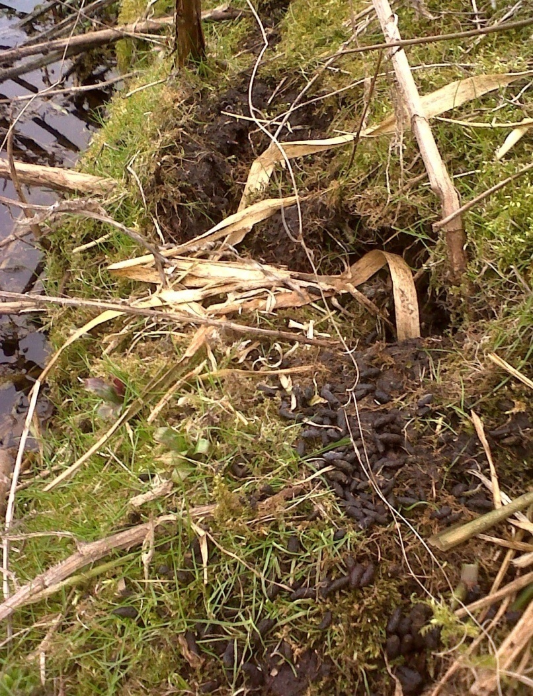
Water Vole latrine by burrow entrance at Thames Road Wetland, Barnes Cray.

Harvest Mouse - Micromys minutus (N) – This is Britain’s smallest rodent, and a BAP species because it is thought to have become much scarcer in recent years, and there are captive breeding and re-introduction schemes being carried out. Distribution is not well known. Its climbing habit means it is rarely caught in traditional on-the-ground live traps for small mammals. The Mammal Society was therefore running a nest recording operation in 2013 and 2014. They may have been widespread in Bexley when it was still a largely agricultural area, and before anyone bothered to keep details of such things.
GiGL has a single record from Crayford Marshes near Erith yacht club, made in 2007.
Site Manager Chris Rose quite accidentally found a Harvest Mouse nest at Thames Road Wetland on 10th June 2014, which consituted the first record of this species here. The nest was about 8 cm in diameter, which could mean it was a breeding nest and not a shelter nest, although it was fairly low down despite the taller vegetation favoured for breeding structures being available all around. The nest did not appear to be in use, which is just as well since it was only spotted in the midst of re-cutting a pathway along a ditch. Breeding nests are in any case only used once. 2 more nests were found quite a distance away on 17th August and another 4 on 29th August. It is likely that if a proper search had been conducted, more could have been located. It seems unlikely that nests would have been missed in the past, given the management regime and intimate observation of the locations concerned since 2010 – but perhaps the animals had been present for a year or two at such low levels that the occasional nest was overlooked. It could be that the increasing density of suitable plants, including Common Reed and Sedges (Reedmace appears an unsuitable medium for weaving the nests into), had led to colonisation off the neighbouring Stanham farm, or from Crayford and/or Dartford Marshes via the adjacent railway embankment.
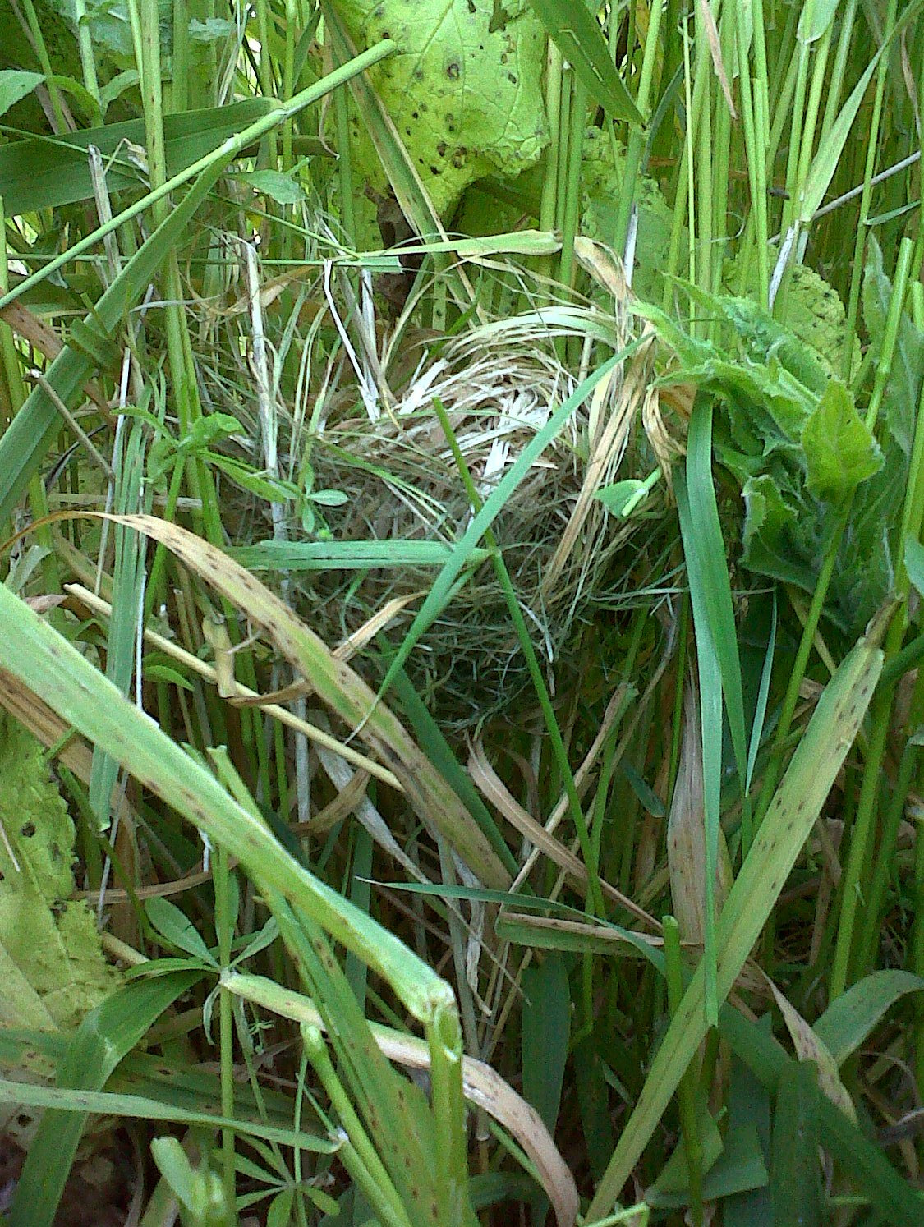
The first Harvest Mouse nest found at Thames Road Wetland, Barnes Cray, June 2014. The nest was not noticed until the stems it was woven into had been cut as part of path maintenance work. This was only the second known record of the species for Bexley. Several more nests were subsequently found on the site that year.

Remains identified by a student as being from Harvest Mice were reported to have been found in Barn Owl pellets at Crossness dating from 4th April and 23rd December 2005, and in four pellets collected on 2nd January 2006. In the wake of theThames Road Wetland finds, Harvest Mouse nest hunts were conducted at Crossness on 12th (‘northern’ marsh and Protected Area) and 26th November 2014 (southern marsh), but these failed to find unequivocal evidence that the species was present either on the northern part of the site, or southern marsh. Both had an example of what looked like it could possibly have been a disintegrated nest in a stand of Bramble, but the that fact no definite nests were found despite extensive searching by teams of several people, suggest that the species is not present, although there is much apparently suitable habitat. Furthermore, various reedbeds have been managed on a rotational basis for some time, and there have been no reports of nests being found during cutting or raking up of the material. Unfortunately the Crossness Owl pellet remains said to have been of Harvest Mice are not available for re-examination.
Dormouse, Hazel - Muscardinus avellanarius (N) – No known records . I stumbled across a report in the online 'Bexley Times' in late 2013 that suggested there might be Dormice in Joydens Wood in Bexley. I followed this up with Site Manager Simon Bateman. He said ‘I think Bexley [Times] has taken this [press release] and used the only Woodland Trust wood in their area, Joyden's, and said it has Dormice. Although there's a good chance that the wood does have dormice, I'm afraid we have no evidence to support this.’
Edible Dormouse - Glis glis (I) - Not recorded in Bexley.
Brown/Common Rat - Rattus norvegicus (I) Brown rats arrived in the UK 1730 from the Baltic, having originated in China and soon displaced the Black Rat. Probably widespread in Bexley. Liable to be seen in the built up area, and in broad daylight in many open spaces across the Borough. Marriott (1925) said the species was ‘not uncommon’ at Lesnes ‘near the farm.’ Prolific in Bursted Woods (despite now-abandoned attempts at control using poison bait). Seen along waterways – one was seen swimming underwater in Willersley Park, Blackfen, which they are not supposed to do! Anyone who enjoys watching Rats will get good views of fairly ‘tame’ animals around the bog garden in Danson Park, which feast on the leftovers from people feeding the ducks. One can sometimes hear ill-informed passers-by exclaiming ‘Ooh, look at that Water Vole ....’. There are records from the last two years of actual predation by a Weasel in Bursted Woods, and attempted predation by one at Crossness.

Black/Ship Rat (Rattus rattus) (I) - No current records in Bexley. Perhaps occurred in the past. The Black Rat, also known as the ship rat, is originally from India, arriving here with the Romans 2,000 years ago in ships and crates of cargo. Conventional history states that fleas on black rats brought the plague to Europe in the Middle Ages, when they came with the last Crusaders returning from the Holy Land in 1348. The Black Death killed three million people in England - over half the population at that time. DNA analysis of bacteria from London plague victims, combined with information about the rate of spread of the disease has cast doubt on the Rat flea explantion, however, with airborne human-to-human transmission now thought more likely by some academics. There are also a number of other competing theories. By the Second World War it was still fairly common in London, a few inland towns and all our main ports; in the early 1950s a survey recorded it at 48 localities. From then until the mid-1980s, numbers fell, according to Dr Graham Twigg, an expert on the Black Rat and plague based at Royal Holloway and Bedford New Colleges in London. Black Rats are now scarce in Britain, confined mainly to ports or coastal towns where they forage in disused buildings and warehouses, with an estimated population of around 1,300 animals. It has been found at Tilbury in fairly recent times.
Red Squirrel - Sciurus vulgaris (N) - Extinct in Bexley sometime after 1925. According to Marriott (1925), there were ‘A few chiefly in Banks Wood’ (which appears to be that section to the west of New Road). Frazer (1965) says of it that ‘In 1908 this was very common (Baker, 1908) ......’ By 1945, the species had become confined to the eastern half of Kent and along the county's western border (Shorten, 1954), but could still be found in 336 parishes. By 1959 it could only be recorded from four parishes (Lloyd, 1962).’
Grey squirrel - Sciurus carolinensis (I) - Introduced from America in 1876 and released by landowners in England. Marriott (1925) states that ‘The North American grey squirrel, well distributed in some parts of Kent, does not appear to have been recorded outside the metropolitan area nearer to the [Lesnes] woods than Keston’. Now widespread in woodland, parks with trees and domestic gardens across Bexley. Can occur at high densities even in a small wood like Bursted. Less frequent away from areas with sufficient trees. One seen at Crossness April-June 2013 (FoCN 26) was regarded as notable for that reason.
Eurasian beaver - Castor fiber (N) – Not recorded in Bexley in historic times. Beavers were hunted to extinction for their meat, pelts and scent glands. The species was extinct in England and Wales by the 12th Century, but survived in Scotland until the 16th Century. Beavers ‘engineer’ their riverine environment in ways that are considered to help with flood control and that create habitat diversity for other species. In 2009 a small number were released in Argyll, Scotland, under licence. A population has developed in theTay catchment founded on escapees from captivity. A decision on their future is due in 2015. Another breeding group of unknown origin has recently been discovered living on the River Otter in Devon. The Devon Wildlife Trust has campaigned successfully for them to be allowed to remain there. Britain is said to be the last large western European nation state where the species had not been reintroduced.
INSECTIVORA (Insectivores)
Common Shrew - Sorex araneus (N) – Frazer 1965 stated that the species was very common, but that all records referred to north and north west Kent. Remains recorded in 2005, 2006, 2007, 2011 and 2012 Barn Owl pellets from Crossness. Site Manager Karen Sutton (pers comm) reports having seen live specimens of this species here. Marriott (1925) says ‘a few dead specimens seen’ at Lesnes, where Chris Rose has seen a dead unidentified Shrew species, as well as another at Braeburn Park in the past few years. An allotment holder at a Barnehurst site reports having seen Shrews there as well as in his garden. They are probably reasonably widespread still.
Pygmy Shrew - Sorex minutus (N) - Remains recorded in 2005, 2006, 2007 and 2011 Barn Owl pellets from Crossness. Site Manager Karen Sutton (pers comm 2014) reports having seen live specimens of this species here. Frazer 1965 reported only nine records of actual localities for the whole of Kent ‘although these are well dispersed.’
Water Shrew - Neomys fodiens (N) - No records from Bexley. Frazer(1965) said ‘Nine localities recorded, none in east Kent.’ GiGL has a single record from Ruxley Gravel Pits in 2005, which is in the Cray river corridor, but just over the southern border of Bexley in Bromley. A signboard at the Belvedere incinerator (reproduced below) claims that both this species and Great Crested Newt (only found in the far south of Bexley) are likely to colonise a ditch and pool dug by the side of the building. The known distributions of these animals mean that this can be dismissed as cynical greenwash. By 2009 Morris was concerned for the future of the species in London due to it being thinly distributed, and subject to serious habitat loss and fragmentation.
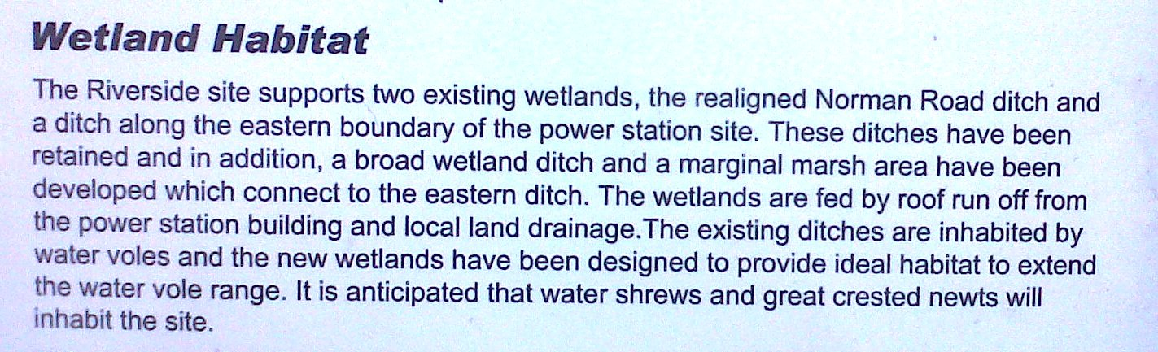

Greater White Toothed Shrew - Crocidura russula (Isl) - Not recorded in Bexley.
Lesser White Toothed Shrew - C. suaveolens (Isl) - Not recorded in Bexley.
Mole, European - Talpa europaea (N) – Marriott (1925) says that the species was ‘common’ at Lesnes, where it is still evident today in the form of molehills out in the wildflower meadow area on the north side of the woods near the Abbey. Molehills can also be seen in numbers at Footscray Meadows. Crossness Nature Reserve Manager Karen Sutton (pers comm 2014) has reported ‘ We also have Mole on site, only recently recorded over the last year or two by way of mole hills.’ In 2014 and 2015 I saw a number of molehills at Crayford Rough.

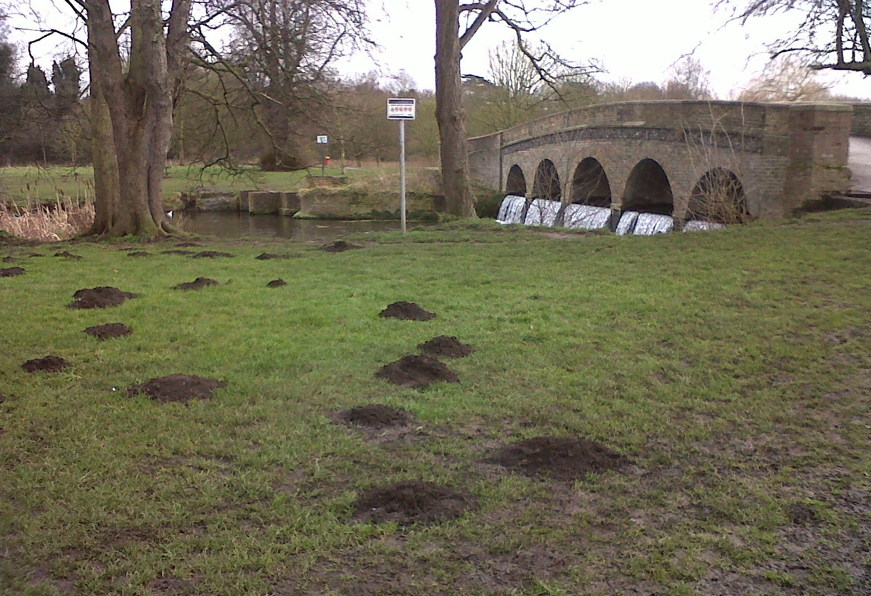
Molehills by Five Arches bridge at Footscray Meadows, February 2014.

Hedgehog, Eurasian - Erinaceus europaeus (N) – Cited by Marriott (1925) as being ‘common’ at Lesnes. Frazer (1965) said ‘Common throughout the county [of Kent], ranging from Woolwich Arsenal to Dungeness.’ That is not the case now. According to the British Trust for ornithology Hedgehogs were estimated to number about 30 million in the 1950s. A recalculation in the 1990s suggested only 1.5 million. Morris (2009) said that his own survey of the species reported in 1966 had found an unbroken distribution throughout much of the south London suburbs, and blamed increased density, smaller gardens, solid fences and large roads for their subsequent decline. A study by researchers at BTO analysed five different long-term data sets (including three bird surveys run by the BTO where volunteers record hedgehogs) and concluded that the proportion of sites with Hedgehogs may have declined as much as 40% between 1996 and 2010. Other studies have also shown a long-term decline.

Urban/suburban areas are important for Hedgehogs, but the BTO in its ‘The state of Britain’s hedgehogs 2011’ report rightly highlights the fact that ‘Gardens have become too tidy, paved over for parking or enclosed within impenetrable fences and walls’, hence the ‘Hedgehog Street’ campaign to try and address these issues: http://www.hedgehogstreet.org/

I have pulled together scattered records from around the Borough for the past 6 years, including a number generated by an appeal for sightings on the Bexley Wildlife Facebook page. There are no records ofthe species in my GiGL dataset to October 2014.

- Carol-Anne Broomfield reports a Hedgehog in her Bexleyheath garden around 2008, eating her cat’s food while the cat stood back and watched.
- In 2013 I was told by a resident that they had found a dead Hedgehog on their lawn in Grasmere Road in Barnehurst, in 2012, adjacent to the allotment site there, and that a friend of theirs had found a dead one on nearby Coniston Road.
- On 16/5/2013 I found a squashed Hedgehog at the north end of Hailey Road in Belvedere, close to where it joins Eastern Way. But Site Manager Karen Sutton (pers comm 5/1/15) says that as far as she knows none have been recorded at nearby Crossness going back to 2006.
- Mandy Stevens said early in 2014 that there are good numbers at Woodlands Farm.
- On 24/7/2014 I found a live Hedgehog on the grass verge at the bottom of Gravel Hill quite late at night. It seem disinclined to roll up properly or move, so I eased it into a plastic bag caught in a nearby hedge and moved it to a scrubby area in the middle of the adjacent Hall Place North. Despite waiting for some time, it did not move at all. I went back on 28/7 and there was no sign of it.
- On 16/8/2014 Council Parks, Open Spaces and Nature Conservation Officer Mark Taylor said he had seen one on Chapel Lane by Shenstone Park ‘a couple of times recently’.
- Kim Ilsey provided me with a photograph taken by her son of a Hedgehog he saw in Cherbury Close, Thamesmead, at 2 a.m. in the summer of 2014, close to Thamesview Golf Centre, which is a large adjoining open space.
-Adriana Rudkin reported on 31/12/2014 that ‘If you walk through Southmere about 2am or the park behind Poplar Place (which lies along the Bexley border with Greenwich in Thamesmead) you always see hedgehogs.’
- Dina Phillips wrote on 31/12/2014 that she ‘saw one near Longmead Road, Sidcup/Albany Park at 3a.m., roughly at the beginning of November’.
- I was shown a photograph of a Hedgehog on the grass by the north edge of Bursted Woods, time-stamped 21.10, 7/4/2015, by a dog-walker with whom I had got into conversation about local wildlife. He had been alerted by the fact that his small dogs had located and were snuffling around the animal.
- One was recorded in a garden on Star Hill, Crayford, DA1 4DB, by John Arnold on 24/4/2015.
- A photograph of one at the foot of a tree in Manor Rd Sidcup, taken by one of her friends at 11 p.m. on 28/7/2015, was posted to the Bexley Wildlfe facebook page by Wren Rose.
- Janet Metcalfe saw and photographed one in Old farm Park, Sidcup, on 11/8/2015, and also posted the photograph on the Bexley Wildlife Facebook page.

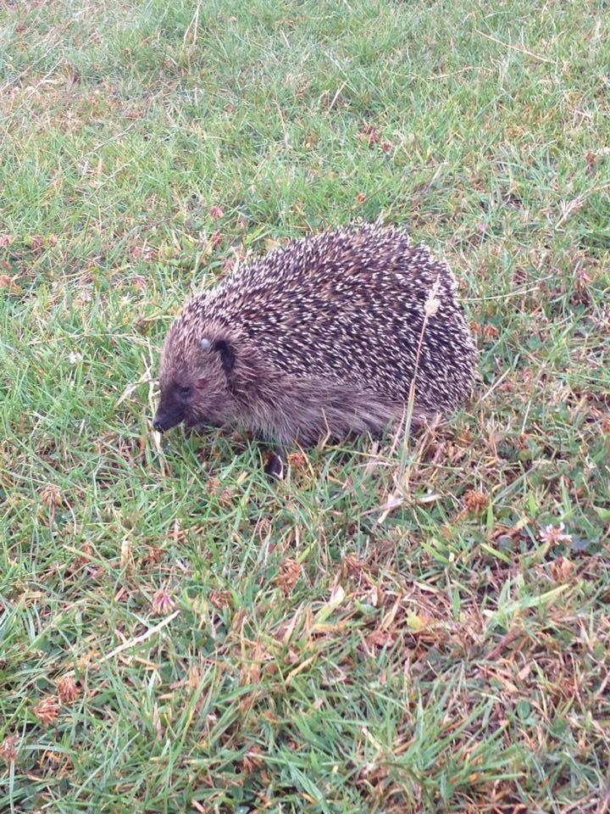
Hedgehog at Old Farm Park, Sidcup, August 11th 2015. Photo by Janet Metcalfe.

An amphibian and reptile survey of allotment sites has also turned up a number of records:

- A Radnor Avenue allotments tenant, one street away from the Danson Park boundary, said in 2012 that Hedgehogs had been seen in the past ‘but not for a while’.
- The Burnell Avenue site in Welling is said to have had one or more Hedgehogs in around 2008 or 2009.
- It was reported to me in 2012 that a Hedgehog had been seen walking along a path at South Road allotment site in Slade Green. I found a recently deceased one in the nearby ‘Dell’ in that year.
- Plotholders at the Old Farm allotments by the railway in Sidcup told me in 2013 that an adult and juvenile had got stuck in netting in 2012 and had been released alive.
- Both Monks Farm (2013 and 2014) and Rosemary Road sites have reported Hedgehogs in recent years. Both border East Wickham Open Space.

LAGOMORPHA (Rabbits and Hares)
Rabbit - Oryctolagus cuniculus (I) Believed to have died out in Britain during glaciations. 2,000 year old Rabbit remains from the excavation of a Roman site in Norfolk had been butchered. Some think the species was present on offshore islands from the 1100s, with definite mainland remains from about 1235. It is not surprising that Rabbits are restricted to the eastern edge of the Borough, where there are connections to the wider countryside. They occur in the in the Cray valley at Stanham Farm, Thames Road Wetland and By-way 105 by the lower Cray, also at Braeburn Park. An allotment holder at the Knoll Road site near Footscray Meadows has reported seeing them there, and they are said to occur in both the Bexley and Dartford parts of Joydens wood by conservation volunteers at that site. Marriott (1925) described them as ‘Fairly plentiful at times’ at Lesnes, but they are long gone here and do not occur out on Erith Marshes either. GiGL has a 2003 record from the Queen Mary’s Hospital area.
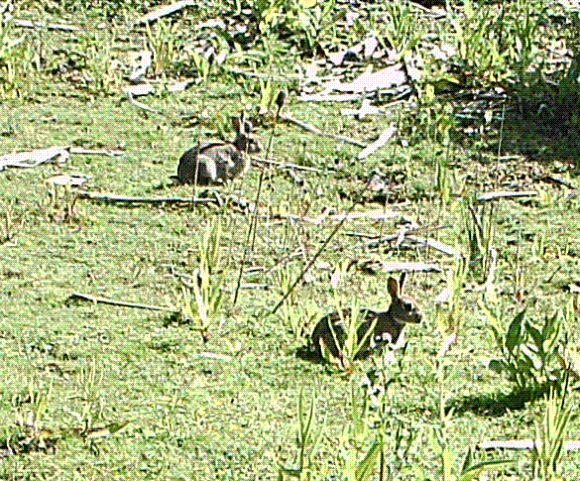

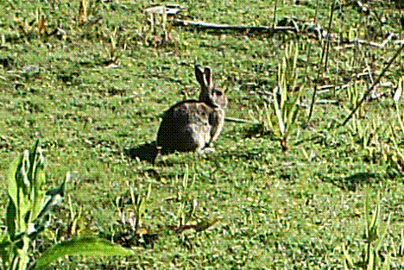

Rabbits at Thames Road Wetland, Barnes Cray, photographed with a motion sensor camera trap.

Brown Hare - Lepus europaeus (I) Extinct in Bexley sometime after 1925. The Brown Hare evolved in continental Europe, but probably did not radiate northwards before Britain was cut off from the mainland by the formation of the English Channel. If that was so, then the Mountain Hare is our only native Hare species. The Brown Hare was possibly introduced by the Romans around 2,000 BP, or by an earlier civilisation – though according to Natural England there are no actual records of it before Norman times, despite it being a food animal. At any rate, it is now considered sufficiently British to be a UK BAP species, given that recent surveys show the Brown Hare has declined by more than 80% during the past 100 years and the decline is ongoing.
The reasons for this decline are not entirely clear, but intensification of agriculture has certainly been a major factor. See: http://www.hare-preservation-trust.co.uk/history.php According to Marriott (1925) ‘One or two were noted in autumn’ at Lesnes, but they have long since been lost to the tideof suburbanisation, and there are no records from anywhere else in the Borough since.
Mountain Hare - Lepus timidus (N) - Not recorded in Bexley.
Irish Hare - Lepus timidus hibernicus (N) - Not recorded in Bexley.

CARNIVORA (Carnivores)
Fox - Vulpes vulpes (N) - Widespread, even ubiquitous, including throughout the built-up area of the Borough, as well as in semi-natural open spaces. Often habituated to people and can frequently be seen in daylight, especially in winter. If not seen, then the high-pitched mating season scream of the vixen can be heard at night from December to February, and at other times the distinctive vocalisations of fighting individuals. Colonisation of cities is a fairly recent phenomenon, beginning in London in the 1940s and being completed by the 1960s, helped by the Foxs’ ability to survive on a catholic diet. Despite their numbers, the life expectancy of urban Foxes is only 12-18 months, with road traffic a significant contributor to the high early mortality. In Bristol and London, about half of the population is one year of age and only about 3% is older than five years. The following website has a wealth of interesting and academically-verified facts about Foxes, presented in layperson’s terms: http://www.thefoxwebsite.net/
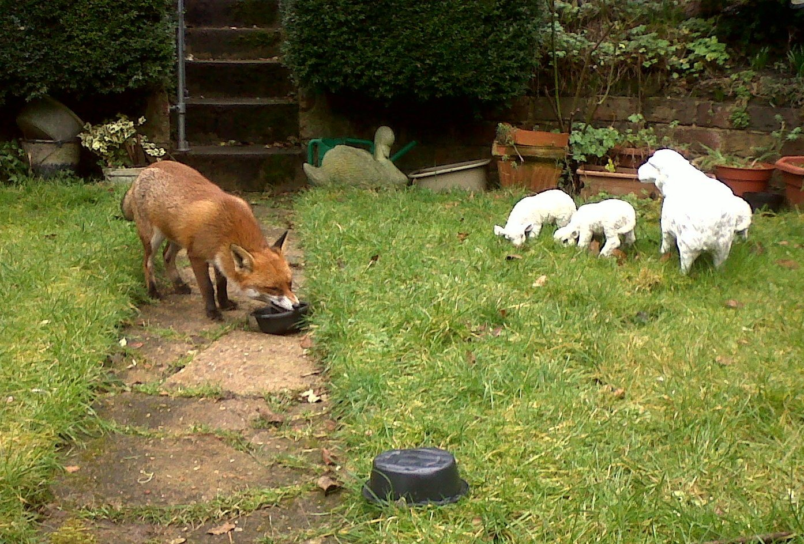
This fox in a Barnehurst garden is more interested in real food scraps that the fake sheep on the lawn.

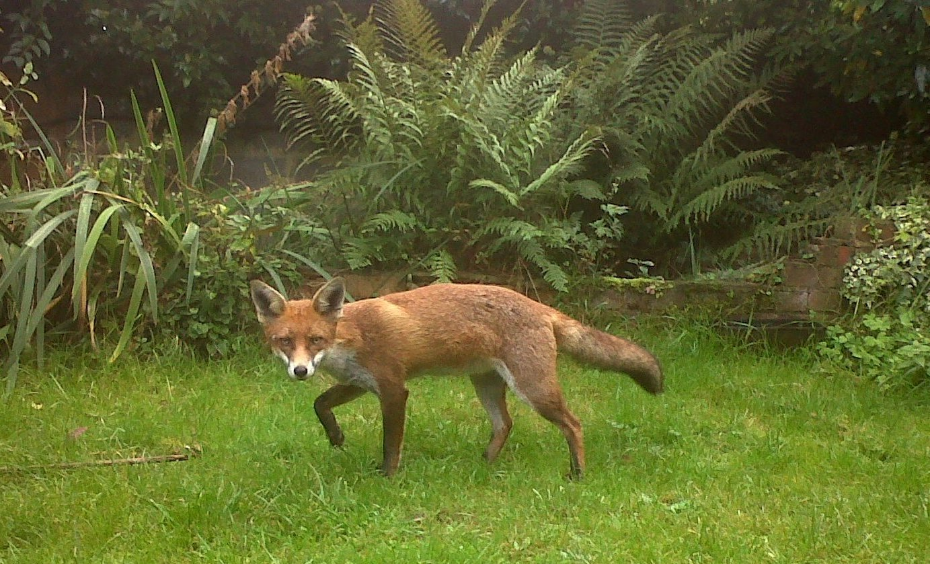

Scottish Wildcat - Felis silvestris (N) - Not recorded in Bexley in historic times. Now confined to the Scottish highlands, Wildcats disappeared from southern England in the 16th century. The last one recorded in northern England was shot in 1849. Hybridisation with domestic/feral cats is a threat to the few remaining true Wildcats.
Feral Cat - Felis catus (F) – The Cat is not recorded in Bexley except as a domestic pet. Despite the number of notices one sees affixed to lamp-posts around Bexley appealing for information about lost Cats, there does not seem to be a feral (semi/’wild’ breeding) population at large in the Borough.
Badger - Meles meles (N) – The species is known to occur in Bexley, but because of the threat of persecution and the fact that this is a publicly accessible document, no details will be given here. Marriott (1925) does not mention Badgers in his treatise on the natural history of Lesnes.
Otter - Lutra lutra (N) - Not recorded in Bexley in historic times. Not currently present. Could one day return? In the early 1960s the species was on the verge of extinction due to toxic pesticide pollution, habitat loss and hunting. With full legal protection, cleaner rivers and managed habitat the Otter has returned to every county in England, with Kent being the last to be recolonised by 2011. Mark Gallant of the North West Kent Countryside Partership has mentioned the fact that Otter has re-appeared on the Darent, but according to the restoration plan at http://gtgkm.org.uk/documents/river-darent-restoration-strategy-1303999189.pdf the overall habitat is unfavourable and there have only been individuals passing through. None have been seen around the confluence with the Cray. Eels are a favoured food, and the VitBe Mill sluice and other blockages up the Cray remain a barrier to re-colonisation by both this species and Trout.
Pine marten - Martes martes (N) - Not recorded in Bexley in historic times. The Vincent Wildlife Trust says ‘It has been suggested that 6,500 years ago, when Britain and Ireland had greater tree cover, Pine Martens were the second most common carnivore in Britain! The clearance of our woodlands, trapping and persecution had a devastating effect on the Pine Marten across Britain and Ireland and by 1915 was found in just a few of the last remaining more remote areas.’ Frazer (1965) says ‘As long ago as 1809, Pocock recorded it as "uncommon and seldom seen" [in Kent]. It may have survived up to a century ago, but is now certainly extinct in the county.’ Today, according to the Mammal Society, ‘Pine Martens are found in the Scottish Highlands and Grampians, with isolated populations in southern Scotland. In England and North Wales Pine Martens seem to be on the verge of extinction. Moves are afoot to bolster these populations. They are widespread and relatively common in Ireland. Although they occur in a wide range of habitats, Pine Martens prefer well-wooded areas with plenty of cover.’ Required territory size is large, for ‘males these are about 10-25 square kilometres (at least 6 times the size of Lesnes Abbey and Bostall Woods combined, or 13 times that part of Joydens Wood within Bexley plus Chalk Wood combined) and for females about 5-15 square kilometres.’
American mink - Neovison vison (I) - Not present in Bexley at this time. First imported to fur farms in Britain from Canada and Alaska in 1929. Because of its highly damaging impact through predation on protected Water Voles, Mink rafts have been deployed along the River Cray (but with no evidence of Mink this no longer happens), and are still set out on ditches at Crossness on Erith Marshes. Concerns were heightened when one was photographed at Thamesmere East Lake in January 2012: http://www.bexleytimes.co.uk/news/minks_and_rarely_seen_ducks_spotted_in_thamesmead_1_1195984 , as although over the border in Greenwich, this was uncomfortably close to Erith Marshes. Nothing more was seen of the animal subsequently.
Polecat - Mustela putorius (N) – Extinct in Bexley, probably before the 1920s (it seems reasonable to conclude it did once occur here). According to Frazer (1965), commenting on status in Kent, it was ‘Now extinct, but formerly plentiful, although rare by the 1870s, when one was trapped at Chattenden (Baker, 1908). Formerly found at Bromley (Tutt, 1909).’ Marriott (1925) reports that a skull was found in a Denehole at Lesnes in 1907-8. Polecats were once widespread and common throughout mainland Britain. Relentless persecution by gamekeepers up until the late 1930s resulted in extermination everywhere except for a small population in north Wales. They have since recovered and are now found throughout rural Wales, the Border counties and are spreading across the Midlands, South and into the South-East.
​Feral Ferret - Mustela furo (or Mustela putorius furo) (F) – Not known to be present in Bexley at this time. The Ferret is the domesticated form of the European Polecat. There may be occasional escapes within the Borough, but I am not aware of any reports. I was witness to the fact that a couple of youths had released a Ferret down some Rabbit burrows adjacent to Thames Road Wetland a couple of years ago, and by nightfall it had not reappeared. They said they’d lost a Ferret overnight before but had recaptured it the next day.
Stoat - Mustela erminea (N) Extinct in Bexley sometime after 1925. Their primary food source is the Rabbit, despite being many times its own weight, supplemented with small rodents and birds. Marriott (1925) stated that ‘Stoats leave plenty of evidence of their presence in the (Lesnes) woods.’, classing them as ‘Not uncommon’ and ‘nest with young noted.’ At that time Rabbits were described as still fairly plentiful in the area. Indeed the number of Stoats in the wild is usually linked to the Rabbit population. Consequently it is not surprising that there is now a lack of confirmed sightings of this species, with a couple of claims from within Bexley in recent times almost certainly being attributable to brief glimpses of Weasels . Numbers are said to have declined across the country, with persecution by gamekeepers in more rural areas, but it is thought likely that they are now being more seriously affected through eating poisoned rats or mice.
Weasel - Mustela nivalis (N) Crossness is the undoubted Weasel hotspot in the borough as far as sightings are concerned. FoCNR Newsletter 26 contains a photograph of a Weasel on the Thames path by Mike Robinson, and reports two sightings in the period April-June 2013. FoCNR Newsletter 27 reports the Weasel seen by Richard Spink in March 2014, and reproduces his photographs of the animal launching an unsuccessful attack on a Brown Rat. Newsletter 28 says there was a further sighting in the period April-June 2014, and another between July and september 2014. Chris Rose saw one dragging a dead Brown Rat in Bursted Woods on April 19th 2013. It probably got there via the adjacent ‘wildlife corridor’ more commonly known as the Bexleyheath railway line. Brian Riches saw a Weasel swim across the river at Foots Cray Meadows in February or March 2013. Wren Rose saw one there in 2014. There is a report of one from the adjacent Stable Meadows allotment site in autumn 2014. Claire Black reported seeing what was almost certainly a Weasel at Hall Place in mid August 2014. She said 'It was chestnut brown with a white underside but small only about 8-9" in length. I was stood looking at fish on the right hand side of the bridge in the middle of Hall Place facing up river and it climbed out of the plants on the bank to my right onto a flat piece of concrete. It popped in and out once or twice and then stopped and looked at me and then scampered across the path leading onto the bridge ...." . Jonathan Rooks has also seen a Weasel at this site. Nigel O’Nions reported seeing one on the Love Lane allotment site by the River Shuttle in Old Bexley in late April or at the beginning of May 2015. John Holland has reported that he had one in a hole in his rockery when he lived adjacent to Crayford Marshes a number of years ago.
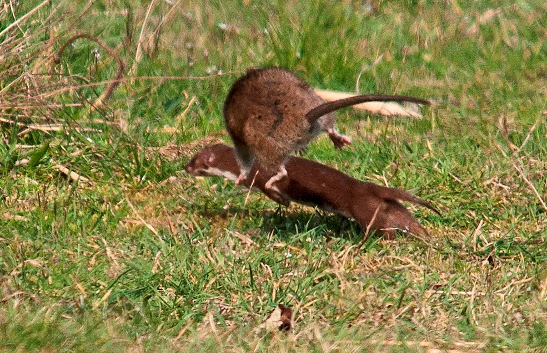

Weasel beating a hasty retreat from a failed attack on a Brown Rat, Crossness, March 2014. Photo: Richard Spink.

CHIROPTERA (Bats)

Good sites to view Bats include Barnehurst Golf Club, Bexley Woods, Bursted Woods, Franks Park and Martens Grove. Bats can also be heard in numbers with detectors at Crossness. Hannah Forshaw, Education Officer at Woodlands Farm reported that 2014 would be the 3rd time the Farm has participated in the Bat Conservation Trust survey. From the data they have sent in previous years, a comparison with 172 other sites in the South East taking part in the survey has shown that Woodlands Farm was 85th best for Common Pipistrelle, 55th for Soprano Pipistrelle and 52nd for Noctule.

Native:
Alcathoe Bat - Myotis alcathoe – No records from Bexley. The Alcathoe bat is relatively new to science being first identified in 2001. It is thought that the Alcathoe Bat has been in the UK for generations but was only identified here in 2003 due to its similaritly to 2 other native bat species; Whiskered and Brandt's bats. http://www.leeds.ac.uk/news/article/786/bat_species_discovered_for_the_first_time_in_uk
Barbastelle - Barbastella barbastellus –May conceivably have occurred in Bexley. Extinct here if so, and not recorded. Interestingly, in Frazer (1965)it is stated that ‘the first specimen recorded in England was from Dartford (Lydekker, 1895). Records from North Kent only.’ According to the Bat Conservation Trust the species is (now) very rare and not recorded from London or Kent.
Bechstein's Bat - Myotis bechsteinii - May have occurred in Bexley in the past. Extinct here if so, and not recorded. The Bat Conservation Trust says that the species’ is very rare, found in southern Wales and parts of southern England’, with only one occupied area in Kent and none in London. ‘The UK is at the nothernmost edge of its distribution range. The Bechstein’s bat has gone from being one of the commonest UK species after the last ice age to one of the rarest, due largely to the destruction of ancient woodland that once covered the UK.’
Brandt's Bat - Myotis brandtii – Not recorded in Bexley. Scattered distribution across England and Wales.
Daubenton's Bat - Myotis daubentonii – One or two recorded by LWT in Bexley Woods in July 2010. Site Manager Karen Sutton (pers comm 5/1/15) says that the species has been recorded at Crossness. The LWT SINC Review 2013 says Daubenton’s Bats have been found at Barnehurst Golf Course. GiGL has the following London Bat Group records: a 1997 record from Chalk Wood, a 2000 record from around Rose Bruford College at Lamorbey, a 2010 record from Danson Park and records up to 2009 at Footscray Meadows/North Cray Woods,
Greater Horseshoe Bat - Rhinolophus ferrumequinum – Extinct in Bexley if it ever occurred here. According to Frazer (1965) the last records from Kent were already 50 years old. UK population estimated at somewhere over 6,600 in 2005. Distribution in 2013 confined to Wales, the southern west midlands, the west country and no further east than a few outliers in central southern England.
Lesser Horseshoe Bat - Rhinolophus hipposideros – Not recorded in Bexley. The Bat Conservation Trust factsheet states that ‘This species has shown a marked decline in numbers and distribution,although there is evidence of a recent increase in Wales. The Lesser Horseshoe bat is rare in the British Isles and is confined to Wales, western England and western Ireland. ‘
Leisler's Bat (Lesser Noctule) - Nyctalus leisleri – Frazer (1965) says that it had been recorded at Abbey Wood (as well as Chislehurst). The Bat Conservation Trust factsheet notes that Leisler’s Bat is found throughout the British Isles, with the exception of northern Scotland. Ireland is a stronghold; ..... (but) ... ‘In view of its rarity in Britain all known roosts are important and special care should be taken of roosts in buildings and of wooded areas where the species is known to occur.
Bat boxes have been successful in encouraging the species in some areas.’ GiGL has London Bat Group records of this species from Franks Park in 2002 and near Southmere Lake in 2008.
Long-eared Bat, Brown - Plecotus auritus – LWT recorded a handful (or in some cases a Myotis species) in Bexley Woods in July, and 2 or 3 in August 2010. GiGL has London Bat Group records from 1986 and 1987 from Footscray Meadows, a 2000 record from near the adjacent Loring Hall, and records from 1997 through to 2006 from Chalk Wood. Also a single record by ‘Ecology Solutions Ltd’ at Erith Quarry in 2014.
Long-eared Bat, Grey - Plecotus austriacus – Not recorded in Bexley. The Bat Conservation Trust factsheet for this species states that ‘The grey long-eared bat is a southern European species, with a distribution extending from the northern Mediterranean coast in the south to southwest England and the Black Sea coast in the north .... In England [it is] restricted to a few colonies in Sussex, Hampshire, the Isle of Wight,Dorset, Devon and Somerset.
Nathusius' Pipistrelle - Pipistrellus nathusii - LWT (2010) recorded one possible member of this species in Bexley Woods in August 2010. GiGL has a 1998 London Bat Group record of the species from Lesnes Abbey Wood. A previous migrant species, it has only been classed as a resident species since 1997.
Natterer's Bat - Myotis nattereri –GiGL has a number of London Bat Group records for the species at Chalk Wood between 1997 and 2009. Natterer’s bats are found throughout most of the British Isles. Generally it is a scarce and poorly known species. The UK population of Natterer’s bats is of international importance.
Noctule - Nyctalus noctula - Marriott (1925) ascribes all Bats seen that were bigger than Pipistelles as ‘probably belong(ing) to this species.’ The LWT survey in Bexley Woods recorded what appears to have been just one individual in July and between 1 and 3 in August 2010. Site Manager Karen Sutton (pers comm 5/1/15) says that the species has been recorded at Crossness. Present at Woodlands Farm according to Hannah Forshaw, Education Officer (perscomm 2014). GiGL has a number of London Bat Group records for the species, the most recent for each site being as follows: Sidcup Golf Course/Lamorbey Lake 1990, Danson Park 2001, East Wickham Open Space 2001, Franks Park 2002, Lesnes Abbey Woods 2007, Southmere Park and Lake 2008. Recorded by ‘Ecology Solutions Ltd’ at Erith Quarry in 2014.
Pipistrelle, Common - Pipistrellus pipistrellus – Marriott (1925) lists this species as ‘common’ at Lesnes, though at that time it was not understood that there were 3 Pipistrelle species. LWT (2010) recorded what were probably several different individuals in Bexley Woods in July and August 2010. Has been recorded at Crossness according to Site Manager Karen Sutton (pers comm 5/1/15). Present at Woodlands Farm according to Hannah Forshaw, Education Officer (perscomm 2014). GiGL has a number of 2013 records from different parts of this site. Recorded by ‘Ecology Solutions Ltd’ at Erith Quarry in 2014.
Pipistrelle, Soprano - Pipistrellus pygmaeus- LWT (2010) recorded what were probably a number of different individuals in Bexley Woods in July and August 2010. Site Manager Karen Sutton (pers comm 5/1/15) says that the species has been recorded at Crossness. Present at Woodlands Farm according to Hannah Forshaw, Education Officer (pers comm 2014). Recorded by ‘Ecology Solutions Ltd’ at Erith Quarry in 2014.
Serotine - Eptesicus serotinus – LWT (2010) noted one possible individual in the August evening survey. Has been recorded at Crossness according to Site Manager Karen Sutton (pers comm 5/1/15).
Whiskered Bat - Myotis mystacinus – Not recorded in Bexley. The national distribution map suggests it could turn up in Bexley. GiGL holds no records of it here.
Vagrants
Greater Mouse-eared Bat - Myotis myotis - Not recorded in Bexley. Did occur in the UK, with the last known colony disappering in 1985, possibly due to a fire. A female was found in 2001 but died, and a male was found hibernating in Sussex in 2002 and was still doing so in 2010.
Kuhl’s Pipistrelle – Pipistrellus kuhlii - Not recorded in Bexley. Listed by the Bat Conservation Trust as having been found in the British Isles more than 10 times since it first turned up in 1991. A southern European species that has undergone a northwards range expansion.
Parti-coloured Bat - Vespertilio murinus- Not recorded in Bexley. Appears to be the most frequent vagrant with 16 known records, one of which was near Brick Lane in London, according to the Bat Conservation Trust’s Rarities and Vagrants factsheet.
Northern Bat - Eptesicus nilssoni - Not recorded in Bexley. http://en.wikipedia.org/wiki/Northern_bat ‘It is widespread throughout Eurasia, and is the most common bat in northern part of the continent. It is found from northern Scandinavia (beyond the Arctic Circle) to northern Italy [and across to] northern Japan.’ It is said to differ little genetically from the Serotine.
Hoary Bat - Lasiurus cinereus - Not recorded in Bexley. A north American species known to travel long distances.
The others species on the Bat Conservation Trust, but not the British Mammal Society’s, vagrant list are:
Northern Bat - Eptescicus nilssoni
Notch-eared Bat - Myotis emarginatus
Pond Bat - Myotis dasycneme
Savi’s Pipistrelle - Hypsugo savii

None of these have been recorded in Bexley.

ARTIODACTYLA (even toed ungulates)
Wild Boar - Sus scrofa (N) - Not recorded in Bexley in historic times. A few pigs of a couple of domestic breeds can be seen at Woodlands Farm.
Chinese Water Deer - Hydropotes inermis (I) - Not recorded in Bexley. According to the British Deer Society ‘Chinese water deer were first kept at London Zoo in 1873 but escaped from Whipsnade Zoo after introduction there in 1929, and later from other sites ..... Currently restricted to Bedfordshire, Cambridgeshire and Norfolk with a few scattered sightings elsewhere ....... IUCN Red Data Book listed as "lower risk, near threatened" in China. The British numbers are thought to account for 10% of the world's population.’
Reeves' Muntjac - Muntiacus reevesi (I) Chris Smith of the Friends of the Shutle team has provided a credible record of this species in the Borough. He said ‘I saw the animal in Willersley Park on April 8th. He says 'When it saw me it jumped across the river towards me. I was only about 20 yards from it. As I was standing still I can only assume it had'nt seen me until it got quite close. When it saw me it ran towards the kid's playground and out of my sight going towards the Marlborough Park exit. I quickly ran down to see if I could see it but it was gone. It may have gone into the Hollies or carried on down the river to Marlborough Park. It was 6.30 in the morning. I saw my neighbour who was walking his dog and asked if he had seen it. He said he had but was not sure what it was.' In September 2015 ‘Bexley Wildlife’ received a recently taken photograph of a deer in the Goldie Leigh hospital grounds, just over the border from Bexley. This in turn gives some credence to a claim made that a deer had been seen in nearby Lesnes Abbey Woods in 2014.
Sika - Cervus nippon (I) - Not recorded in Bexley.
Red deer - Cervus elaphus (N) - Not recorded in Bexley in historic times.
Roe deer - Capreolus capreolus (N) - Not recorded in Bexley in historic times.
Fallow deer - Dama dama (N) - Not recorded in Bexley.
Reindeer - Rangifer tarandus (N / current population domesticated from Sweden) Not recorded in Bexley in historic times.
Feral goat - Capra aegagrus hircus (F) - Not recorded in Bexley.
Feral Sheep - Ovis aries (F) - Not recorded in Bexley. Domestic breeds of Sheep can be seen at Woodlands farm on Shooters Hill (though I am not clear whether they are ever pastured in the fields on the Bexley side of the border with Greenwich, which cuts through the farm), and on Stanham Farm in Crayford, though just over the Bexley border on the Kent side of the Stanham River.
Cattle - Bos primigenius (domesticated) - Domestic breeds of cattle can be seen at Woodlands Farm, which straddles the Greenwich/Bexley border, and at Stanham Farm – but on Kent side of the border which follows the Stanham River. The last recorded live Auroch, the larger progenitor of today’s domestic cattle, which was once widespread across Europe (including the UK), India and North Africa, died in 1627 in the Jaktorów Forest, Poland, from natural causes, after hunting had gradually wiped the species out everywhere else. It died out in the UK in the Iron Age. Various attempts have been, and are being made to ‘re-create’ the species from selected, more ‘primitive’, breeds of cattle, with a particular view to use in re-wilding programmes: http://www.rewildingeurope.com/publications/the-aurochs-born-to-be-wild/

PERRISODACTYLA (odd toed ungulates)

Feral horse (Exmoor / Dartmoor pony) - Equus ferus caballus (managed) – Not strictly recorded in Bexley. The nearest we have to ‘wild’ horses in the Borough are the traveller’s ponies that roam the uncultivated part of Stanham Farm from Maiden Lane down to the Dartford-Slade Green railway line and onto the eastern end of Thames Road Wetland, at which latter location they perform the useful function ofeating Reedmace in winter and poaching the ground at the water’s margin, providing an ideal seed-bed for Brookweed, which is a very rare plant in London. Those on Crayford Marshes also look relatively natural. The fairly intense grazing at Erith Marshes (Crossness/Southern Marsh), on the other hand, simply gives the appearance of horses in a farm field. Breeds such as Konik Ponies are now being used for conservation grazing purposes and re-wilding schemes in the UK and on the continent.

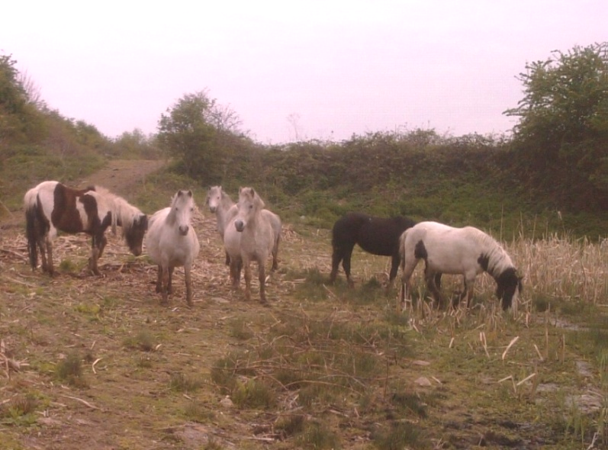
These relatively free-roaming Horses seen
at Thames Road Wetland perform a useful ‘conservation grazing’ function.

MARSUPIAL

Red-necked wallaby - Macropus rufogriseus (I) - Not recorded in Bexley.

PINNIPEDIA (Seals)

Native

Frazer (1965) comments that ‘while seals are generally uncommon, they have been noted from the Thames and Medway.’ The number and spread of seals has clearly increased in the last 50 years.
Common seal (Phoca vitulina) (N) John Bramley of Kent Mammal Group in a talk on 22nd March 2013 (reported in FoCNR Newsletter 25) stated that it was ’not too uncommon to see Common Seals in the River Thames at Crossness.’
The Bexley Times of May 20th 2014 reported a Seal supposedly stuck in the thames mud in Bexley, publishing a photograph said to be the animal in question, which is a Common Seal. http://www.bexleytimes.co.uk/news/helicopters_called_to_bexley_after_reports_of_seal_stuck_in_the_thames_1_3608279

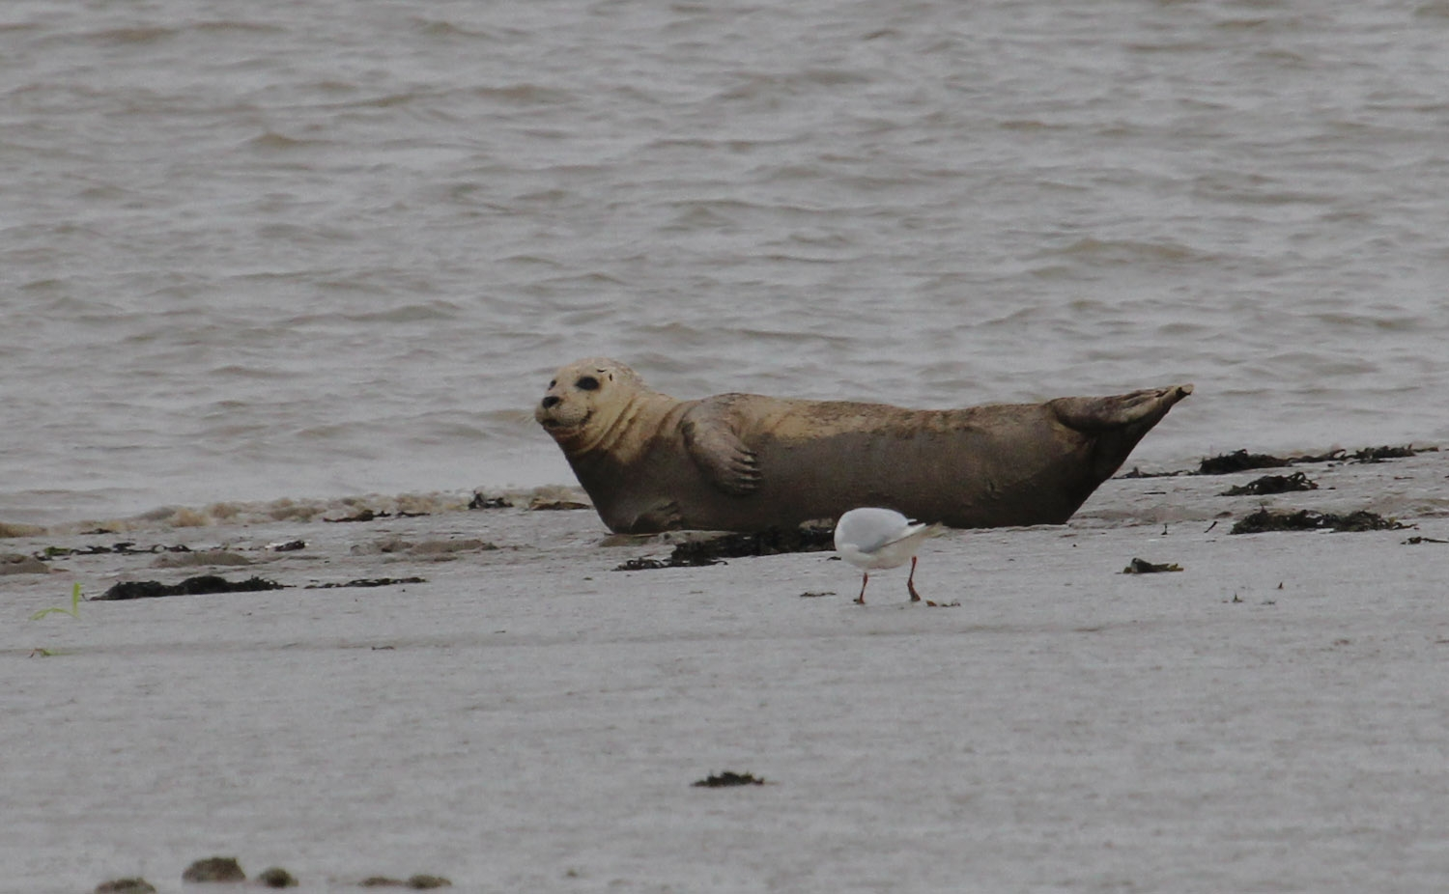
Common Seal at Crayford Ness, 30/7/2015. Photo: Ralph Todd

Grey seal (Halichoerus grypus) (N) John Bramley of Kent Mammal Group in a talk on 22nd March 2013 (reported in FoCN 25) stated that it was ’not too uncommon to see Grey Seals in the River Thames at Crossness.’
The London Bird Club wiki carried a 3rd August 2014 report of a Grey Seal seen off Crossness by former Bexley Council Biodiversity Officer John Archer.
Grey Seal off Crayford Ness. July 2015. Photo: Ralph Todd.
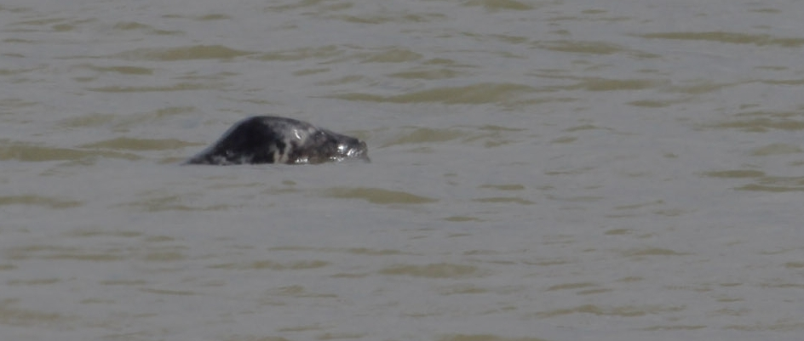

FoCN27 reported a sighting of an unidentified species of Seal off Crossness in July-Sept 2013, and another on a date during Jan-March 2014, for which a photograph by Mike Robinson was published, showing a rear view of the head of what looks like a Common Seal, carrying a large fish in its mouth.
There have been a number of 2014 and 2015 reports of Seals seen around Crossness and Crayford Ness posted to the Bexley Wildlife Facebook page, including one from Steve Carter of 8 Common Seals hauled out onto the mud at the latter location on 3rd September 2015. Whether this represents a real increasein ‘occupancy’ of the Borough’s waters by these species, or is a function of greater observer interest and an on-line facility for instant public reporting cannot yet be determined.
Vagrants
Ringed Seal - Pusa hispida – Not recorded in/off Bexley.
Bearded Seal - Erignathus barbatus – Not recorded in/off Bexley. Has been recorded in Medway and Swale according to John Bramley of Kent Mammal Group in a talk on 22nd March 2013 (reported in FoCNR Newsletter 25)
Hooded Seal - Cystophora cristatus – Not recorded in/off Bexley.
Harp Seal - Pagophilus groenlandicus – Not recorded in/off Bexley.
Walrus - Odobenus rosmarus – Not recorded in/off Bexley.

CETACEA (Whales, dolphins and porpoises including vagrants)

22 species have been recorded in UK waters, of which one is not uncommon off Bexley.
Harbour Porpoise (Phocoena phocoena) John Bramley of Kent Mammal Group in a talk on 22nd March 2013 (reported in FoCN 25) stated that it was ’not too uncommon to see Harbour Porpoises in the River Thames at Crossness.’ Five must have passed Bexley, probably in early December 2013, from the content of this report about the Marine Policing Unit tracking the animals off Lambeth : http://www.theguardian.com/environment/2013/dec/06/five-porpoises-river-thames-sighted One seen off Crossness April-June 2013 (FoCNR Newsletter 26).
Northern Right Whale - Eubalaena glacialis - The Evening Standard of 20th June 2013 in an article about the whales of London:
http://www.standard.co.uk/comment/comment/philip-hoare-the-whales-of-london-8666799.html
reported that the ‘Natural History Museum has confirmed that the whale skeleton found in the mud at Deptford recently was a Right Whale harpooned to death on the river banks in May 1658, an event recorded by the diarist, John Evelyn.’ The unfortunate animal must therefore have passed by what is now the Borough of Bexley.

Minke Whale - Balaenoptera acutorostrata - According to Fraser (1965) ‘In July 1961, a 15 ft. female penetrated as far upriver as Kew, where it stranded.’
Sei Whale - Balaenoptera borealis - Not recorded off Bexley.
Blue Whale - Balaenoptera musculus - Not recorded off Bexley.
Fin whale - Balaenoptera physalis – Fraser (1965) says that ‘In June 1658 a sixty-foot specimen was killed at Greenwich, while in November 1899, a pair of adults were seen in the Thames between the Albert Docks and Barking Creek (Baker, 1908).’

Humpback whale - Megaptera novaeangliae – ‘One went as far up the Thames as Deptford Creek in 1842’ according to Fraser (1965).Rather more recently it’s conceivable that the individual featured in the report below made it to Bexley waters and headed back the other way. We shall never know ....
http://www.telegraph.co.uk/earth/earthnews/6190335/Whale-found-dead-in-Thames.html
4:04PM BST 14 Sep 2009: The 9.5m-long (28ft) juvenile male whale was first spotted in the River Thames on Thursday at Gravesend, but was not seen again until it was found dead on Saturday morning near Dartford Bridge. Initial examination suggests the humpback, the first to have been found in the Thames, may have died of starvation. Scientists from The Zoological Society of London (ZSL), which manages the UK Cetacean Strandings Investigation Programme, said on Monday the beaching of the humpback whale was an ''incredibly unusual event''.
Beluga - Delphinapterus leucas - Not recorded off Bexley.
Sperm Whale - Physeter macrocephalus. Fraser(1965) believed that based on size the 66-foot whale recorded as stranded at the Royal Arsenal, Woolwich, on November 27th 1899 (Tutt, 1909), must have been this species and not a Bottle-nosed Whale as was claimed.
Pygmy Sperm Whale - Kogia breviceps - Not recorded off Bexley.
Cuvier's Beaked Whale - Ziphius cavirostris - Not recorded off Bexley.
Northern Bottlenose Whale - Hyperoodon ampullatus - One passed Bexley in January 2006. http://en.wikipedia.org/wiki/River_Thames_whale
‘A juvenile female Northern bottlenose whale was discovered swimming in the River Thames in central London on Friday 20 January 2006. According to the BBC, she was five metres (16 ft) long and weighed about seven tonnes (24,400 lb). The whale appeared to have been lost, as her normal habitat would have been around the coasts of the far north of Scotland and Northern Ireland, and in the seas around the Arctic Ocean. It was the first time the species had been seen in the Thames since records began in 1913. She died from convulsions as she was being rescued shortly after 19:00 on 21 January 2006.’
Sowerby's Beaked Whale - Mesoplodon bidens - Not recorded off Bexley.
Gervais' Beaked Whale - Mesoplodon europaeus - Not recorded off Bexley.
True's Beaked Whale - Mesoplodon mirus - Not recorded off Bexley.
Narwhal - Monodon monoceros - Not recorded off Bexley.
Killer Whale - Orcinus orca According to:
http://www.standard.co.uk/comment/comment/philip-hoare-the-whales-of-london-8666799.html
in 1791, a 30ft orca was chased up the river by a boatload of sailors who set out from Greenwich hospital armed with billhooks and knives. It got as far as Deptford before it .... was butchered.
Short-beaked Common Dolphin - Delphinus delphis – Frazer (1965) stated that ‘This is common in the English Channel, and thrice between 1935 and 1947 penetrated up the Thames to London. Not recorded off Bexley recently.
Common Bottlenose Dolphin - Tursiops truncatus – Fraser (1965) says ‘There are four records of passage up to London between 1918 and 1939. Two actively feeding in the Thames off Rainham Marshes RSPB reserve on 7th April 2014 (British Wildlife, June 2014), which is pretty much opposite Crayford Marshes.
Striped Dolphin - Stenella coeruleoalba - Not recorded off Bexley.
White-beaked dolphin - Lagenorhynchus albirostris - Not recorded off Bexley.
Atlantic White-sided Dolphin - Lagenorhynchus acutus - Not recorded off Bexley.
Risso's dolphin - Grampus griseus - Not recorded off Bexley.

SPECIES THAT BECAME EXTINCT IN PRE-HISTORY
Bexley has some claim to fame in regards to extinct mammal species due to the late Palaeocene and early Eocene (50 to 60 million year old) fossils in the Blackheath Beds at Lesnes Abbey Woods, from which 22 species of mammals in 12 orders have been identified. These include the fossilised remains of a small pony-like mammal, Lessnessina packmani, only known from this site.

The site has been designated a geological SSSI for its fossils:
http://en.wikipedia.org/wiki/Abbey_Wood_SSSI

ENDPIECE

The distributions of Rodent and Insectivore species in particular, require more attention. Do the Yellow-necked Mouse or Hazel Dormouse occur in Bexley? Does the Stoat cling on down in the Joydens Wood area, perhaps? Might additional Bat species wander into the Borough on occasion?

Erith Marshes (Crossness and Southern Marsh) is the best place to look for mammals on the basis of current records, with 20 species recorded, plus Hedgehog and Leisler’s Bats having been found in the immediate vicinity. There are also Horses there. Crayford Marshes may be as good, with the addition of Harvest Mouse, but much of the land is private and inaccessible, and records do not currently exist to confirm that possibility.

